Submission to: | Department of Industry
Title: | Energy Green Paper
Date: | 5 November 2014

Contents

1. Introduction 3
2. Australian Trucking Association 3
3. Recommendations 4
4. Fuel Security 5
5. Alternative transport fuel 10
6. Renewable fuels 11
7. Increasing heavy vehicle fuel efficiency 11

Introduction

The Energy Green Paper:
Includes policy approaches to ensure reliable and affordable energy that, when used productively, supports business competitiveness, lowers the cost of living, and grows exports. The Government is keen to consult on the ways the goals in the Energy Green Paper could be achieved.
The 2011 National Energy Security Assessment (NESA) also identified several watch-points in relation to Australia’s future energy supplies, including:
- Australia’s declining oil refining capacity
- Uncertainties surrounding CSG developments
- LNG developments on the east coast causing supply shortages
- Energy price pressure

Issues surrounding fuel security, declining on-shore refining facilities, renewable fuel compatibility and government inaction to support high productivity vehicles will result in the industry not reaching its full potential in the more efficient use of energy.

However, Australia’s energy security issues should not be overstated by outdated and unrepresentative international assessments, as Australia has ‘flexible, resilient and reliable supply chain, including secure shipping routes and a significant volume of stock on the water owned by local companies.’

Australian Trucking Association

The Australian Trucking Association (ATA) is the peak body that represents the trucking industry. Its members include state and sector based trucking associations, some of the nation’s largest transport companies, and businesses with leading expertise in truck technology.

Recommendations

Recommendation 1

The government should recommend that the International Energy Agency (IEA) review the requirement for measures to hold 90 days of net imports, given that it was originally set in 1974 and does not allow the inclusion of ‘stocks at sea’, which accounts for over a quarter of Australia’s oil stocks.

Recommendation 2

The government should comply with the revised IEA stock holding rule.

Recommendation 3

The government should continue to monitor fuel security in Australia by:
- Continuing the National Emergency Security Assessments and Liquid Fuels Vulnerability assessments.
- Improving the data collection of Petroleum statistics via the Mandatory Reporting Regime which is being developed.
- Maintaining the current National Emergency Management.
- Identifying and addressing government policy and regulatory weaknesses that threatens Australia maintaining a high level of liquid fuel security over the longer term.
Recommendation 4

The government should seek to improve investment in energy security by removing barriers to investment in this sector such as:
- streamlining approvals for new or expanded facilities or port deepening,
- providing a stable policy and investment environment for the industry, and
- ensuring research and development policies encourage the development of transport fuels.

Recommendation 5

The Government should provide a positive investment environment for alternative fuel infrastructure in order to support the heavy vehicle industry use of CNG/LNG heavy vehicles.

Recommendation 6

The Government should support research into renewable fuels such as algal biofuel in order to provide a diverse range of fuels for the industry to use.

Recommendation 7

The Government should develop an integrated and effective plan to remove the regulatory impediments preventing the use of high productivity vehicles that contribute to improved fuel efficiency of use.

Recommendation 8

The Government should regulate road and rail freight so each mode is as efficient as possible, without regard for potential modal shift.

Fuel Security

As the road freight industry is one of the largest consumers of diesel in Australia, fuel security is key to the viability of the industry.

International Energy Agency (IEA) and emergency response mechanisms

Australia is a member of the International Energy Agency (IEA), which is an autonomous organisation that works to ensure reliable, affordable and clean energy for its 28 member countries. IEA’s initial role in the 1970s was to help countries co-ordinate a collective response to major disruptions in oil supply through the release of emergency oil stocks to the markets. Today, the IEA’s focus is on energy security, economic development, environmental awareness and engagement worldwide.

In order to be a member of the IEA countries must:
- Be a member of the Organisation for Economic Co-operation and Development (OECD),
- have reserves of crude oil and/or product equivalent to 90 days of the prior year’s average net oil imports to which the government (even if it does not own those stocks directly) has immediate access should the Co-ordinated Emergency Response Measures (CERM) – which provide a rapid and flexible system of response to actual or imminent oil supply disruptions – be activated;
- have a demand restraint program for reducing national oil consumption by up to 10%;
- have legislation and organisation necessary to operate, on a national basis, the CERM; and
- have legislation and measures in place to ensure that all oil companies operating under its jurisdiction report information as is necessary.

IEA has an emergency response mechanism which was established in the 1974 International Energy Programme (IEP). The IEA state ‘The Agreement enables co-ordinated and collective action by requiring IEA countries to hold oil stocks equivalent to at least 90 days of net oil imports and to release stocks, restrain demand, switch to other fuels, and increase domestic production in a timely and coordinated manner in the event of a significant oil supply disruption.’

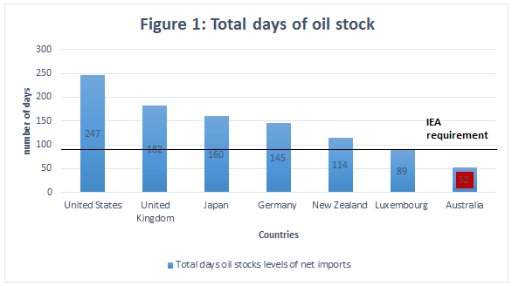
*
Source: International Energy Agency, Closing Oil stock Levels in Days of Net Imports as of June 2014, Accessible at www.iea.org/netimports, 2014

Australia has not met the 90 days minimum since December 2009. The current stock of Australian fuel holding stands at 52 days, which is lowest of the IEA member countries. Luxembourg is the next lowest oil stock country with 89 days.

The Liquid Fuel security Vulnerability Assessment in 2011 stated that Australia’s 90 day stockholding is likely to worsen with the increase in net imports.

Nations benefit from being in the IEA IEP because in the event that there is an oil supply disruption that is likely to cause considerable economic damage to member countries, they can make their stocks available to the market in order to offset any physical shortage of oil and ensure a steady supply.

The three most common reasons for the release of the stockpiled fuel are unforseen technical problems, weather and civil unrest. The IEA have stated that ‘Military or terrorist attacks which target energy infrastructure for political motives, or disputes between governments, while rare, are other significant concerns for world oil markets’.
IEA stocks have been released in the past for large events such as the build up to the Gulf War in 1991; after Hurricanes Katrina and Rita damaged offshore oil rigs, pipelines and oil refineries in the Gulf of Mexico in 2005; and in response to the prolonged disruption of oil supplies from Libya in 2011.
While the IEA have stated that ‘a release is not undertaken to moderate prices, although it can have that impact by calming the market, and thus exerting downward pressure on prices.’ There have been cases where nations have released fuel in order to dampen the prices in the market.
The general procedure for releasing extra oil supplies is noted in the IEA Initial Contingency Response Plan. The plan involves the IEA Secretariat sending all member countries preliminary assessments that there is a supply disruption. Then if there is cause for collective action, a detailed Initial Assessment will be issued, including an Initial Response Plan for releasing a specific volume of oil in the first 30 days of the crisis.
During this period members will be consulted on the need for activation. Finally if there is agreement for action the IEA Executive Director will issue a Notice of Activation, accompanied by a public press release.
Further follow-ups will be done and when appropriate, the IEA will recommend bringing the action to an end and will propose a schedule for re-establishing emergency stocks in those situations where they have fallen below the mandatory 90 days.
More specifically for Australia if there is an oil emergency the Minister in charge of the Resources and Energy portfolio is responsible for co-ordinating an emergency response. A national Liquid Fuel Emergency would involve a sustained and extensive shortage in the supply of liquid fuels.

The Department of Industry is responsible for the National Oil Supplies Emergency Committee (NOSEC) under which the Commonwealth and state governments create their management response to a national liquid fuel emergency.

The NOSEC is responsible for ensuring that the Minister for Resources, Energy, and Tourism and the Standing Council on Energy and Resources (SCER) receive relevant advice and information on issues confronting national supply of crude oil and petroleum products.

The Governor-General may declare a national liquid fuel emergency under the Australian government’s Liquid Fuel Emergency Act of 1984 (the Act). The Act provides the Australian Government with the authority needed to prepare for, and manage, a national Liquid Fuel Emergency.

A national emergency can only be declared if the situation meets the following criteria:
- the use of emergency powers is in the public interest;
- there is no real prospect of averting the shortage through voluntary increase of supplies by oil companies; And
- the minister has provided the opportunity for prior consultation with the relevant ministers for energy in all Australian states and territories.
The National Liquid Fuel Emergency Response Plan (NLFERP) is the contingency plan against a possible national liquid fuel supply emergency. The Australian Government, in partnership with State and Territory Governments and fuel industry representatives, has developed a NLFERP.

The NLFERP works to bring normal fuel supply levels into place and includes a communication plan designed to support the successful management of any Liquid Fuel Emergency.

If an emergency that begins in a State or Territory escalates to have national implications, the National Liquid Fuels Emergency Response Plan may override arrangements of the States and Territories. This is due to the Act prevailing over state legislation.

The constitutional basis for Australian Government action under the Act reflects that a national Liquid Fuel Emergency is a matter of national concern. A national Liquid Fuel Emergency involves specific Australian Government responsibilities including:

- Defence
- Protection of the existence of Australia as nation
- Australia’s obligations under international law
- Supplies to the territories and to the Australian Government or its authorities—as well as ensuring that trade or commerce may be carried on without obstruction or hindrance, and to the extent that the Constitution permits, in an efficient, competitive and profitable manner.
- The Act also incorporates contingency planning powers which may be activated prior to a national Liquid Fuel Emergency including powers to direct fuel industry corporations to maintain particular levels of reserves, develop bulk allocation procedures and to maintain and disclose statistical information.
The civilian stockpile must be in addition to defence force oil stocks which need to be reserved for national security purposes.

In order to maintain fuel security established assessments such as the National Emergency Security Assessments and Liquid Fuels Vulnerability assessments should continue to be completed regularly.

However, the government should improve the collection of petroleum data. A higher-quality and broader coverage of Australian Petroleum Statistics (under the announced Mandatory Reporting Regime) should be developed.

Additionally, the government should seek to identify and address any government policy and regulatory weaknesses to Australia maintaining a high level of liquid fuel security.

Limitations of the oil stockpiles requirements

The IEA regulations were created in 1974 in response to OPEC issues and many international oil companies see the 90 day requirement as outdated in today’s optimised market structure of multiple oil suppliers. Countries outside Europe see the IEA regulation as Eurocentric and benefitting European countries who can easily stockpile fuels. EU countries have also been able to count hydro carbon waxes, which will not be refined for oil, towards their stockholding. Therefore, many see the IEA as increasing bureaucratic red tape on the oil industry and IEA non-EU member countries.

Additionally, the IEA do not allow ‘stocks on water’ to be included in the oil stockpile, while they allow fuel held overseas for a country to be included. IEA oil stocktaking rules ignore how Australia stores and transports petroleum products. This storage method accounts for more than a quarter of total oil stockholding directly owned and controlled by Australian companies.

Australia has a very efficient network of shipping routes around Australia that provide an extensive source of oil for Australia and other Asia-Pacific regions. If there was a supply disruption ‘petroleum product cargoes at sea can be redirected by Australian companies to Australian ports to help manage disruptions’

Roughly 2-3 weeks of Australian supply is on the water at one time. Storing fuel on ships is seen as a logical and flexible way to store fuel as it can be diverted to where it is needed.

Figure 2: Australia’s major imports shipping routes: Petroleum products
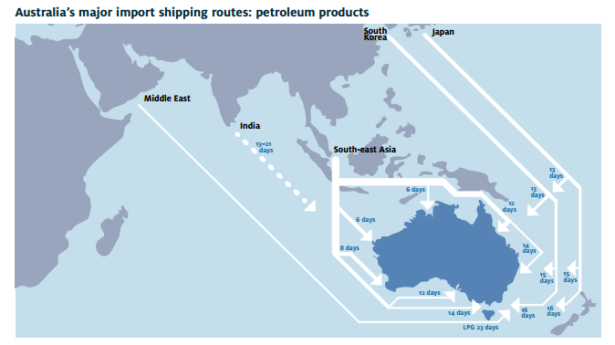
Source: Australian Institutive of Petroleum, Maintaining Supply Security and Reliability for Liquid Fuels in Australia, Accessible at www.aip.com.au September 2013, P 9

The risk of overseas oil supply disruptions is also considered low at this stage with ‘strong business pressures on refiners and fuel suppliers to maintain a resilient and efficient supply chain, since this is essential to minimise costs and to maintain or increase sales through a reputation for reliable supply’.
The petroleum industry regularly reviews commercial industry stockholdings to reflect the operation conditions throughout the supply chain and the risks and consequences of supply disruptions. An increase in stock levels beyond commercial levels would place significant additional costs on the supply system, which unless government funded would ultimately be passed onto consumers (if it was funded by the petroleum industry) or taxpayers (if it was funded by government). The government should investigate how much oil stocks are necessary for national interests to be secure and delineate this from commercial stock holdings.

The government should press the IEA to review its 90 days stockholding requirement to reflect developments in the petroleum market since 1974, including the development of ‘stocks at sea’. The government should then, over time, seek to comply with the revised stockholding rules.

Currently, all of Australia’s oil stocks are held by commercial entities. The Australian Government provides no capacity and holds no stocks. In the US, the Government owned capacity has around 106 days’ worth of fuel, and Japan’s Government holds 91 days. In Germany, the majority of fuel oil stocks are stored in Government capacity storage. In order to secure Australia’s national interests, the Government should provide capacity storage to the revised IEA stockholding level.

Onshore oil refineries

Australia’s onshore oil refining capacity is declining. In 2015 two refineries (Kurnell in Sydney and Bulwer Island in Brisbane) will close, leaving four refineries in Australia. Not only does this put further pressure on fuel security in Australia but is losing a vital industry that can produce export materials, similar to mining.

Given that oil refineries are a critical infrastructure the government position on making sure these industries are maintainable should be considered. The Australian Institutive of Petroleum have suggested that if the government consider the closing of refineries to be a security risk the future of keeping refineries open should be considered in a cost benefit analysis to measure the costs of maintaining these processing abilities.

There are contributing factors to why Australian onshore refining is declining; a higher operating costs base, lack of economies of scale compared with regional competitors, higher labour costs, relative age of refineries, the scale of refineries and the high Australian dollar.

The Liquid Fuel Security Vulnerability Assessment in 2011 found that while the import to local stock ratio was declining this was not a cause for concern for supply security reasons in the short term because of the nature of the petroleum market globally and in the Asia Pacific region. Asia is a more attractive investment and productive area for oil refining because of economies of scale in refining due to size, scale, lower unit costs and storage capacity

The ensure fuel security and to make sure Australia’s remaining oil refineries are as competitive as possible the government should:
- Streamline approvals for new or expanded facilities or port deepening.
- Limit regulatory burdens that reduced the industry’s ability to compete effectively in the Asia Pacific region. Any regulatory change should involve extensive consultation with stakeholders and a Regulatory Impact Statement being completed.
- Provide a stable policy and investment environment for the industry.
- Ensure research and development policies encourage the commercial development of transport fuels which can contribute to liquid fuel security in Australia.
Recommendation 1

The government should recommend that the International Energy Agency (IEA) review the requirement for measures to hold 90 days of net imports, given that it was originally set in 1974 and does not allow the inclusion of ‘stocks at sea’, which accounts for over a quarter of Australia’s oil stocks.

Recommendation 2

The government should comply with the revised IEA stock holding rule.

Recommendation 3

The government should continue to monitor fuel security in Australia by:
- Continuing the National Emergency Security Assessments and Liquid Fuels Vulnerability assessments.
- Improving the data collection of Petroleum statistics via the Mandatory Reporting Regime which is being developed.
- Identifying and addressing government policy and regulatory weaknesses that threatens Australia maintaining a high level of liquid fuel security over the longer term.
Recommendation 4

The government should seek to improve investment in energy security by removing barriers to investment in this sector such as:
- streamlining approvals for new or expanded facilities or port deepening,
- providing a stable policy and investment environment for the industry, and
- ensuring research and development policies encourage the development of transport fuels.

Alternative transport fuels

LNG and CNG are an alternative source of fuel for the industry with lower emissions. However, there are some technical issues and drawbacks compared with diesel that limit LNG/CNG heavy vehicle uptake.

For LNG heavy vehicles, the tank needs to be 1.5 times larger in order to have the correct capacity. For CNG vehicles the tank needs to be even larger. CNG heavy vehicles also need to be modified to have spark plugs fitted in order for combustion and LNG vehicles require a small amount of diesel to start ignition. The cost of modifying vehicles to CNG/LNG is $50,000 - $60,000. The refuelling of these vehicles also takes considerable time compared to diesel heavy vehicles.

The industry has trialled LNG heavy vehicles and believes there are significant gains to be made in the use of LNG/CNG smaller heavy vehicles such as three axle rigid trucks. These vehicles are not constrained by length and weight dimensions compared with larger high productivity vehicles such as B-doubles or truck and dogs. Larger trucks are limited by the turning circle, length and weight required for a multi combination vehicle and, therefore, not as suitable for alternative fuels as single combination small heavy vehicles.

The industry has concerns about additional mass concessions for the steer axle of prime movers because of the increased impact on the infrastructure the concessions would cause.

The Government should provide a positive investment environment for alternative fuel infrastructure in order to support the heavy vehicle industry use of CNG/LNG heavy vehicles.

Recommendation 5

The Government should provide a positive investment environment for alternative fuel infrastructure in order to support the heavy vehicle industry use of CNG/LNG heavy vehicles.

Renewable fuels

Renewable fuels such as biodiesel blends have the potential to provide an abundant source of fuel to the trucking industry. However, availability, taxation and engine warranty issues constrain the use of these renewable fuels in the trucking industry.

Biodiesel blends are not readily available in many areas. B20 (a standard blend containing 20 per cent biodiesel) can only be sold with a special approval under section 13 of the Fuel Quality Standards Act. For operators, using blends with more than 20 per cent biodiesel raises fuel tax issues.

Engine manufacturers are generally reluctant to approve the use of blends with biodiesel concentrations of more than 5-7 per cent. The use of blends with a concentration of biodiesel higher than this level is especially problematic for advanced engines that comply with the Euro 6 emission standard.

Therefore, first generation biofuels are not the answer to reduce Australia’s dependence on fossil fuels.

Accordingly, the Government need to look ahead and support research and development, and the commercialisation of advanced renewables such as algal biodiesel fuels.

CSIRO research has shown it should be possible to produce algal biodiesel at a lower cost and with less greenhouse gas emissions than fossil fuels.

Algal biofuel is still in the research stage and not yet commercially available. The expected costs are currently high for infrastructure, and there is a lack of a user base for growing and harvesting the algae. These costs are expected to reduce with time.

The Government should contribute additional funds to support the further development of synthesising macro algae into synthetic crude oil.

Recommendation 6

The Government should support research into renewable fuels such as algal biofuel in order to provide a diverse range of fuels for the industry to use.

Increasing heavy vehicle fuel efficiency

The ATA’s environmental credentials report shows the industry’s greenhouse gas emissions fell 35% per billion tonne kilometres between 1990 and 2011, as a result of improvements in engine technology and the use of safer trucks with greater capacity. The industry is committed to improving fuel efficiency.

The heavy vehicle industry is highly motivated to improve fuel efficiency because of the competitive nature of the trucking industry and tight margins. There are a number of options available to further increase the trucking industry fuel efficiency.

Replacing the double tyres used on trucks and trailers with single ultrawide tyres could deliver a 4% to 8% improvement in fuel consumption. Under the national mass limits, however, vehicles with single ultrawide tyres cannot carry as much mass as vehicles with double tyres. As a result, they are not used.

The best way trucking businesses can reduce their fuel consumption is to use high productivity vehicles like B-triples or super B-doubles on appropriate routes. By using B-triples instead of semitrailers, an operator could reduce their fuel consumption considerably.

Heavy vehicle type | No. of trips per 1000 tonnes | Fuel required to deliver 1,000 tonnes 1,000 Kms and return
Traditional 3 axle rigid | 77 | 43,120
Traditional 6 axle semi-trailer | 42 | 39,480
Innovative 9 axle B-double | 26 | 32,240
Traditional 11 axle road train | 21 | 28,560
Innovative 12 axle B-triple | 20 | 27,200
Traditional 16 axle road train | 15 | 24,000
Figure 3: fuel and number of trips needed to move 1000 tonnes
Source: Truck Impact Chart: ATA and Barkwood Consulting Pty Ltd 2010 (Appendix A)
While the industry wants to reduce emissions via technology such as ADR 80/03 heavy vehicles, the industry is limited by government policies that allow the use of more efficient vehicles. This is because of first and last mile restrictions and high productivity vehicle restrictions on main roads.

In its Energy White Paper, the Government should announce an integrated and effective plan to remove the red tape and regulatory impediments that prevent the industry from increasing its use of high productivity vehicles.

Rail freight versus road freight

It is sometimes suggested that the solution to reduce Australian transport energy use is to move more freight onto rail.

The Henry Tax Review recommended:

On routes where road freight is in direct competition with that is required to recover its capital costs, heavy vehicles should face an additional charge on a comparable basis. Where this improves the efficient allocation of freight between transport modes.

The Tax Review also stated that the heavy vehicle industry does not pay for all its attributable costs.

However, the heavy vehicle charges model, PayGo, has been overcharging the industry since 2007. This is because the model uses a lagged population in the 7 year model but the most up to date expenditure data. This year alone the industry will pay over $200 million in excess taxes because state transport ministers did not agree to stop the over-charging.

Therefore arguments that the industry is underpaying its attributable costs are unfounded.

Modal choice for transporters depends on a number of parameters; what is to be shipped, is it time sensitive, the cost, availability of mode of freight and how far it has to travel.

Road transport is the dominant mode of freight transport in Australia when transporting non-bulk goods because Australia’s population is dispersed, the trucking industry is relied on heavily by the community compared with less time sensitive modes like rail and coastal shipping.

The ATA supports efficient movement of freight. The Government should understand that only a small amount of freight is contestable with rail. Rail excels at transporting heavy bulk, such as consolidated grain and mining resources. The road freight fleet moves time sensitive material and direct delivery packages. Decisions on which mode of freight transport will work best are normally based on the constraints mentioned above. Road and rail should be viewed as complementary modes of freight transport.

Pricing analysis have shown a weak level of substitution between the modes. A price elasticity report conducted by BITRE showed that even if there were large increases in freight rates, rail freight was unresponsive to the increase. Only in the medium distance corridors if the road freight rate increases by 1% would there be a 1.08% increase in rail freight.

Both road and rail should be priced to promote efficient use and efforts to force freight onto a non-competitive or applicable freight mode will only cause a loss for the community.

The heavy vehicle industry pays for impact and emissions via the road user charge and mandated emissions standards. For instance, operators can only access the fuel tax credit if they meet a number of criteria, including meeting emissions standards. There are no such emission controls on the rail industry.

Recommendation 7

The Government should develop an integrated and effective plan to remove the regulatory impediments preventing the use of high productivity vehicles.

Recommendation 8

The Government should regulate road and rail freight so each mode is as efficient as possible, without regard for potential modal shift.

APPENDIX A: The ATA and Barkwood Consulting Pty Ltd Truck Impact Chart

The ATA and Barkwood Consulting Pty Ltd have developed a Truck Impact Chart that clearly demonstrates a number of different heavy vehicle combinations and covers GCM, payload, the equivalent standard axles (ESAs) for each vehicle combination, being the measure by which impact of a truck on the road is measured, the amount of trips required to move 1,000 tonnes of freight, the amount of fuel required to move 1,000 tonnes of freight, emissions and driver requirement. The information provided in the tables throughout this document is taken from the Truck Impact Chart.

The Truck Impact Chart has been reviewed RTA’s Senior Pavement Engineer, Ravindra Prathapa. The Truck Impact Chart has also been separately peer reviewed by Bob Pearson, Pearson Transport Resources, and was referred to by TheCIE in the Benefit/Cost Analysis for the National Heavy Vehicle Regulator draft Regulatory Impact Statement, released in February 2011.

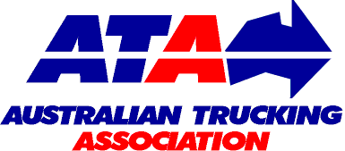 | Authors: | David Coonan - Australian Trucking Association | BARKWOOD CONSULTING Pty Ltd
 |  | Bob Woodward - Barkwood Consulting Pty Ltd.
This document has been prepared to assist operators and road asset managers in assessing the merits of utilising larger vehicle combinations in a transport task.
The assessment process assumes that the vehicle is dedicated to a specific task, operating travel being 50% unladen and 50% laden. The task relativities are 1000 tonnes with a lead of 1000 kilometres.
Equivalent Standard Axles: | ESA’s are calculated by the average of the sum of ESA’s for zero load (empty) plus ESA’s for 100% load and multiplied by the number of trips as required for the transport task.
Vehicle tare weights: | Are predictions based on the averages for a range of equipment within each combination category. These estimates have been reviewed by a number of operators and confirmed as being representative of “real” vehicles of the category.
Fuel consumption estimates: | Are predictions based on accumulated averages where operation is nominally 50% unladen and 50% laden. Actual consumption will vary with operating conditions.
Emissions: | Reference is based on total fuel consumption only.
20 metre 7 axle Truck & Dog: | The maximum allowable mass limits for this combination at either CML or HML (for standard combination) is 55.5 tonnes.
19 metre 7 Axle B-double: | The maximum allowable mass limits for this combination at either CML or HML (for standard combination) is 55.5 tonnes.
B-triple: | Consists of a complying B-double with an additional complying leading trailer.
Converter Dolly: | All combinations utilizing a converter dolly are configured with a tandem axle. The configured vertical imposed loading of a 6x4 prime mover is similar to the allowable imposed vertical loading of a tandem axle converter dolly.
AB-triple: | Consists of a complying B-double with an additional complying road train leading trailer and a complying converter dolly.
BAB-Quad: | Consists of a complying B-double with an additional complying converter dolly and additional complying set of B-double trailers.

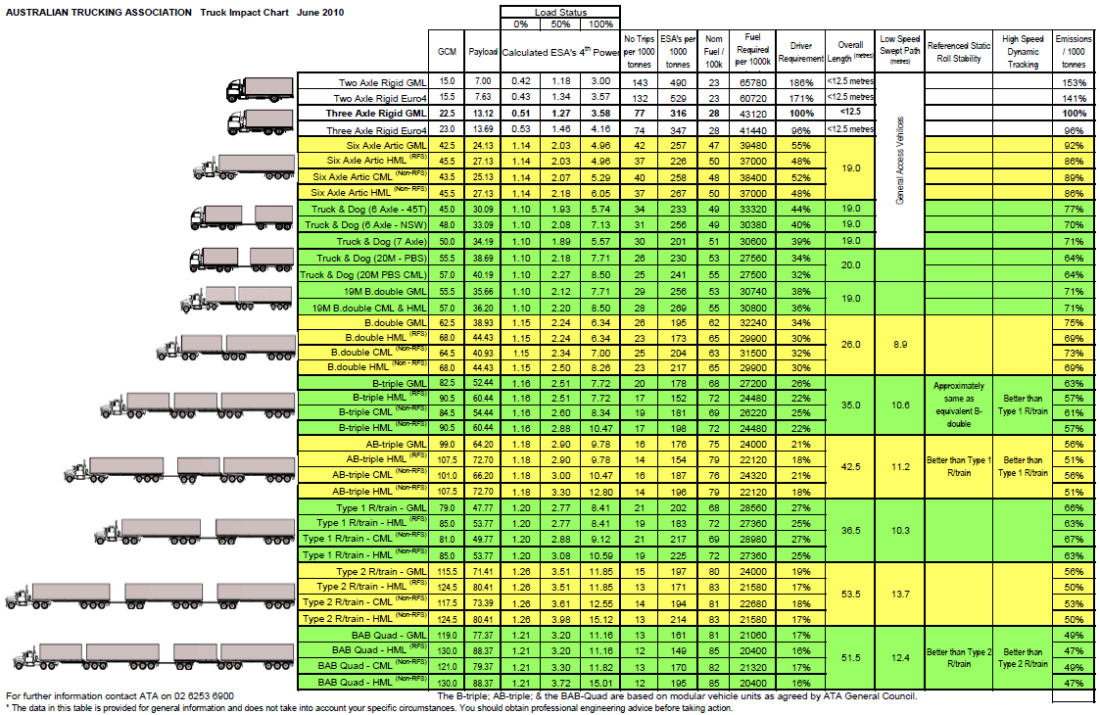

Department of Industry, Energy Green Paper, Accessible at www.ewp.industry.gov.au, September 2014, P 48
Australian Institutive of Petroleum, Maintaining Supply Security and Reliability for Liquid Fuels in Australia, Accessible at www.aip.com.au September 2013, P 3
Exporting countries such as Canada and Norway are not required to meet the 90 day oil stock holding.
International Energy Agency, Closing Oil stock Levels in Days of Net Imports as of June 2014, Accessible at www.iea.org/netimports, 2014
Department of Resources Energy and Tourism, Liquid Fuels Vulnerability Assessment: A review of liquid fuels vulnerability, Accessible at www.aip.com.au, October 2011, P Xiii
International Energy Agency, How does the IEA respond to major disruptions in the supply of oil? Accessible at www.iea.org/topics/energysecurity/respondingtomajorsupplydisruptions
Australian Institutive of Petroleum, Maintaining Supply Security and Reliability for Liquid Fuels in Australia, Accessible at www.aip.com.au September 2013, P 22
Australian Institutive of Petroleum, Maintaining Supply Security and Reliability for Liquid Fuels in Australia, Accessible at www.aip.com.au September 2013, P 19
Australian Institutive of Petroleum, Maintaining Supply Security and Reliability for Liquid Fuels in Australia, Accessible at www.aip.com.au September 2013, P 8
Australian Institutive of Petroleum, Maintaining Supply Security and Reliability for Liquid Fuels in Australia, Accessible at www.aip.com.au September 2013, P 9
Australian Institutive of Petroleum, Maintaining Supply Security and Reliability for Liquid Fuels in Australia, Accessible at www.aip.com.au September 2013, P 6
International Energy Agency, Closing Oil stock Levels in Days of Net Imports as of June 2014, Accessible at www.iea.org/netimports, 2014
Australian Institutive of Petroleum, Maintaining Supply Security and Reliability for Liquid Fuels in Australia, Accessible at www.aip.com.au September 2013, P 11
BP Australia Submission to parliamentary inquiry into Australia’s oil refinery industry Accessible at www.aph.gov.au/parliamentary_business/committees/house_of_representatives_committees?url=economics/oilrefineries/subs.htm, November 2012, P 6
Department of Resources Energy and Tourism, Liquid Fuels Vulnerability Assessment: A review of liquid fuels vulnerability, Accessible at www.aip.com.au, October 2011, P viii
Australian Institutive of Petroleum, Maintaining Supply Security and Reliability for Liquid Fuels in Australia, Accessible at www.aip.com.au September 2013, P 5
Australian Institutive of Petroleum, Maintaining Supply Security and Reliability for Liquid Fuels in Australia, Accessible at www.aip.com.au September 2013, P 21
Centre for International Economics Environmental Credentials of the Australian Trucking Industry Accessible at www.atatruck.net.au/industry-resources/environmental-credentials-australian-trucking-industry , 2011, P 6
Centre for International Economics Environmental Credentials of the Australian Trucking Industry Accessible at www.atatruck.net.au/industry-resources/environmental-credentials-australian-trucking-industry , 2011, P 19
Australia's Future Tax System, Final Report, Accessible at www.taxreview.treasury.gov.au, December 2009, P 377
National Transport Commission, 2014 Heavy Vehicle Charges Determination Regulatory Impact Statement, Accessible at www.ntc.wdu.com.au/viewpage.aspx?documentid=2513, February 2014, P 59
BITRE Transport and Regional Economics Australian Transport Statistics Yearbook 2012, Table T 2.1b Total, bulk and non–bulk domestic freight, by transport mode— non–bulk Bureau of Infrastructure, Accessible at www.bitre.gov.au/publications/2012/stats_002.aspx, 2012, P 48
BITRE Road and rail freight: Information sheet 34 competitors or complements? Accessible at www.bitre.gov.au/publications/2009/is_034.aspx ,2009

