Submission to: | The Board of Taxation
Title: | Small Business Tax Impediments
Date: | 27 May 2014

Contents

1. Introduction 3
2. Australian Trucking Association 3
3. Recommendations 3
4. Small business threshold 4
5. Fuel usage benchmarks 5
6. Publishing the statutory cap on the effective life on trucks 6

Introduction
The Board of Taxation has started a fast-track review into the tax system impediments small business face.
The Board has been asked:
- to identify features of the tax system that are unreasonably or unnecessarily hindering or preventing small businesses from pursuing and achieving their commercial goals, and;
- to provide business and broader community perspectives on issues in the tax system that are of most concern to small businesses, and identify the short and medium-term priorities for small business tax reform in Australia, while noting that frequent change is often cited as a contributing factor to the compliance burden facing small business. The Board’s report should have a particular focus on high priority options for simplification and deregulation.
Against the above background, the Board is seeking submissions which identify the most serious tax system impediments that small businesses face in achieving their commercial goals, along with a sense of their relative priority.
The heavy vehicle industry predominately consists of small businesses with 89 per cent of the industry owning 2 or fewer trucks. However, the industry’s contribution to the economy is significant. The industry generates direct as well as flow on activity through its support to a diverse range of industries and supply chains. The road transport industry added more than $18 billion to the Australian economy in FY2012 or 1.4 per cent of Gross Domestic Product.

Australian Trucking Association

The ATA is the peak body that represents the trucking industry. Its members include state and sector-based trucking associations, some of the nation’s largest transport companies, and businesses with leading expertise in truck technology.

Recommendations

Recommendation 1

The Australian Tax Office should raise the small business threshold to $5 million.

Recommendation 2

The Australian Tax Office should recast its fuel usage benchmarks.

Recommendation 3

The Australian Tax Office should better publicise the statutory cap on the effective life on trucks.

Small business threshold

The ATO definition of ‘small business’ a business with a turnover of $2 million (excluding GST) or less does not capture all small businesses in the trucking industry.

A trucking company can have turnover of more than $2 million; however it may employ fewer than 20 workers. The amount of turnover is considerable but the resources available to complete tax administration, including business activity statements, superannuation payments and other tax responsibilities may not be sophisticated.

It should be noted that the Australian Bureau of Statistics, Fair Work Australia and the ATO have different definitions of what a small business is:

Australian Bureau of Statistics
A small business is defined as a business employing less than 20 people.

Categories of small businesses include:
- non-employing businesses - sole proprietorships and partnerships without employees;
- micro businesses - businesses employing less than 5 people, including non-employing businesses;
- other small businesses - businesses employing 5 or more people, but less than 20 people;
Small businesses tend to have the following management or organisational characteristics:
- independent ownership and operations;
- close control by owners/managers who also contribute most, if not all the operating capital; and
- principal decision-making by the owners/managers.

The ABS also recognises sub-types of small businesses – micro businesses that have less than 5 employees.

Fair work Australia

A small business has less than 15 employees whether full or part time.

Therefore, the ATO’s small business definition should be less conservative given the Australian Bureau of Statistics and Fair Work Australia definitions which refer to employee numbers, not turnover as an identifier for small business. Given the above comments, the ATO should raise its threshold turnover from $2 million to $5 million.

Recommendation 1

The Australian Tax Office should raise the small business threshold to $5 million.

Fuel usage benchmarks

The ATO states that it publishes its benchmarks as a range representing the ratios reported by businesses grouped by either side of the average. Benchmarks are made available as a guide for businesses to review their performance and business practices against other similar businesses.

The ATO uses benchmarks to identify businesses that it says may be avoiding their tax obligations by not reporting some or all of their income.

The ATO benchmarks that apply to trucking businesses are as following:

Benchmark Ratio | Annual turnover range
Income tax return | $50,000 - $200,000 | $200,000 - $600,000 | More than $600,000
Labour/turnover | 21%- 32% | 15%- 25% | 20%- 29%
Motor vehicle expenses/turnover | 14%- 28% | 8%- 31% | 3%-26%
Last modified 25 March 2014.

The ATO benchmarks for motor vehicle/turnover considerably underestimate the vehicle expenses that can be incurred by legitimate trucking businesses.

As the table below shows fuel expenses can amount to as much as 45% of a trucking companies business costs, or about 43.7 % of net expenses given the profitability of a typical trucking business, particularly in the case of businesses that solely carry out interstate road transport work.

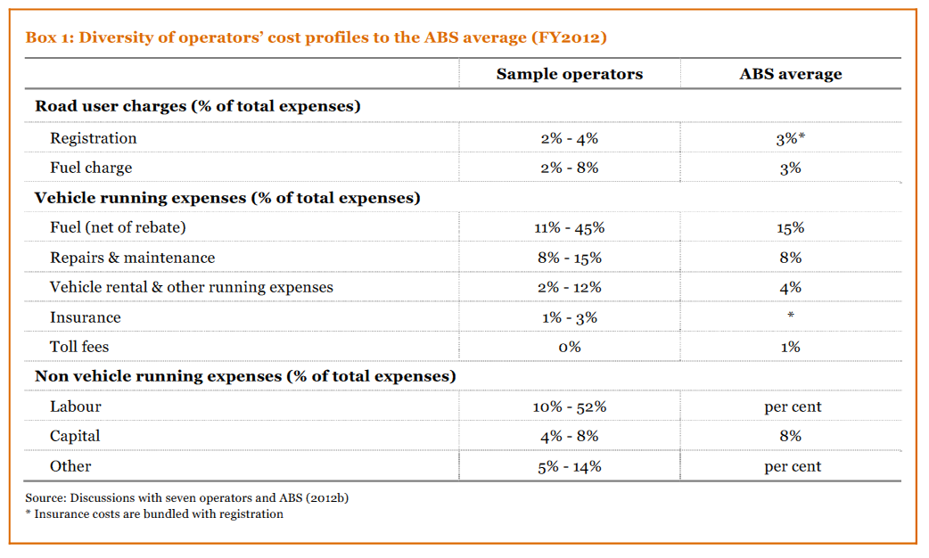
Source: Page 18 A future strategy for road supply and charging in Australia, PricewaterhouseCoopers 2013

The ATO’s underestimate of the motor vehicle expenses involved in running trucking businesses has imposed real costs on some business.

The ATA is aware of at least one interstate transport business that has been audited because its motor vehicle expenses turnover ratio was outside the ATO’s expected benchmarks but within the typical range for an interstate trucking business.

Recommendation 2

The Australian Tax Office should redraw the fuel usage benchmarks and should allow operators to provide fair and reasonable methods to support fuel usage figures.

Publishing the statutory cap on the effective life on trucks

There is currently some confusion over the correct figure for the effective life on trucks.

The relevant tax ruling: ‘Income tax: effective life of depreciating assets’ is misleading as it uses the commissioner’s determination (15 years), and not the much lower figure legislated by parliament (10 years).

As a result, some accountants have used the wrong figure for their trucking industry clients, because they did not follow the fine print through.

The ATO should better publicise the applicable effective life on trucks.

Recommendation 3

The Australian Tax Office should better publicise the statutory cap on the effective life on trucks.

Page 12 A future strategy for road supply and charging in Australia, PricewaterhouseCoopers 2013

