Submission to: | The Productivity Commission
Title: | Public Infrastructure: Issues Paper
Date: | 20 December 2013

Contents

1. Introduction 3
2. Australian Trucking Association 3
3. Executive Summary 3
4. Government cooperation and practices 4
5. Heavy vehicle infrastructure expenditure 5
5.1 The heavy vehicle charging model – PayGo 5
5.2 State heavy vehicle expenditure reporting 5
5.3 Audits 6
5.4 Benchmarking 6
6. Project governance 7
7. Alternative sources of infrastructure financing 7
7.1 Private investment 7
7.2 Marginal cost user charges 8
8. Heavy vehicle access demand 9
8.1 Last and first mile access 9
8.2 Heavy vehicle infrastructure maintenance 10
9. Inputs into road infrastructure projects 11

Appendix A: Road expenditure and maintenance expenditure 2012-13……………………………………13

Appendix B: The ATA and Barkwood Consulting Pty Ltd Truck Impact Chart………………….………..14

Introduction

The Productivity Commission enquiry into public infrastructure is focusing on two broad streams of work:
- the provision, funding, and financing of major public infrastructure, and
- the scope for reducing the costs associated with such infrastructure.

The commission will make recommendations to improve the outcomes in infrastructure provision for the benefit of the community as a whole.

While the Commission may be expecting large scale recommendations to be made by stakeholders, there are small and incremental changes that can be made to make big differences, at least in the provision of heavy vehicle specific infrastructure and expenditure oversight. Additionally, while the commission may be concerned with funding certainty it appears the performance of road authorities management is not up to the standards it should be.
The heavy vehicle industry and its interactions with government road agencies is set to change as a result of the short term 2013-14 National Transport Commission (NTC) heavy vehicle charges determination and the longer term review of charges and supply side reform, the Heavy Vehicle Charging and Investment reform (HVCI) project.
The Australian Trucking Association (ATA) also commissioned an independent report on the recommended way forward in terms of heavy vehicle charges and supply side reform. The PricewaterhouseCoopers (PwC) report: A future strategy for road supply and charging in Australia provided short, medium and long term reforms necessary to support growth in Australia. A copy of the PwC report is provided with the submission.

Australian Trucking Association

The ATA is the peak body that represents the trucking industry. Its members include state and sector based trucking associations, some of the nation’s largest transport companies, and businesses with leading expertise in truck technology.

Executive Summary

There are fundamental differences in the practices and interactions between the Commonwealth and states on the matter of road infrastructure provision. This approach leads to disjointed road provision decisions and less than optimal outcomes in infrastructure provision.

The PwC report recommended a three tiered approach to the road network with a transparent funding allocation formula will help to increase accountability and focus. We also caution that without calculating the asset base of the road infrastructure any proposed moves to focus on the network approach may be futile.

Improving the transparency and accountability and oversight of road provision authorities should occur, including the adoption of basic audit practices. Having these processes in place should reduce waste and promote best practice reporting.

The project governance of infrastructure projects in Australia also needs improving. With 48% of projects failing to meet baseline timeframes, costs and quality objectives, considerable work is needed to fix flaws in project governance.

While public private partnership investment can provide a stream of financing for public infrastructure it comes with possible extra costs in establishing contracts and associated extra transparency and accountability. Private financing is also unlikely to solve the pervading issue of community service obligation (CSO) road and low volume road provision.

Implementing marginal cost road user charges would cause unintentional welfare effects, due to the vast population spread in Australia and the associated costs with this dispersion.

Road authorities have contrasting approaches to granting heavy vehicle access and there is a lack of reproach for industry over rejected access decisions. External review of rejected access decisions should be employed. Rejected access decisions provide information for the government on where access is sought, but being currently denied by the industry. We doubt progress in this area can be made until there is consistent information and education provided to road managers.

The commission may want to use the Road Construction Maintenance and Price Index (RCMPI), as it provides a good index to compare input costs of road construction over the years and information on the activity share of costs and the activity share on different types of roads.

Government cooperation and practices

In financing and funding heavy vehicle infrastructure there is a funding hierarchy that presents intergovernmental pressures. The Commonwealth receives revenue from the road user charge (RUC), states receive revenue from registration charges and local government receives grants from the Commonwealth and revenue from the states.

It should be noted that while local governments receive grants that are notionally for road spending the grants are not tied and the money industry pays does not necessarily end up being spent on heavy vehicle infrastructure. This lack of accountability and control over money provided by the industry needs to be rectified.

The PwC report highlighted the lack of national cohesion in road supply decision making. ‘Competing interests among different levels of government and different agencies at each level can result in patch protection and bureaucratic processes blocking meaningful transport reform’.

Currently states are simply handed their appropriate amount of funding, given heavy vehicle expenditure. However, in the future there should be moves to tie funding to performance of road authorities. The PwC report recommended that in the medium to long run, given the uptake of benchmarking and reporting, efficient road investment and maintenance costs could be independently assessed and tied to funding allocation. Incentives to outperform benchmarks should be provided, for instance by allowing a road supplier to retain unspent funds and invest in other priorities.

There are fundamental operational differences between the states and the Commonwealth which present disassociated projects and aims. For instance while there is the HVCI review which all states are aware of and participating, NSW has a separate review into road pricing which overlaps with the HVCI project. This duplication occurs far too often in the road infrastructure area.

Another reason for the divergence away from consistency in road infrastructure is the fact the Commonwealth and the states calculate cost benefit analysis differently. State road agencies use a qualitative approach, whereas the Commonwealth use a quantitative approach to cost benefit analysis. Having a consistent approach to evaluating road infrastructure projects would make better sense than the current system.

While government organisations such as Infrastructure Australia (IA) are focusing on nationally significant freight projects through the Land Freight Network Strategy, extending the focus to a whole of network approach would provide a more coherent view of the network.

The PwC report made a short term recommendation regarding the heavy vehicle industry for the creation of a national road freight network hierarchy agreed by the industry and road suppliers. Each level of the hierarchy will be associated with harmonised and aspirational levels of heavy vehicle access. This would be a three tier freight network with each tier targeting a particular heavy vehicle access level to focus investment, reporting and funding.

Tier 1 – primary land freight transport corridors – the highest level of access, building on IAs national land freight network.

Tier 2 – significant last and first mile higher mass limits connections – level of access below of tier 1, but may align with Tier 1 mass limits to ensure end to end trip productivity is achieved.

Tier 3 – remaining freight network – a minimum level of access in line with current general access requirements, supplemented by ad hoc improvements over seen by the NHVR.

The tiered approach is akin to defining service standards in the utilities sector. This would have to be supplemented with harmonised approaches by road managers such as the pavement depth reasonably required to allow B-doubles with GML.

However, before any of the positive changes can come from the tier identification it is crucial that the current asset base of roads is identified. Without having some idea of the value and the identity of the road network it is hard to make decisions when there is such a gap.

In addition to the three tier approach, PWC have recommended that in three years, a transparent formula for allocating funding to road suppliers should be established. Funding allocations should reflect road costs, heavy vehicle usage and access upgrades required for Tier 1 and Tier 2 roads. This would be a superior funding mechanism than the current system where road funding allocations are dictated by how much a state budgets to spend and is recouped from the industry through the RUC and registration charges.

The formula would also include a mechanism to fund low-volume roads, which would be classed as Tier 3, through community service obligations (CSO). It is important that rural, remote and regional Australia is adequately funded so improvements can be made for these communities and the operators working in those areas.

The formula would provide certainty of heavy vehicle related funding to road owners.

Heavy vehicle infrastructure expenditure

The heavy vehicle charging model – PayGo

The heavy vehicle industry pays for capital and maintenance through a charging model called PayGo which is operated by the NTC. The PayGo model recovers the capital and maintenance costs over a seven year period. It is a very sophisticated model that allocates cost to each different type/combination of heavy vehicle via sensitive parameters such as heavy vehicle infrastructure impact (equivalent standard axles), the length of the vehicle (passenger car units) and vehicle kilometres travelled.

The PayGo model recovers the cost base via a RUC and state based registration charges. The commonwealth collects the revenue from the RUC and states receive the revenue from registration charges.

State heavy vehicle expenditure reporting

States record heavy vehicle expenditure into an NTC expenditure template which categorises spending e.g. bridge maintenance and rehabilitation or road pavement and shoulder maintenance (see appendix A for the full expenditure template). The expenditure total is fed into the PayGo model and forms the cost base to be recovered from the heavy vehicle industry.

The current state heavy vehicle road expenditure and maintenance inputs into the PayGo model are unaudited. Industry has raised the issue of possible inefficient spending and lack of consistency due to the fact that the expenditure industry pays for is not subjected to independent audits.

In the recent heavy vehicle charges determination carried out by the NTC the findings in a Deloittes Review of Reported Jurisdictional Road Expenditure Data 2012 report showed inconsistency in what some states included in categories, some including costs which were not listed in the guidelines.

Audits

States heavy vehicle expenditure inputs should have the same level of accountability and scrutiny as other public and private entities. The ATA raised issues over the accuracy and consistency of the reported expenditure. The ATA has also asked how road agencies could demonstrate they were spending heavy vehicle revenue efficiently and maintaining the network.

It was highlighted that the cost categories in the expenditure template differ to how jurisdictions record their financial costs. This has given rise to a number of reporting issues.

The NTC charges determination regulatory impact statement (RIS), which is out for stakeholder review now, recommends that designing an appropriate framework for the scrutiny of costs can deliver significant efficiency benefits for road users and the ATA shares this view.

The NTC have recommended a commitment to investigate the possibility of introducing procedural style audits for completion on the returned expenditure templates. This would increase the transparency and accountability of reported costs.

The total cost associated with this level of audit is estimated to be $115,000 to $125,000. The cost of the audit being recovered from industry is not ideal, given that the audit process is an established procedure that should have already been in place years ago. However, if the audit is done correctly and provides industry with more understanding about the reported costs and leads to an improvement in road agency recording practices it will be a benefit for all.

The ATA wants the audit process to become an established practice road agencies carry out in order for industry to have more confidence that what they are paying for is appropriate and approved.

Benchmarking

Currently, information on the competence of one road agency compared with another is limited. There is not an easily obtained and reviewable source of data for industry to use to review the efficiency of heavy vehicle-specific expenditure.

PwC recommended that state, territory and local government road owners should report investment and maintenance activity on each tier of the network. This information should then be compared with cost benchmarks and the levels of access achieved, relative to agreed targets or benchmarks for increased transparency and accountability.

Having this expenditure data publicly available would enable unit cost estimates of road maintenance and investment (e.g. by lane kilometres on a given network tier). These estimates would be developed into efficient benchmark investment and maintenance costs that could be used to inform the amount of expenditure that is recovered from heavy vehicle road users.

In the longer term, once basic benchmarking was established, independent benchmarking of efficient road investment and maintenance costs should be tied to funding allocations for road agencies. Such a move would support efficiency incentives and appropriate pricing.

Incentives to outperform guidelines should be provided, for instance, by allowing a road supplier to retain unspent funds to invest in other relevant priorities. However, safeguards would be required to ensure quality of supply and to avoid inflated project estimates.

The current NTC heavy vehicle charges determination has highlighted that road agencies cannot split maintenance and capital costs in project costs. The NTC are recommending introducing benchmark reporting of jurisdictional business, as part of the broader accountability measures. This will help highlight cost differences between states and will provide industry with some idea of cost drivers in different states and the relative levels of access provided.

Audits and benchmarking combined should give states the incentive to use best practice when it comes to calculating appropriate costs and providing information that can be compared to other states and can explain why systematic and inherent differences occur in the road provision and maintenance costs. Ultimately, we believe that audits and benchmarking will reduce wasteful actions.

Project governance

A recent report to Infrastructure Australia (IA) about infrastructure project governance effectiveness in Australia found that on average, 48% of projects failed to meet baseline timeframes, costs and quality objectives.

There is a high level of non-compliance with basic governance measures:
- 87% did not have approved governance plans
- 94% did not measure governance in team member performance
- 80% said project skills were not adequate
- 55% governance team members did not exhibit proper corporate behaviour

Unsurprisingly, the report concluded that ‘a major cause of project failure in Australia has its roots in project governance or the lack thereof. The delivery of project governance in Australia is also highly dysfunctional.’

The report to IA further highlights the need for benchmarking and governance reform.

Increased accountability and transparency in planning, design decisions, along with the construction phase of capital and maintenance needs to be implemented.

Alternative sources of infrastructure financing

Private investment

The Productivity Commission is keen to investigate the potential for greater private investment into public infrastructure. While the 2013 RCMPI found that private sector involvement in road construction and maintenance projects increase to 56.4% compared to 40.4% in 1997, there are some fundamental issues that need to be carefully investigated before believing that private investment is the cure-all to public infrastructure financing.

Fair access prices and private investment for infrastructure need to be considered. Private investment infrastructure costs include a risk premium and will have shareholder interests at their core. It should also be noted that the cost of negotiating private contracts tends to be higher and the heavy vehicle industry wears the costs of these negotiations, unfairly some would suggest.

NSW has had previous experience with public private partnerships (PPP). The NSW Treasury has strict guidelines on PPP procurement and investment decisions, which are continuing to be altered as PPP projects are carried out. An evaluation of PPP arrangements noted that public trust of PPP projects improves with a high level of transparency of contracts. As stated above, the transparency, accountability and project governance is far from what one would expect to be acceptable in a private company or other utility sectors.

There is a belief that toll roads and other such projects have failed to show the benefits of using PPP investment in public road infrastructure. The effects of the GFC and other economic shocks present challenges to the availability of private investment funding.

The NSW Treasury recommends the NSW Government should adhere to some important principles when examining alternative funding modes:

- the primary consideration is that any future asset acquisition and financing arrangements are to be managed in terms of efficient service delivery, rather than to generate rates of return for private sector investors and,
- the challenge is to design mechanisms to encourage long term investment in public assets that can provide the required services that are value for money.

The ATA strongly supports the points noted above when discussing any funding model for public infrastructure, nationally.

The problem current road users encounter is that roads are built (in many cases) to the lowest capital cost, however, this means maintenance costs are higher over the asset life. PPP projects have an incentive to provide infrastructure at a higher capital cost but with a lower maintenance cost over the lifetime of the asset. Changing the impetus of road agencies to provide high quality infrastructure with low marginal costs to maintain would provide a superior infrastructure network.

PPP investment does not solve the pervading CSO issue with providing non-commercial roads, as the returns on rural and regional roads are unattractive. Therefore, PPP investment is likely to provide help in arterial and freeways, but will not solve provision and maintenance of CSO applicable roads.

Marginal cost user charges

As stated above, PPP investment is unlikely to cover the high marginal cost of low volume roads and CSO roads. Economic theorists in the road charging area have been pushing the idea of making the heavy vehicle industry pay for specific marginal costs of operation on roads through mass distance location charging.

While road access pricing based on actual costs use of road infrastructure seems theoretically fair and understandable by road users, due to the nature of differing road qualities, contrasting levels of service, varying demands and different regional areas, if full cost recovery occurred those who used regional roads or low quality roads would be paying prohibitive costs to access the infrastructure.

The extracts below on modelling explain why marginal costs differ for road types:

In general, freeways are better able to withstand heavy loads because they are built to a higher strength standard, incorporating greater pavement depth and stronger materials to support the higher expected volume and mix of vehicle traffic. While freeways are generally likely to have higher construction costs, they are likely to have lower marginal costs of road wear. Alternatively, local and collector roads are likely to have higher marginal costs. These road types are designed to accommodate lower heavy vehicle traffic and so are built to a lower strength standard.

The results (of testing marginal costs) are consistent with prior expectation and historical observation, with short and long-run marginal cost estimates being considerably lower for stronger roads (such as freeways and arterial roads) than for local access roads (which are built to lower strength standards). Figure 1 shows the relationships between all four road categories according to the short-run model. The bars reflect a weighted average of the different road types that make up a road classification. The lines that bisect the bars reflect the range of results for individual road types within the road classification. The short-run marginal cost of local roads is significantly higher than the marginal cost of freeways and arterial roads, although it should be noted that local road travel is typically only used on part of a vehicle trip and the proportion of local road travel could be quite low for some heavy vehicle types. Long-run marginal costs are generally at or above the level of short-run marginal costs.’

Figure 1: Short-run marginal cost relatives of different road types
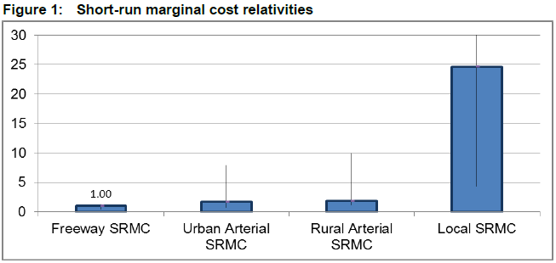
Source: Page V - National Transport Commission Modelling the Marginal Cost of Road Wear Research Paper May 2011

Due to these factors, proceeding with actual costs for road use in order to be equitable may have unintended consequences for rural and regional areas in Australia. The Commission should examine how to moderate between actual costs and equitable but fair charges for road users.

Non-commercial roads (local or collector roads) still need to have a standard level of service for users.

CSO considerations lie at the heart of how a road access pricing regime would be created and it should not be left to the last minute to decide how regional roads will be dealt with under this scheme. Presently, around 75% of local rural road expenditure and 50% of local arterial road expenditure is excluded from the heavy vehicle charges model cost base.

The situation is comparable to how phone lines and other utilities are provided across Australia. While it may cost more to provide wiring to a rural or regional area than an urban area consumers in both areas are charged the same installation cost and pay the same access cost for a given package. If the true marginal cost were to be paid by the rural consumers there would be a welfare effect of them not accessing the internet/phone. The same applies for road access.

Heavy vehicle access demand

Last and first mile access

For the heavy vehicle industry, specifically operators on the east coast, one of the largest concerns is first and last mile access and general access. The first and last mile access problem is when an operator may have to choose a less productive vehicle to carry out the freight task because the more productive larger vehicle cannot get access to the destination.

The ATA constructed a truck impact chart, which reports the ESA figures and other characteristics of different combinations (see appendix B).

For example when transporting a freight task of 1000 tonnes, B-double trucks transport the freight in only 26 trips with a total ESA figure of 195. Comparing this to a traditional semi-trailer, it takes 16 more trips to complete the freight task and adds 62 ESA for the same freight task.

Figure 2: ESA impact for a selection of heavy vehicle combinations
Heavy vehicle | No. of trips per 1000 tonnes | Equivalent Standard Axle per 1000 tonnes (ESA)
Traditional 3 axle rigid | 77 | 316
Traditional 6 axle semi-trailer | 42 | 257
Innovative 9 axle B-double | 26 | 195
Innovative 12 axle B-triple | 20 | 178

Source: The ATA and Barkwood Consulting Pty Ltd Truck Impact Chart

Reducing the number of trips necessary for freight movement lessens the ESA effect that trucks have on road wear.

The NTC has identified economic gains from harmonising heavy vehicle access arrangements of up to $12 billion in present value terms over 20 years with the majority of the gains to be found in harmonising HPV access to more roads, and flow on productivity effects.

Currently, decisions on road access for heavy vehicles are not externally reviewable. Road managers, including local councils, are not held to account for verdicts and do not have to justify decisions. If road mangers are to be more accountable for their actions, third party review of road manager access decisions needs to occur.

Over time, a series of tribunal decisions would establish precedents for road agencies to use to make consistent access decisions. Many law reform papers report better decision-making flows from external reviews being available. In the broader regulatory environment, it is now uncommon for government agency decisions not to be subject to external review.

Wrong decisions impose costs not just on the companies seeking administrative review, but also on the government. Therefore, using a process of external review may add more systematic approach to decisions and move agencies toward best practice decision making. Further, external reviews allow political oversight to focus on high level access and charging policy issues rather than being dealing with lobbying on specific access decisions.

It is also important that rejected decisions be recorded and presented transparently to industry and the governments in order for further appropriate action to be taken on road manager responses.

Industry needs consistent outcomes that show rigour, with the same outcomes in same circumstances and value for investment in roads from sensible access decisions.

There are also calls for improved road authority knowledge on high productivity vehicles (HPV). Restricting access for HPV or Higher Mass Limit (HML) vehicles has a negative effect on the productivity of industry, the local community and the economy. Allowing these vehicles to access suitable routes means freight movements could be undertaken more safely with less total road wear and at a cheaper cost for the operator and subsequently for businesses.

While higher mass limits on road friendly suspension (RFS) for articulated vehicles and some rigid trucks was endorsed by the Australian Transport Council in 2000, many road agencies have still not agreed to commit to this productivity understanding that reduces the number of trips needed to move freight and allows additional mass for the same amount of road impact. Much of the rejection of RFS is due to misconceptions about the impact of HPVs.

There should be a drive to educate those agencies and councils making access decisions on the real impacts and benefits of HML/HPV vehicles.

Such vehicles will enable Australia to meet the doubling of the freight task in 2030 and the tripling by 2050.
The ATA has made efforts to inform local government and other road stakeholders of the benefits of High Productivity Vehicles, such as providing a Factsheet on HPVs.

Heavy vehicle infrastructure maintenance

For the heavy vehicle industry, indicating where maintenance needs to be carried out is not a straightforward process and there is currently no formal communication relationship for the industry to do this. As indicated above, the industry has concerns about project governance and road authorities’ ability to assess and provide adequate repairs to the road network. The problem of funding for maintenance has become more acute over recent years as less and less money is being spent and provided to road managers to be used for maintenance.

As stated in the PPP section, currently road managers tend to build roads to a low capital cost which leads to a higher marginal maintenance cost over the lifetime of the asset. Having road managers build roads to a higher capital quality with lower marginal costs is the only way that maintenance costs over time will reduce. When viewing the RCMPI work it is clear that input costs of maintenance are outpacing the input costs of capital. Therefore, when viewing reasons why optimal infrastructure is not being provided it is worth making the distinction between capital and maintenance costs.

Inputs into road infrastructure projects

The Productivity Commission report notes that the cost structure of major projects in Australia is considerably higher than other countries. The Bureau of Transport and Regional Economics (BITRE) Road Construction and Maintenance Price Index (RCMPI) is designed to allow the Australian road industry to monitor price movements of inputs to road construction and maintenance.

It is used as an adjuster to convert nominal (current prices) road expenditure into real (constant price) values. It is intended to reflect trends in prices of major input components of road construction and maintenance. It is then applied to heavy vehicles charges through the annual adjustment.

The RCMPI consists of 8 major inputs including, site based labour, office based labour, bituminous material, cement and concrete, quarry products, other materials, plant hire/depreciation and fuel. Since the base year (1993) you can see that around 2003 the RCMPI has outpaced the CPI.

Figure 3: BITRE RCMPI, and two ABS price indexes
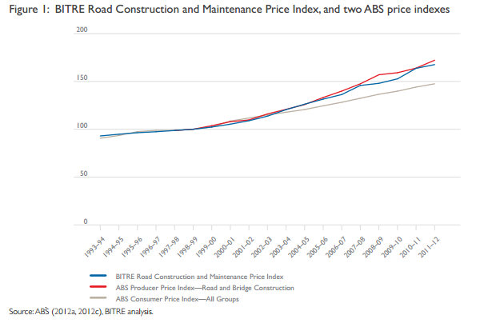
Source: Page 1 BITRE Road Construction and maintenance price index 2012 update

The 2013 RCMPI was re-calibrated with a revised base index (2011-12) and provided two new sub-indexes by major activity; construction and maintenance and three new sub-indexes by road type; arterial, sealed local and unsealed.

This refining of information sought from state and territory road authorities and local governments indicates that benchmarking can be done across roads and across jurisdictions. More useful information will be produced from these refinements. The BITRE requested information on the per cent share of inputs used in the construction and maintenance of applicable roads, the length of roads by road type and information of the percentage of construction and maintenance workers they contracted to private sector firms (and local government in the case of state authorities).

Private contractors were also approached to collate data via surveys about the input per cent shares used in the private sector, including total value of construction and maintenance cost of road projects delivered in 2011-12, the number of kilometres a company constructed or maintained in 2011-12 per state for each road type.

In 2011-2012 and 2012-2012 the index increased 1.42%. The most significant contributors to the index increase were rises in ‘site based labour’ and ‘bituminous material’ costs. The maintenance sub-index also rose at a greater rate than the construction sub-index.

The Commission may also want to pay attention to the ABS road and bridge index, noting the differences in the two indexes, RCMPI is the input price index that measures changes in the prices of inputs, while the ABS index measures changes in the prices (revenues) received by the businesses undertaking the road and bridge construction less any direct tax paid.

The BITRE provides a breakdown of input per cent share by road type and activity. Providing this type of information is very useful to the government and to industry as it transparently presents the index shares.

Figure 4: Input per cent share: RCMPI, arterial, sealed local and unsealed local roads sub-indexes
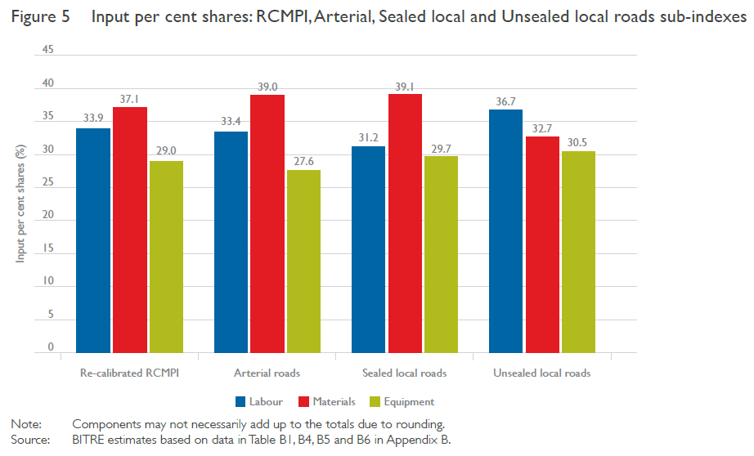
Source: Page 12 BITRE Road Construction and maintenance price index 2013 update

This is the kind of information that the PwC report indicated should be benchmarked and recorded.

APPENDIX A: Road expenditure and maintenance expenditure 2012-13

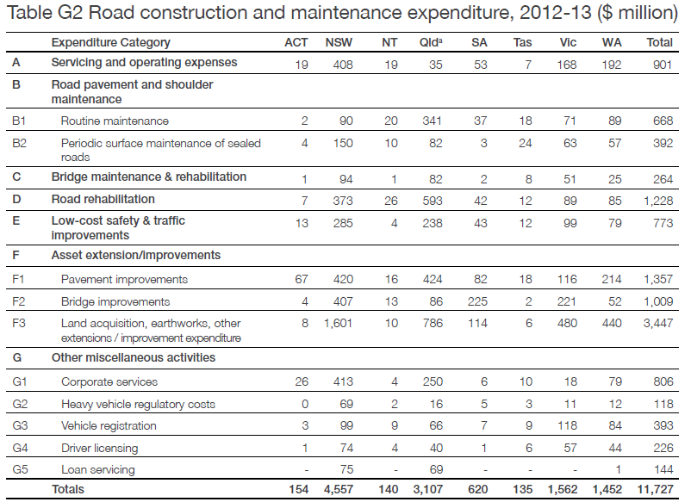
Source: Page 102 - NTC 2013 Annual Report

APPENDIX B: The ATA and Barkwood Consulting Pty Ltd Truck Impact Chart

The ATA and Barkwood Consulting Pty Ltd have developed a Truck Impact Chart that clearly demonstrates a number of different heavy vehicle combinations and covers GCM, payload, the equivalent standard axles (ESAs) for each vehicle combination, being the measure by which impact of a truck on the road is measured, the amount of trips required to move 1,000 tonnes of freight, the amount of fuel required to move 1,000 tonnes of freight, emissions and driver requirement. The information provided in the tables throughout this document is taken from the Truck Impact Chart.

The Truck Impact Chart has been reviewed RTA’s Senior Pavement Engineer, Ravindra Prathapa. The Truck Impact Chart has also been separately peer reviewed by Bob Pearson, Pearson Transport Resources, and was referred to by TheCIE in the Benefit/Cost Analysis for the National Heavy Vehicle Regulator draft Regulatory Impact Statement, released in February 2011.

 | Authors: | David Coonan - Australian Trucking Association | BARKWOOD CONSULTING Pty Ltd
 |  | Bob Woodward - Barkwood Consulting Pty Ltd.
This document has been prepared to assist operators and road asset managers in assessing the merits of utilising larger vehicle combinations in a transport task.
The assessment process assumes that the vehicle is dedicated to a specific task, operating travel being 50% unladen and 50% laden. The task relativities are 1000 tonnes with a lead of 1000 kilometres.
Equivalent Standard Axles: | ESA’s are calculated by the average of the sum of ESA’s for zero load (empty) plus ESA’s for 100% load and multiplied by the number of trips as required for the transport task.
Vehicle tare weights: | Are predictions based on the averages for a range of equipment within each combination category. These estimates have been reviewed by a number of operators and confirmed as being representative of “real” vehicles of the category.
Fuel consumption estimates: | Are predictions based on accumulated averages where operation is nominally 50% unladen and 50% laden. Actual consumption will vary with operating conditions.
Emissions: | Reference is based on total fuel consumption only.
20 metre 7 axle Truck & Dog: | The maximum allowable mass limits for this combination at either CML or HML (for standard combination) is 55.5 tonnes.
19 metre 7 Axle B-double: | The maximum allowable mass limits for this combination at either CML or HML (for standard combination) is 55.5 tonnes.
B-triple: | Consists of a complying B-double with an additional complying leading trailer.
Converter Dolly: | All combinations utilizing a converter dolly are configured with a tandem axle. The configured vertical imposed loading of a 6x4 prime mover is similar to the allowable imposed vertical loading of a tandem axle converter dolly.
AB-triple: | Consists of a complying B-double with an additional complying road train leading trailer and a complying converter dolly.
BAB-Quad: | Consists of a complying B-double with an additional complying converter dolly and additional complying set of B-double trailers.

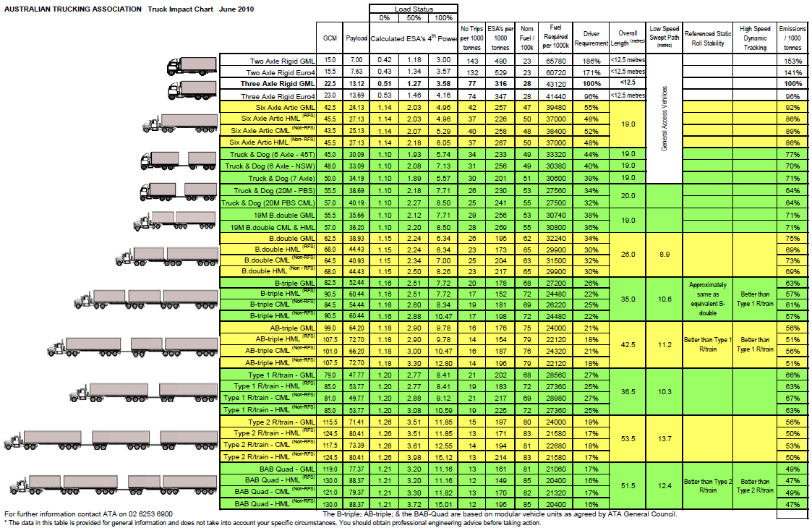

Page 23 – PricewaterhouseCoopers: A future strategy for road supply and charging in Australia 2013
Page 32 – PricewaterhouseCoopers: A future strategy for road supply and charging in Australia 2013
Page 32 – PricewaterhouseCoopers: A future strategy for road supply and charging in Australia 2013
Page 4 - Caravel to Infrastructure Australia: A Review of Project Governance Effectiveness in Australia, March 2013
Page 5 - Caravel to Infrastructure Australia: A Review of Project Governance Effectiveness in Australia, March 2013
http://www.treasury.nsw.gov.au/ppp/working_with_government_wwg_guidelines_for_privately_financed_projects
Page V - National Transport Commission Modelling the Marginal Cost of Road Wear Research Paper May 2011
NTC Heavy Vehicle charges determination regulatory impact statement volume I, December 2007
Page 27 – PricewaterhouseCoopers: A future strategy for road supply and charging in Australia 2013

