Submission to: | Australian Government
Title: | Agricultural Competitiveness Issues Paper
Date: | 23 April 2014

Contents

1. Introduction 3
2. Australian Trucking Association 3
3. Recommendations 3
4. Food security and fuel security 4
5. An overview of heavy vehicle impact 5
6. Heavy vehicle access issues 7
7. Failures in government planning 8
8. Funding for rural roads 11
9. Heavy vehicle charges 12
10. The industry has a strong chain of responsibility 18
APPENDIX A: The ATA and Barkwood Consulting Pty Ltd Truck Impact Chart 19

Introduction

The Government has released an issues paper on developing the agricultural competitiveness of Australia. The paper examines the issues of food security, improving market returns for the agricultural sector, access to investment, fair returns, efficiency and competitiveness of inputs, effectiveness of regulations, opportunities for enhancing exports and incentives for investment and job creation in the agricultural sector.

The agricultural sector and the trucking industry are complementary industries with similar demographics and similar concerns with the regulatory environment. Given there is considerable crossover between the two industries, making sure national surface transport infrastructure is supporting agricultural freight will maximise the competitiveness and productiveness of both industries.

The trucking industry in particular is fully prepared to achieve productivity gains through greater access for high productivity vehicles. However, it is restricted by onerous regulations and consistently non-productive decision-making and planning by state and local governments and road agencies.

In the regional, rural, and remote context, local governments own and manage approximately 80 % of Australia’s total road network. Local governments are able to declare certain roads or bridges inaccessible to particular vehicle types, or place restrictions or conditions on access and use (including parking). Local government road access and use decisions frequently affect heavy vehicles.

Australian Trucking Association

The ATA is the peak body that represents the trucking industry. Its members include state and sector-based trucking associations, some of the nation’s largest transport companies, and businesses with leading expertise in truck technology.

Recommendations

Recommendation 1

The Government should understand that fuel security and food security issues are intertwined, and ensure road transport planning and investment processes support these national goals.

Recommendation 2

The Government should support the use of high productivity vehicles over traditional combinations because of their safety and productivity benefits.

Recommendation 3

The Government should understand the heavy vehicle access issues we have highlighted and work with states to improve the use of high productivity vehicles, without the requirement of unnecessary and costly telematic monitoring for access.

Recommendation 4

The Government should:
- Take action on the concerns the ATA has raised over road agencies resources for road provision and assessment costs.
- Implement external review of access decisions.
- Implement stronger accountability, benchmarking and transparency controls over road projects and expenditure.
- Implement the PricewaterhouseCoopers three tiered approach to the road network to get all levels of government to focus on appropriate levels of capital and maintenance expenditure.

Recommendation 5

The Government should:
- Support the implementation of conditional grants to state and local governments.
- Take stock of the prevalence of Community Service Obligation (CSO) roads.
- Acknowledge that private partnership infrastructure investment is unlikely to provide funding for CSO roads which are widespread in regional, rural and remote Australia.

Recommendation 6

The Government should:
- Support the heavy vehicle charges determination option A, which will remove the current over-recovery from the industry in the charges model. This option should be implemented 1 July 2014, not in a three year staged approach given the $232 million plus over recovery it will cause.
- Disband the Heavy Vehicle Charging and Investment (HVCI) reform and support the Transport and Infrastructure Senior Officials Committee (TISOC) working group recommendations on ‘no regrets’ supply side measures.
- Only support the implementation of variable charging if the government can demonstrate the detailed data collected through variable charging can, and will, be used to improve road investment decision-making and outcomes, in such a way that the added cost, time and complexity of the new process is warranted.
Recommendation 7

- The government should support the extension of the heavy vehicle chain of responsibility so that it covers vehicle maintenance and those responsible for a vehicle’s safe operation.

Food security and fuel security

The issues paper notes the importance of food security and how high levels of competitiveness and productivity help secure the supply of food for the nation, and beyond to export customers. Australia generally has a high level of food security but there must be an equal consideration of fuel security and the pressures that growth in population and consumer demand bring. Without high levels of fuel security nationally, there is no guarantee such demand can be met at the most efficient price, if energy supply is volatile.

The presence of fuel security represents one less volatile (thus less costly) input for agri-businesses to worry about in a generally lumpy revenue sector and it could help smooth periods of economic uncertainty for those businesses.

We encourage the Government to pursue new ways to protect the food security and fuel security of Australia if we are to continue to have a non-volatile market for the most basic of human requirements.

Road and freight infrastructure generally will need to be run more efficiently in order to meet the demands of new agriculture production, especially in the expansion of agriculture into northern Australia, higher yields from water resources, new crops and more intensive production systems through additional water supplies.

Australia is a valuable food export hub so it is important that freight movements within Australia exploit this advantage and ensure freight costs are as competitive as possible. Global markets are a source of wealth to Australia and road agencies and governments together need to think of the bigger picture with the general treatment of freight movements.

Recommendation 1

The Government should understand that fuel security and food security issues are intertwined, and ensure road transport planning and investment processes support these national goals.

An overview of heavy vehicle impact

Just as the nature of agricultural produce freighted is diverse, the type of heavy vehicle suitable for the transport task also varies. In large farm operations, larger trucks such as semi-trailers, B-doubles or road trains are favoured to complete the freight task. In smaller farm operations, a smaller rigid truck might better suit the freight task.

Heavy vehicles more than pay their share of the appropriate heavy vehicle road expenditure, which is calculated via a set of parameters. The most sensitive parameter is the impact the specific type or class of heavy vehicle has on the road. In theory, the PayGo model recovers the full cost of both capital and operational historic road expenditure over seven years. The cost base allocated to the heavy vehicle fleet (over 4.5 tonnes) is used to derive the target amount to be recovered from each heavy vehicle class.

The measure of road wear impact is called the ‘Equivalent Standard Axle’ (ESA). A section of road is built to withstand a certain number of traffic passes or total ESA passes. As traffic moves along a section of road, the road’s structure deteriorates according to the ESA factor of the vehicle passing over it. Using ESA figures to measure vehicle impacts on road infrastructure is a well-established engineering method.

When examining heavy vehicle ESA, ARRB Group Ltd (ARRB) captures the ESA data from Weigh-in-motion (WIM) devices, which are located along major freight routes across Australia.

In regional, rural and remote Australia the heavy vehicle industry’s workhorses are road train combinations and B-doubles. These vehicle types allows for greater productivity due to their payload sizes compared with a semi-trailer, and they have been the main contributors to the regional, rural and remote trucking industry’s productivity gains over the past 20 years.

While road trains have contributed to the agricultural competitiveness of Australia, B-double vehicles, as well as B-triple vehicles have become popular because of improved safety due to increased stability from the way the trailers are combined (using a “B” or turntable coupling) compared with the drawbar used for coupling traditional road trains or truck and dog combinations (“A” coupling) (see Figure 1 below). Despite their length and larger appearance, B-double and B-triple vehicles are less likely to cause significant infrastructure damage because of the way they are built, compared with rigid trucks and semi-trailers.

Figure 1: Types of Trailer Connection Coupling

“B” coupling
“B” coupling
“A” coupling

What can be seen from Table 1 below is that more productive heavy vehicles (B-doubles, B-triples and road trains) take fewer trips to complete a freight task of moving 1000 tonnes and all provide improved productivity over general access vehicles. B-doubles and B-triples are safer combinations and have lower impact on the infrastructure (ESA) compared to traditional heavy vehicles. These vehicles have even less impact on roads when equipped with Road Friendly Suspension (air-bag suspension) (RFS) as opposed to traditional steel spring suspension found in many smaller, traditional trucks, such as rigid trucks and semi-trailers. These facts are accepted by government and based on OECD research back to 2000. Yet, despite all this evidence, B-doubles, B-triples and road trains are often denied access to local roads by local governments under the guise of protecting their sensitive infrastructure assets at the cost of agricultural competitiveness.

Table 1: ESA Measurements

Heavy vehicle type | No. of trips per 1000 tonnes | Total ESA
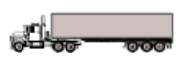  Traditional 3 axle rigid | 77 | 316
Traditional 6 axle semi-trailer | 42 | 257
Innovative 9 axle B-double | 26 | 195
Traditional 11 axle road train | 21 | 202
Innovative 12 axle B-triple | 20 | 178
Traditional 16 axle road train | 15 | 197
Source: ATA and Barkwood Consulting Pty Ltd 2010

While access restrictions cause both industries to lose productive potential, when access is granted there are still cases where excessive and unnecessary costs are forced onto truck operators in order to access these local government jurisdiction routes.

Local governments are coming under increasing pressure to allow high productivity vehicles on their roads because of their safety, productivity and economic advantages. However, in reality many local governments simply do not want large heavy vehicles operating in their jurisdiction because of perceived community concern. There is a tendency for local government to use the excuse they are protecting assets, instead of actively protecting them by investing in maintenance and improvements that would encourage more productive vehicles to operate there. There is a popular misconception outside the industry about the impact of heavy vehicles and many people are unaware that large, modern heavy vehicles are safer, much more productive and directly help to reduce the numbers of trucks on the road.

This widespread misunderstanding has a cost that falls on trucking operators, businesses who use road freight services and end consumers of the goods transported. A larger concern for local governments should be that if they continue to stall or block measures to allow access for more productive heavy vehicles, they are creating long-term economic damage to the future of their own communities. Supply chains are the physical manifestation of the laws of supply and demand, and they dynamically adapt in shape (route) and speed (efficiency) to outside pressures (eg barriers to access, regulatory costs, and competition from other modes). Over time, if councils fail to adapt to the needs of modern freight and logistics activity, such council areas will be bypassed or their use minimised by major freight movements, and consumer costs in those locations will also rise.

Recommendation 2

The Government should support the use of high productivity vehicles over traditional combinations because of their safety and productivity benefits.

Heavy vehicle access issues

The trucking industry in regional, rural and remote Australia is adversely affected by poor public sector decision-making, slow or inadequate review processes and a big fixation on ribbon cutting at all levels of government. Without significant cultural reform, the productivity gains the industry needs to achieve in order to support the productive output of growth industries like the agricultural sector will not happen.

The main reason for current restrictions on heavy vehicle productivity and higher costs for industry is the lack of widespread road access for productive vehicles, and for vehicles that can carry higher mass limits (HML). Allowing these vehicles access to more routes currently in demand means freight movements could be undertaken more safely, with less road wear and at a lower cost to the operator and other businesses.

Although HML articulated vehicles with RFS were endorsed by the Australian Transport Council in 2000, many local governments have still not agreed to this decision. Much of the rejection of RFS is due to misconceptions about high productivity vehicles that actually reduce the number of truck trips needed to move loads and allow additional mass for the same road impact.

Along with restrictions on HML, operators find that problems with ‘first and last mile’ access impose additional costs on their businesses. Larger combinations often have to de-couple trailers in order to pass through local government areas to reach their destinations or leaving the origin of the freight task. First and last mile constraints interfere with the freight task, as it can mean operators have no other option but to use less productive heavy vehicle combinations for the whole journey. In other cases time and money are wasted while drivers de-couple at designated depots in order to meet the length requirements set by some local councils.

Last mile permits have been abused by local governments to prevent access to larger heavy vehicles. Allowing access for HPVs to operate on suitable roads would broaden and complete the supply chain for operators, improve safety for the community and reduce road wear.

The industry also encounters differing treatment from states based on combinations and mass. The Intelligent Access Program (IAP) is a program used in some jurisdictions that monitor heavy vehicle conditional access. Transport Certification Australia (TCA) is the public company wholly owned by participating road agencies that oversees certification of IAP devices. TCA claims that IAP is a voluntary program but if operators want to operate at a higher level of efficiency using certain safe, HPVs, they must purchase and use IAP for compliance.

Most states do not require IAP for their vehicles, regardless of the mass limit involved. However, New South Wales and Queensland currently require IAP to be fitted to prescriptive modular combinations, such as B-doubles operating at HML, without any justifiable safety or road impact-related reasons.

IAP also highlights the unproductive presence of jurisdictional differences in deciding which vehicles require expensive access monitoring. Other states do not impose IAP because national policies on HML for vehicles fitted with RFS do not require its use. IAP should be applied to high risk situations, like the use of ultra-heavy cranes. Applying IAP to large, safe combinations that pose no increased risk suppresses the original benefits IAP ostensibly aimed for.

In NSW, operators seeking to access HML had to pre-enrol in the scheme, during which over 3,000 vehicles became pre-enrolled. Recent comments made by New South Wales and Queensland public sector representatives indicate that only 705 vehicles presently use IAP, a significant shortfall in the numbers originally expected to take up the technology.

Data captured by the IAP devices is also susceptible to inconsistency and uncertainties arise surrounding the legitimacy and value of the information being captured. Operators who have fitted IAP with the expectations of commercial gain have reported receiving upwards of 1,500 non-conformance reports per vehicle per month, but that at those notified times no non-conformance existed, meaning the IAP reports themselves were incorrect. There is no accountability for this poor result in the TCA IAP model and the industry expects IAP performance outcomes to be carefully evaluated in any program review.

While technology has been embraced by some operators to suit their fleet management approaches, government policy has failed to support the steadily growing voluntary uptake of telematic systems by operators. Thus the very real savings to the taxpayer emerging from a market-based response to compliance through technology are not acknowledged.

Recommendation 3

The Government should understand the heavy vehicle access issues we have highlighted and work with states to improve the use of high productivity vehicles, without the requirement of unnecessary and costly telematic monitoring for access.

Failures in government planning

Local governments, in many cases, lack the resources or training to make informed decisions about road provision and maintenance projects. Improving best practices and setting guidelines for approval and processes of road provision should be encouraged by the Commonwealth and the states.

Many businesses in rural areas struggle with gaining approval for planning heavy vehicle access to their premises. With rural companies, for growth in output to be accommodated they need to have this met with the use of larger heavy vehicles. Companies can apply for planning approval and road upgrading. In some cases a local government may quote a contribution for upgrading. However, there can be significant differences in the costs of road provision and in many cases companies seek private provision quotes and find them to be more cost effective.

Planning failures may happen because many local governments do not have expertise in road management. This has been noted by Infrastructure Australia who offered training programs for road providers in order to promote best practice of planning protocol and outcomes.

Assessment Costs

Where local road access or use is granted to heavy vehicles, this can follow the operator having to pay hefty engineering assessment costs imposed by local governments. These assessment costs multiply as operators usually need to make numerous applications. Any fees set by local governments for engineering assessments need to be reasonable, not prohibitive.

Lack of external review of access decisions

Currently, decisions regarding road access for heavy vehicles are not reviewable externally. Local government agencies follow guidelines set by the national heavy vehicle regulator (NHVR). However, this process is in its infancy and adherence to guidelines could be open to interpretation. The only review method available to trucking companies that are adversely affected by local government decisions are the internal review mechanisms within local governments.

As a consequence, trucking companies often do not take up the option of internal review due to the lack of confidence in local governments being able to objectively, transparently and fairly review their own decisions. The trucking industry should be legally entitled to a statement of reasons and access to external merits review mechanisms through the administrative appeals state body. Over time, a series of tribunal decisions would establish precedents local governments would be obliged to follow.

Lack of accountability and transparency of heavy vehicle expenditure

There are currently limited benchmarks in place for states and local government to publically show what has been spent, where it has been spent and whether it was the right spending decision. The ATA has called for greater benchmarking of road expenditure to be implemented in order for costs to be compared and improved upon.

A PricewaterhouseCoopers (PwC) report was provided to the ATA last year that examined the correct way forward for heavy vehicle charging and road provision reform. A future Strategy for Road Supply and Charging in Australia provides short-, medium- and long-term reform actions to improve the current situation.

The PwC report has the short-term recommendation that there should be reporting, benchmarking and reviewing road costs from states, territories and local government road owners on each level of the road network. Comparing these costs to established benchmarks and the associated level of access with the investment would improve the accountability of road agency spending.

Additionally, the Productivity Commission also recommends that the Australian government should include a detailed benchmarking framework for major construction projects throughout Australia, with the collection of data being a requirement when the Australian government provides funding.

We would also extend the data collection to significant road infrastructure projects, as this is crucial work that is more likely to be of use if benchmarked; as the Productivity Commission note in the Public Infrastructure Draft Report, large projects can suffer from not being ‘like for like’ and benchmarking usefulness could be limited.

The ATA supports the Productivity Commission’s view that the provision of data to support the benchmarking framework should be a requirement attached to all Australian Government funding for major infrastructure projects and that ongoing benchmarking must be seen to be independent of both government and industry influence. The benchmarking must also be seen as technically robust and credible.

Commonwealth and state focus on big capital items at the cost of maintenance

Governments past and present have a passion for funding and providing large capital infrastructure projects, which provide media announceables and ribbon cutting opportunities. However, there is an ever-increasing maintenance backlog. The poor focus at all government levels needs to change in order for Australia to be provided with suitable quality roads. Road agencies have indicated that less and less money is being provided and spent on maintenance of road infrastructure. Given the marginal costs associated with non-freeway roads making sure that there is a consistent maintenance program by local road managers is crucial to providing adequate roads for all road users.

Making sure there is a coordinated approach to road planning and provision is crucial. Infrastructure Australia’s (IA) role in providing independent oversight and advice in all levels of road infrastructure provision also needs to be maximised. While we support the Government’s plans to restructure the scope, transparency and accountability of IA, IA still lack focus on the entire network. The National Land Transport Network only makes up 2.8% of the entire road network, with the arterial network comprises around 20% and the remainder being local roads. Ignoring the largest part of the road network is illogical.

The PwC report made a short term recommendation regarding the creation of a national road freight network hierarchy agreed by the industry and road suppliers which would give proper focus on each level of road network. Each level of the hierarchy would be associated with harmonised and aspirational levels of heavy vehicle access. This would be a three tier freight network with each tier targeting a particular heavy vehicle access level to focus investment, reporting and funding.

Tier 1 – primary land freight transport corridors – the highest level of access, building on IA’s national land freight network.

Tier 2 – significant last and first mile higher mass limits connections – level of access below of tier 1, but may align with Tier 1 mass limits to ensure end to end trip productivity is achieved.

Tier 3 – remaining freight network – a minimum level of access in line with current general access requirements, supplemented by ad hoc improvements over seen by the NHVR.

The tiered approach is akin to defining service standards in the utilities sector. This would have to be supplemented with harmonised approaches by road managers such as the pavement depth reasonably required to allow B-doubles with general mass limits (GML).

Recommendation 4

The Government should:
- Take action on the concerns the ATA has raised over road agencies resources for road provision and assessment costs.
- Implement external review of access decisions.
- Implement stronger accountability, benchmarking and transparency controls over road projects and expenditure.
- Implement the PricewaterhouseCoopers three tiered approach to the road network to get all levels of government to focus on appropriate levels of capital and maintenance expenditure.

Funding for rural roads

In the process of funding heavy vehicle infrastructure there is a funding hierarchy that creates intergovernmental pressures. As generally understood, the Commonwealth receives revenue from the nationally-applied road user charge (RUC), states receive revenue from vehicle registration charges and local governments receive grants and other funding from the Commonwealth and revenue from the states.

Conditional Grants

It should be noted that while local governments receive grants notionally for road expenditure these grants are not tied. The money industry pays does not necessarily end up being spent on heavy vehicle infrastructure. This lack of accountability and control over money provided by the industry needs to be corrected.

Currently states are given their appropriate amount of funding, given heavy vehicle expenditure. However, in the future there should be moves towards tied funding for gauging the performance of the road authorities. The PwC report recommended that in the medium to long run, given the uptake of benchmarking and reporting, efficient road investment and maintenance costs could be independently assessed and tied to funding allocation. Incentives to outperform benchmarks should be provided, for instance by allowing a road supplier to retain unspent funds and invest in other priorities.

In addition to the three tier road network approach, PWC has recommended that in three years, a transparent formula for allocation of funding to road suppliers should be established. Funding allocations should reflect road construction and maintenance and repair costs, heavy vehicle usage and access upgrades required for Tier 1 and Tier 2 roads. This would be a superior funding mechanism than the current system where road funding allocations are dictated by how much a state budgets to spend and is recouped from the industry through the RUC and registration charges.

The Productivity Commission recommended that federal funding including non-grant-based forms of assistance (such as loans and government guarantees) for public infrastructure that is provided to local and state jurisdictions be made conditional.

Productivity Commission draft recommendation 7.3
The Productivity Commission further suggests a sensible set of conditions for this funding:

- Use of effective cost benefit analysis and transparency assessments including the methodology and assumptions.
- Evidence of demonstrable net public benefits from the project which is not obtainable without Australian Government support.
- Evidence that competitive processes will be used for the selection of financing, design, construction, maintenance and operations of public infrastructure services where these tasks have been outsourced to the private sector.
- Ex-post evaluation and publication of public infrastructure project outcomes.
- Consultation on the criteria to be applied and any potential implementation issues associated with such an approach should be undertaken with local, State and territory Governments.
- All governments should be encouraged to apply the above principles and actions to their own-funded projects.

The ATA also shares the Productivity Commission’s view that the stagnation in providing suitable infrastructure is the reason why there should be nationwide reform that could be boosted through leverage from the Australian Government’s large annual outlays of infrastructure funding for the states and territories.
Community Service Obligations

Many of the roads in Australia will also require community service obligations (CSO) or other government funding. Road owner resources and user charges will not cover the full cost of providing and maintaining these roads. Presently, around 75% of local rural road expenditure and 50% of local arterial road expenditure is excluded from the national heavy vehicle charges model cost base. The Productivity Commission has also recognised that ‘the extent to which user charges are able to recover the full costs of supply differ across sector and region’.

Therefore, when considering regional, rural and remote funding for roads it is more than likely these roads will be partly funded by CSOs.

The PwC funding formula mentioned above would also include a mechanism to fund low-volume roads, which would be classed as Tier 3, through CSOs. It is important that rural, remote and regional Australia is adequately funded so improvements can be made for these communities and the operators working in those areas.

Opportunities for private infrastructure financing

The Government is keen to investigate the potential for greater private investment into public infrastructure. Fair access prices and private investment for infrastructure need to be considered. Private investment infrastructure costs include a risk premium and will have shareholder interests at their core.

However, private investment is not the ‘cure-all’ to public infrastructure financing in regional, rural and remote Australia. It should also be noted that the cost of negotiating private contracts tends to be higher and the heavy vehicle industry wears the costs of these negotiations, unfairly some would suggest.

Private investment also does not solve the pervasive CSO issue with providing non-commercial roads, as the revenue returns on rural and regional roads are unattractive. Therefore, this type of investment is likely to assist with provision of arterial and freeways, but will not solve the provision and maintenance of CSO-applicable roads.

Recommendation 5

The Government should:
- Support the implementation of conditional grants to state and local governments.
- Take stock of the prevalence of Community Service Obligation (CSO) roads.
- Acknowledge that private partnership infrastructure investment is unlikely to provide funding for CSO roads which are widespread in regional, rural and remote Australia.

Heavy vehicle charges

With many farmers owning or using trucks to move produce or farm inputs, agriculture businesses are affected by the charges faced by the heavy vehicle industry. Therefore, how much these costs are, and how they are collected, are issues of interest and consequence to the agricultural sector.

Current charges are recovered through registration charges and a road user charge (RUC). The RUC is the result of a fuel tax credit being applied to the full excise rate.

Current charges

The National Transport Commission (NTC) reviewed the current charges model for trucks (PayGo) given industry concern about the accuracy of the charges. The PayGo model is a seven year averaging expenditure recovery model that recovers capital and maintenance attributable to heavy vehicles.

The model uses a lagged midpoint population, however, it also uses the most recent expenditure year data, and this has resulted in the overcharging of industry since PayGo was first introduced in 2007. This has meant the model underestimates the true heavy vehicle population and that heavy vehicle charges are higher than they should be.

The ATA has calculated over-recovery for 2013-2014 by comparing the PayGo cost base to be recovered in 2013-2014 ($2.9 billion) with the estimated revenue taken in the 2013-2014 period using actual heavy vehicle registration figures provided by states and territories from December 2011. Estimated revenue is calculated using 2013-2014 heavy vehicle charges and RUC for 2013-2014. In this calculation, industry is projected to pay $3.7 billion, meaning an over-recovery of over $800 million.

An opportunity for reform

The NTC provided three options to reform the PayGo model. All the options include technical updates to include in the model including up to date expenditure and heavy vehicle population figures. However, each option has a different RUC and registration share (A 64:36, B 70:30, C 77:23).

However, the NTC has provided a proposal for a three year transition to A due to concerns some states and territories have over their previous revenue predictions. The NTC has estimated there will be $232 million over-recovered from the trucking industry in 2014-2015 if option A is not adopted in 2014, due to not updating the technical inputs to the model. The ATA finds this three year staged implementation unacceptable because there are no technical or other explicable reasons to not move to A. Inputs simply need to be updated, and while $232 million between all states and the Commonwealth is a relatively small dip in revenue it would be a comparatively large, inefficient tax for industry that it should not be paying.

While the effect of removing the $232 million over-recovery from industry will have an effect on budgeted government revenue, it needs to be balanced against the fact that it will lower freight operating costs with flow on effects to freight customers and the rest of the economy.

The ATA provided three recommendations to the NTC on this specific matter:

- The ATA recommends all the NTC-proposed technical updates to the PayGo model, except the NHVR funding allocation methodology, be implemented by 1 July 2014, given industry feedback on the assumptions behind the proposed weightings of the allocation.

- The ATA rejects the NTC proposal for a three year staged implementation to option A, given the $232 million over-recovery it will cause.

- The ATA recommends option A be implemented by 1 July 2014, moving to Option B on 1 July 2015 given government timeframes for implementing the road user charge revenue redistribution necessary with option B.

The ATA supports a higher proportion of truck charges being recovered through the RUC, because increasing the variable charge reduces the cash constraint that a large fixed registration charge presents. It also promotes paying for use, as ‘fuel burn’ is a proxy for mass, distance and road and vehicle condition. Fuel consumption increases with increased mass and distance travelled. Increasing the proportion of charges via fuel use also advances the public energy efficiency agenda, as operators become even more conscious of their fuel usage. Operators have also stressed that a larger portion of charges are recovered through the road use-related RUC, rather than through a fixed registration charge, which makes it far easier to recover their costs.

Reference to the graph below supports industry’s view that on a freight task basis, fuel consumption reflects road wear very well. This graph is drawn from Appendix A, which was peer reviewed, published and referenced as an authoritative source by government-appointed consultants.

Figure 2: Fuel usage versus ESAs (vehicles weighing GML)

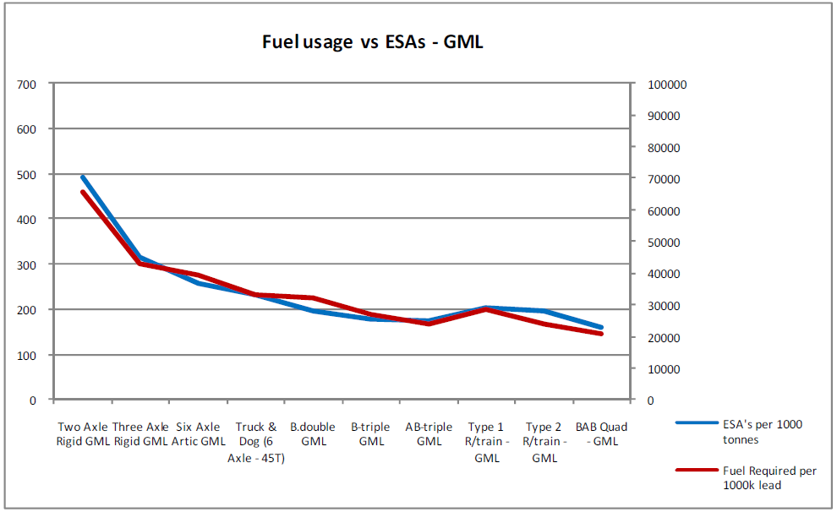
Source: The ATA and Barkwood Consulting Pty Ltd Truck Impact Chart

The heavy vehicle charging and investment (HVCI) reform

While the NTC PayGo model deals with current industry charges, HVCI is tasked with making recommendations for future heavy vehicle charging and road provision reform. HVCI favours Mass Distance Location charging (MDL). The industry would no longer be paying a tax as such, since the charges would be a ‘fee for service’ similar to a charge in a utility sector.

This approach originally assumed that each truck would have a telematics device that would measure MDL. However, as the HVCI process has progressed it has become clear to stakeholders that it is not cost effective for every truck to possess a telematic device.

As the agricultural sector knows well, the majority of operators in the trucking industry manage fewer than five trucks and telematics is typically unsuitable and expensive for them. These operators would nevertheless be expected to provide more frequent self declarations of mass, distance and location. This gives rise to different and greater compliance and enforcement burdens within the industry, plus significant additional paperwork for the bulk of operators. Industry is vehemently opposed to such a segregated charging system for many reasons:

- Separate charging systems do not present a level playing field for operators compared with the ‘one size fits all’ approach for collecting revenue currently.
- Smaller operators will be administratively and financially over-burdened in comparison with larger operators who may be better resourced to deal with telematics-based charging compliance and enforcement.
- The cost of implementing and monitoring such a large system.
- Risks associated with moving away from the Australian Tax Office (ATO), which assesses risk based on detailed information.
The mass component of the charge would be ‘maximum declarable mass’, which would mean that heavy vehicles were assumed to be carrying full mass all the time, which is clearly inaccurate. The current charging model uses vehicles AGM which is taken from WIM stations that record the actual mass for the vehicle type. Moving to fixed full declarable mass is not more accurate. In fact, it is a step backward in terms of reflecting what mass trucks actually are and the costs associated with that mass.

Distinct sections of the industry ‘mass out’ differently, truck and dogs carrying bulk freight are likely to be close to gross vehicle mass (GVM). However, semi trailers or HPVs are likely to ‘volume out’ due to freighting lighter consumer goods.

The distance and location based component of the charge depends upon the availability of mobile stations for transmitting data and this coverage is patchy across parts of regional, rural and remote Australia.

Under MDL, operators would still have to purchase fuel and claim a full fuel tax credit. This will have significant effects on cash flow for operators.

HVCI’s proposal would greatly increase the cost of transporting freight to and from rural, remote and regional areas, because roads in these places are built to a lighter construction standard than highways. To meet the cost of road wear, charges for local roads in rural areas would need to be an average of 25 times higher than the charges for highways (see box 1).

Box 1: Marginal costs of different road types

Road access pricing based on actual costs use of road infrastructure seems theoretically fair and understandable by road users. However, due to the nature of differing road qualities, contrasting levels of service, varying demands and different regional areas, if full cost recovery occurred those who used regional roads or low quality roads would be paying prohibitive costs to access the infrastructure.

These extracts below on modelling explain why marginal costs differ for road types:

Figure 3 Short-run marginal cost relatives of different road types
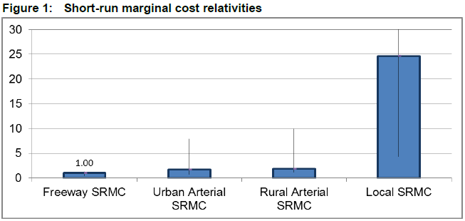
Source: Page V - National Transport Commission Modelling the Marginal Cost of Road Wear Research Paper May 2011

‘In general, freeways are better able to withstand heavy loads because they are built to a higher strength standard, incorporating greater pavement depth and stronger materials to support the higher expected volume and mix of vehicle traffic. While freeways are generally likely to have higher construction costs, they are likely to have lower marginal costs of road wear. Alternatively, local and collector roads are likely to have higher marginal costs. These road types are designed to accommodate lower heavy vehicle traffic and so are built to a lower strength standard.

The results (of testing marginal costs) are consistent with prior expectation and historical observation, with short and long-run marginal cost estimates being considerably lower for stronger roads (such as freeways and arterial roads) than for local access roads (which are built to lower strength standards). Figure 1 shows the relationships between all four road categories according to the short-run model. The bars reflect a weighted average of the different road types that make up a road classification. The lines that bisect the bars reflect the range of results for individual road types within the road classification. The short-run marginal cost of local roads is significantly higher than the marginal cost of freeways and arterial roads, although it should be noted that local road travel is typically only used on part of a vehicle trip and the proportion of local road travel could be quite low for some heavy vehicle types. Long-run marginal costs are generally at or above the level of short-run marginal costs.’

Due to these factors, proceeding with actual costs for road use in order to be equitable may produce unintended consequences for rural and regional areas in Australia.

Given growing concerns over the HVCI reform process, the ATA recommended earlier this year to the Commonwealth Treasury and other government agencies that HVCI be disbanded as the outcomes of its recommendations will increase the cost of transporting freight, increase costs for rural Australia, add extra administrative costs to trucking businesses and yet not provide any improvements in road provision.

The Productivity Commission stated in the Public Infrastructure draft report that a direct user charges system would have to be ‘revenue neutral’ for it to be acceptable. A better test would be ‘cost neutrality’ for industry. However, it is unlikely that mass distance and location charging which has such specific monitoring technology, extra compliance and enforcement costs, and government and operator administration costs, would be cost neutral. Someone in that chain will wear the excessive costs of a bloated data collection and charging system and it is likely to be the industry and the community. This will affect the competitive provision of infrastructure due to funding being spent on a complex charging system instead of on roads. The ATA does not believe the move to more direct charges will not cost road users additional monies on top of the current charges recovery method.

The taskforce should also be aware that the future of HVCI process has not been decided by transport ministers. At the most recent HVCI board meeting, the HVCI budget was not approved and deferred, as was its implementation plan also. A separate Transport and Infrastructure Senior Officials Committee (TISOC) working group has been established to make recommendations to the Transport and Infrastructure Council (TIC) on the issue of heavy vehicle charging and investment reform. Early indications of the working group’s outcomes imply that strong ‘no regrets’ supply side reform measures will be recommended.

The way forward for user charges in Australia

The ATA rejects direct in vehicle user charges at this stage, given that this is cost prohibitive and that there is much to be done on the supply side before any drastic changes are made to road user charges.

As noted above, the majority of regional, rural and remote roads in Australia will always need to be partly funded by consumer service obligations regardless of any direct charging system, as the Commission has indicated. Hence, there should be a rethink of the in vehicle focus of direct charges and look towards where user charges can have some positive impact on driver behaviour and recover the costs of provision fully.

The current model for securing private sector investment towards road construction involves direct tolling. Superannuation funds and other private sector investors are interested in these assets, but only if they provide a secure income stream. A direct urban tolling system is far superior in targeting issues such as congestion instead of enforcing an expensive system on all of Australia that will only have a small impact on the behaviour of most drivers and penalise regional, rural and remote communities.

One justification for more direct user charges such as MDL charges is that road agencies have insufficient data to inform decision making. However, we question this assertion as after continued questioning states are yet to inform the industry of what data they use now and what they need in addition to this.
There is presently considerable data available for this purpose. Simply increasing the amount of data that road agencies receive does not equate to better delivery outcomes.

Collecting data is also not a costless process. Hence, tradeoffs have to be made between cost, volume and accuracy of data when formulating policy.

It is obvious to both road users and road asset holders where there are transport issues. Sir Rod Eddington’s report on UK infrastructure noted that:

In most cases, the best signals to identify where transport is acting to hold back growth will be the presence of clear signs of economic success (economic growth and very high wages and land prices), and that transport demand is starting to outstrip supply (signs of congestion and unreliability). In areas without such clear signs, it is unlikely that transport is holding back productivity and growth.

There is a great deal of data available for heavy vehicle usage. The main sources are:

- State and territory CULWAY/WIM (weigh-in-motion) data;
- FDF FreightInfo inter-regional freight movements database;
- ABS Survey of Motor Vehicle Use (SMVU); and
- State and territory commercial vehicle traffic counts.

Where a particular data source has shortcomings, these can often be overcome by using observed patterns from other data sources or via ‘informed estimates’. For instance, BITRE notes that:

…some data (SA and NT) include estimates of the net freight task, others (NSW) the net freight task needs to be estimated by multiplying the difference between the average gross vehicle weight and the estimated average tare weight, for each Austroads vehicle class, by the total number of vehicles in each class, and summing over all vehicles classes.

Overall, the Weigh-in-Motion (WIM) data provided by various state authorities provides an accurate real-world picture of road freight flows between capital cities, with the exception of the Sydney-Canberra route.

TISOC approved an expansion of the ABS SMVU to double the number of heavy vehicles surveyed and to have an additional focus on freight movements. In addition, industry now has the capacity to gather statistics on demand from the NHVR records of failed access requests and attendant statements of reasons.

There is little evidence to suggest that more data being provided to road agencies and local government will lead to better delivery outcomes. Hence, data sought from direct user charges is already being provided through less costly methods than direct monitoring of road users.

This data could also feed into the distribution of funds to states and local governments based on tier one to three spending and access expectations.

A direct tolling system captures all the appropriate costs from the users of the toll road. This is far more efficient than a whole system charging approach, like MDL. If direct tolling is implemented with the PwC three tiered approach Australia would have a targeted, accountable and efficient system of providing and monitoring road infrastructure across Australia.

We would urge the Commission to ignore the HVCI recommendations as they will negatively affect the productivity of the trucking industry and instead focus on implementing the PwC three tier approach and investigate ways to implement direct tolls where appropriate.

Currently there is much that can be done by government on the supply side before major changes are made to the charging recovery methodology.

Recommendation 6

The Government should:
- Support the heavy vehicle charges determination option A, which will remove the current over-recovery from the industry in the charges model. This option should be implemented 1 July 2014, not in a three year staged approach given the $232 million plus over recovery it will cause.
- Disband the Heavy Vehicle Charging and Investment (HVCI) reform and support the Transport and Infrastructure Senior Officials Committee (TISOC) working group recommendations on ‘no regrets’ supply side measures.
- Only support the implementation of variable charging if the government can demonstrate the detailed data collected through variable charging can, and will, be used to improve road investment decision-making and outcomes, in such a way that the added cost, time and complexity of the new process is warranted.

The industry has a strong chain of responsibility

When agri-business utilises a heavy freight vehicle to transport its produce and other freight, it is captured by certain legal duties present in the recently enacted Heavy Vehicle National Law relating to the areas of driver fatigue, vehicle speed, mass and loading. The so-called ‘Chain of Responsibility’ (COR) operating environment means there is formal accountability placed on those within the freight supply chain who are reasonably capable of imposing influence on the conduct of the task itself (ie, on the vehicle’s performance and driver’s behaviour).

Although this area of law is currently under review, duties under the COR legal framework currently extend to the suppliers of freight itself, to company management, to workshop managers and to other relevant parties in the chain.

Model characteristics for COR were most recently presented by the ATA to the National Transport Commission in March, 2014. The ATA’s preferred COR model is about achieving legal fairness and true accountability for chain parties other than merely the truck driver and operator. It is also about delivering the intended structural reform needed to address the root causes of undesirable on-road behaviour. Enforcement activity today is still focused on drivers and operators and not on other relevant parties who can be, and too often are, the root cause of an incident. Specifically, the ATA recommended that chain parties undertaking vehicle maintenance and those responsible for a vehicle’s safe operation should attract COR duties similar to those currently imposed for speed, fatigue, mass, dimensions and loading.

Recommendation 7

- The government should support the extension of the heavy vehicle chain of responsibility so that it covers vehicle maintenance and those responsible for a vehicle’s safe operation.

APPENDIX A: The ATA and Barkwood Consulting Pty Ltd Truck Impact Chart

The ATA and Barkwood Consulting Pty Ltd have developed a Truck Impact Chart that clearly demonstrates a number of different heavy vehicle combinations and covers GCM, payload, the equivalent standard axles (ESAs) for each vehicle combination, being the measure by which impact of a truck on the road is measured, the amount of trips required to move 1,000 tonnes of freight, the amount of fuel required to move 1,000 tonnes of freight, emissions and driver requirement. The information provided in the tables throughout this document is taken from the Truck Impact Chart.

The Truck Impact Chart has been reviewed RTA’s Senior Pavement Engineer, Ravindra Prathapa. The Truck Impact Chart has also been separately peer reviewed by Bob Pearson, Pearson Transport Resources, and was referred to by TheCIE in the Benefit/Cost Analysis for the National Heavy Vehicle Regulator draft Regulatory Impact Statement, released in February 2011.

Authors:  David Coonan: –  Australian Trucking Association | 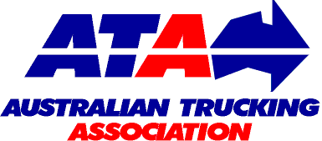 | BARKWOOD CONSULTING Pty Ltd
Bob Woodward: –
Barkwood Consulting Pty Ltd.

This document has been prepared to assist operators and road asset managers in assessing the merits of utilising larger vehicle combinations in a transport task.

The assessment process assumes that the vehicle is dedicated to a specific task, operating travel being 50% unladen and 50% laden. The task relativities are 1000 tonnes with a lead of 1000 kilometres.
Equivalent Standard Axles: | ESA’s are calculated by the average of the sum of ESA’s for zero load (empty) plus ESA’s for 100% load and multiplied by the number of trips as required for the transport task.
Vehicle tare weights: | Are predictions based on the averages for a range of equipment within each combination category. These estimates have been reviewed by a number of operators and confirmed as being representative of “real” vehicles of the category.
Fuel consumption estimates: | Are predictions based on accumulated averages where operation is nominally 50% unladen and 50% laden. Actual consumption will vary with operating conditions.
Emissions: | Reference is based on total fuel consumption only.
20 metre 7 axle Truck & Dog: | The maximum allowable mass limits for this combination at either CML or HML (for standard combination) is 55.5 tonnes.
19 metre 7 Axle B-double: | The maximum allowable mass limits for this combination at either CML or HML (for standard combination) is 55.5 tonnes.
B-triple: | Consists of a complying B-double with an additional complying leading trailer.
Converter Dolly: | All combinations utilizing a converter dolly are configured with a tandem axle. The configured vertical imposed loading of a 6x4 prime mover is similar to the allowable imposed vertical loading of a tandem axle converter dolly.
AB-triple: | Consists of a complying B-double with an additional complying road train leading trailer and a complying converter dolly.
BAB-Quad: | Consists of a complying B-double with an additional complying converter dolly and additional complying set of B-double trailers.

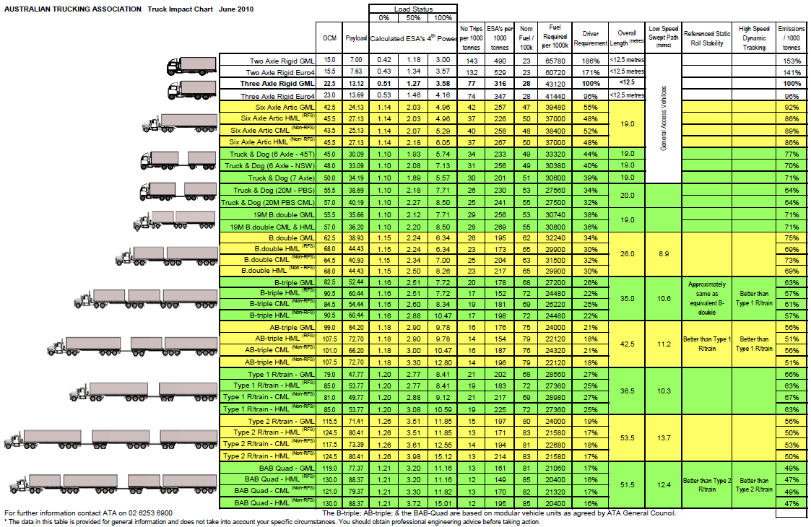

Page 20 Infrastructure Australia – A report to the Council of Australian Government 2011
Page 20 The Productivity Commission: Public Infrastructure Draft Report - March 2014
Page 303 The Productivity Commission: Public Infrastructure Draft Report - March 2014
Page 23 PwC report to the Australian Trucking Association: A Future Strategy for Road Supply and Charging in Australia, March 2013.
Page 32 PricewaterhouseCoopers: A future strategy for road supply and charging in Australia 2013
Page 36 The Productivity Commission: Public Infrastructure Draft Report - March 2014
Page 30 The Productivity Commission: Public Infrastructure Draft Report - March 2014
NTC Heavy Vehicle charges determination regulatory impact statement volume I, December 2007
Page 11 The Productivity Commission: Public Infrastructure Draft Report - March 2014
See the ATA submission to the NTC 2014 Heavy Vehicle Charges Determination, January 2014 for more detail.
Page V National Transport Commission Modelling the Marginal Cost of Road Wear Research Paper May 2011
The Department of Transport The Eddington Transport Study December 2006
Page 195 Bureau of Infrastructure, Transport and Regional Economics 2009, National road network intercity traffic projections to 2030, Working Paper 75, BITRE, Canberra

