|  |  |
| --- | --- |
| **Submission to:** | NSW Legislative Assembly: Committee on Transport and Infrastructure |
| **Title:** | Inquiry into Road Access Pricing |
| **Date:** | 22 February 2013 |

**Contents**

1. Introduction 3

2. NSW Australian Trucking Association 3

3. Recommendations 3

4. Road access pricing issues 6

4.1 Equitable charging for road access based on actual costs and the impact of road use 6

4.2 Encouraging the use of different modes of transport 8

4.3 Generating sustainable levels of income for maintenance of, and investment in, the transport network 8

4.4 Providing pricing signals to road users by time of day, distance and type of road 9

4.5 Supply side reform 10

4.6 Capabilities of road access pricing technologies 13

4.7 Federal state jurisdictional issues 14

4.8 The socio-economic impact of road access pricing throughout NSW 14

4.9 Options available for a staged implementation of road access pricing applicable to NSW. 14

APPENDIX A: The ATA and Barkwood Consulting Pty Ltd Truck Impact Chart 19

# Introduction

The ATA NSW have been contributing to the discussion on road access pricing for many years and plays an active role in the Heavy Vehicle Charging and Investment reform (HVCI) and the National Transport Commission’s (NTC) heavy vehicle charges review.

The heavy vehicle industry, unlike other road users, pays charges that reflect usage and recover the cost of heavy vehicle effects on infrastructure, including related capital costs. Heavy vehicle charges are calculated based on heavy vehicle impact on road infrastructure. Registration charges and the fuel excise that industry pays reflect heavy vehicle specific expenditure by road agencies.

This submission discusses heavy vehicle charges in terms of the registration and excise charges the heavy vehicle industry pays under the ‘pay as you go’ (PayGo) charging model. Toll road charges are not deliberated and should not be interpreted as the charges mentioned in this submission.

ATA NSW is encouraged that discussion about light vehicle and heavy vehicle road access pricing is taking place. The heavy vehicle industry has been the only focus for COAG’s HVCI project for some time. However, light vehicles contribute to many significant costs in the road sector.

The trucking industry currently contributes $3bn out of a total road cost of $15bn. We have stated that the partial market approach taken by HVCI will only have a marginal application, and that if all road users were included in the project any net benefits would be higher and societal effects better addressed.

Road access pricing is a national concern and there should be a high level of consultation on the issue. Australia is unique in its composition of population spread, road types and areas of production. The Committee cannot ignore the constraints this vastness and inconsistency in road quality presents. This inquiry is a golden opportunity to promote the reality of the situation and to inform current projects considering direct pricing, a forward looking cost base, and the associated need for a community service obligation (CSO) to address the social and societal equity standards in our community in the near future.

ATA NSW supports national consistency on issues, as ATA and industry have shown with their work towards the National Heavy Vehicle Regulator (NHVR). The findings of this Committee should be incorporated into the HVCI.

# NSW Australian Trucking Association

The NSW Australian Trucking Association (ATA NSW) is the peak body that represents the trucking industry in NSW. Its members include state and sector based trucking businesses, some of the nation’s largest transport companies, and businesses with leading expertise in truck technology.

# Recommendations

**Recommendation 1**

**Equitable road access charging based on actual costs of impact and use, will need to take account of the effects this has on regional and rural NSW.**

**Recommendation 2**

**Community service obligations will be necessary to support rural and regional roads and communities in NSW.**

**Recommendation 3**

**The Committee should be aware of the Equivalent Standard Axle (ESA) impact of heavy vehicles.**

**Recommendation 4**

**Freight access prices of one mode of transport should not be artificially inflated to support another mode, as this will lead to a deadweight loss to society.**

**Recommendation 5**

**Treasury guidelines on privately financed project principles should be adhered to by NSW.**

**Recommendation 6**

**Legitimate reasons why time of day, distance and type of road charging are necessary above the current road arrangements need to be presented.**

**Recommendation 7**

**If times of day access prices are to be proposed, accurate costs must be presented to road users.**

**Recommendation 8**

**The Committee should be aware that heavy vehicles have limited choice when it comes to choosing alternative routes, altering time and choosing destination and origin.**

**Recommendation 9**

**Supply side reform should also be analysed when examining changes to road access pricing.**

**Recommendation 10**

**Improve first and last mile access for heavy vehicles and support the use of high productivity vehicles in NSW to improve productivity.**

**Recommendation 11**

**The Committee should examine current streams of data and evaluate if the extra cost of gathering more detailed data is a sensible investment.**

**Recommendation 12**

**Road expenditure inputs recorded by NSW should be audited by an independent third party.**

**Recommendation 13**

**Technology should be based on its capability to provide services, not based on who accredited the device.**

**Recommendation 14**

**Costs of telematic devices should be transparent to users.**

**Recommendation 15**

**NSW should review IAP, given the engineering findings of limited extra impact on infrastructure.**

**Recommendation 16**

**Federal and State jurisdictional issues with revenue should be negotiated.**

**Recommendation 17**

**National harmonisation of heavy vehicle charging methods should be sought by the Committee.**

**Recommendation 18**

**Impacts of suggested direct charges should be properly investigated and evaluated by the Committee**

**Recommendation 19**

**Increasing the variable share of charges road users pay would be a logical interim step towards direct user charges.**

**Recommendation 20**

**Incremental charging should not be embraced for road access charges, as it misinterprets how heavy vehicles currently pay for impact.**

**Recommendation 21**

**Mass, distance and location charging is not feasible or practical to implement in the next decade given technological and institutional constraints.**

**Recommendation 22**

**PayGo should continue to be refined with more accurate data and serves as a very good estimate for heavy vehicle impact on infrastructure.**

**Recommendation 23**

**Light vehicles should be included in the PayGo model in order to capture their impact on infrastructure and calculate more accurate costs.**

# Road access pricing issues

* 1. Equitable charging for road access based on actual costs and the impact of road use

Equitable charging based on actual costs

Road access pricing based on actual costs use of road infrastructure seems theoretically fair and understandable by road users. However, due to the nature of differing road qualities, contrasting levels of service, varying demands and different regional areas, if full cost recovery occurred those who used regional roads or low quality roads would be paying prohibitive costs to access the infrastructure.

These extracts below on modelling explain why marginal costs differ for road types[1]:

In general, freeways are better able to withstand heavy loads because they are built to a higher strength standard, incorporating greater pavement depth and stronger materials to support the higher expected volume and mix of vehicle traffic. While freeways are generally likely to have higher construction costs, they are likely to have lower marginal costs of road wear. Alternatively, local and collector roads are likely to have higher marginal costs. These road types are designed to accommodate lower heavy vehicle traffic and so are built to a lower strength standard.

The results (of testing marginal costs) are consistent with prior expectation and historical observation, with short and long-run marginal cost estimates being considerably lower for stronger roads (such as freeways and arterial roads) than for local access roads (which are built to lower strength standards). Figure 1 shows the relationships between all four road categories according to the short-run model. The bars reflect a weighted average of the different road types that make up a road classification. The lines that bisect the bars reflect the range of results for individual road types within the road classification. The short-run marginal cost of local roads is significantly higher than the marginal cost of freeways and arterial roads, although it should be noted that local road travel is typically only used on part of a vehicle trip and the proportion of local road travel could be quite low for some heavy vehicle types. Long-run marginal costs are generally at or above the level of short-run marginal costs.’

**Figure 1 Short-run marginal cost relatives of different road types**

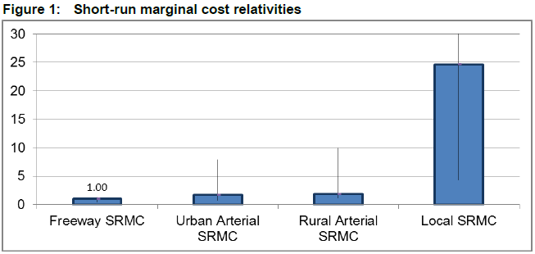

Source:Page V - National Transport Commission Modelling the Marginal Cost of Road Wear Research Paper May 2011

Due to these factors, proceeding with actual costs for road use in order to be equitable may have unintended consequences for rural and regional areas in Australia. The Committee should examine how to moderate between actual costs and equitable but fair charges for road users.

Non-commercial roads (local or collector roads) still need to have a standard level of service for users. HVCI has previously looked at community service obligation (CSO) considerations that need to be addressed when dealing with roads with high maintenance costs. However, HVCI did not believe it was an issue to be debated now.

ATA NSW disagrees, and believes CSO considerations lie at the heart of how a road access pricing regime would be created and it should not be left to the last minute to decide how regional roads will be dealt with under this scheme. Presently, around 75% of local rural road expenditure and 50% of local arterial road expenditure is excluded from the heavy vehicle charges model cost base.[2]

Impact of road use

Paying charges based on impact is implicit in the way heavy vehicles currently pay for their share of road expenditure costs. This is based on the principle of full cost recovery of both capital and operational historic road expenditure in any given year. The cost base allocated to the heavy vehicle fleet over 4.5 tonnes is used to derive the target amount to be recovered from each heavy vehicle class.

The measure of wear impact is called an Equivalent Standard Axle (ESA). A section of road is built to withstand a certain number of traffic passes or total ESA passes. As traffic drives along a section of road, its structure deteriorates according to the ESA factor of the vehicle passing over it.

Using ESA figures to measure vehicle impact on infrastructure is a well established engineering method and should be recommended by the Committee as the way to accurately gauge the impact of vehicles.

While the idea of using ESAs as a measurement is established, what the ESA measurements for heavy vehicles should be are under refinement by ARRB and the National Transport Commission. This is due to improved data on heavy vehicles impacts and light vehicle ESA.

When examining heavy vehicle ESA, ARRB captures the ESA reading from Weigh-in-motion (WIM) devices.

The ATA constructed a truck impact chart, which reports the ESA figures and other characteristics of different combinations (see appendix A)

The results show that when transporting a freight task of 1000 tonnes, B-double trucks transport the freight in only 26 trips with a total ESA figure of 195. Comparing this to a traditional semi-trailer, it takes 16 more trips to complete the freight task and adds 62 ESA for the same freight task.

**Figure 2: ESA impact for a selection of heavy vehicle combinations**

|  |  |  |
| --- | --- | --- |
| Heavy vehicle | No. of trips per 1000 tonnes | Equivalent Standard Axle per 1000 tonnes (ESA) |
| Traditional 3 axle rigid | 77 | 316 |
| Traditional 6 axle semi-trailer | 42 | 257 |
| Innovative 9 axle B-double | 26 | 195 |
| Innovative 12 axle B-triple | 20 | 178 |

Source: The ATA and Barkwood Consulting Pty Ltd Truck Impact Chart

Reducing the number of trips necessary for freight movement lessens the ESA effect that trucks have on road wear.

While heavy vehicles and weathering have been considered to account for 100% of road deterioration in the past, the impact of light vehicles is currently being examined. If light vehicles are included in the PayGo model charges would be more reflective of use then they currently are.



Equitable road access charging based on actual costs of impact and use, will need to take account of the effects this has on regional and rural NSW.



Community service obligations will be necessary to support rural and regional roads and communities in NSW.



The Committee should be aware of the Equivalent Standard Axle (ESA) impact of heavy vehicles.

* 1. Encouraging the use of different modes of transport

While the Committee is likely to focus on light vehicle issues and encouraging the use of different modes of public transport, it is important that issues surrounding freight transport modes are discussed in order to clear misconceptions about road freight and rail freight use.

The way freight is shipped depends on a number of factors; what is to be shipped, is it time sensitive, the cost, availability of mode of freight and how far it has to travel.

ATA NSW supports efficient movement of freight. The Committee should understand that only a small amount of freight is contestable with rail. Rail excels at transporting heavy bulk, such as consolidated grain and mining resources. The road freight fleet moves time sensitive material and direct delivery packages. Decisions on which mode of freight transport will work best are normally based on the constraints mentioned above. Road and rail should be viewed as complementary modes of freight transport.

Instigating access prices that disadvantage one mode of freight over another for political reasons will lead to a deadweight loss to the community as prices for freight transport will be artificially inflated.

Both road and rail should be priced to promote efficient use. Any charges should be ‘safe’ to avoid negative GDP impacts associated with charges exceeding marginal cost of direct impact.



Freight access prices of one mode of transport should not be artificially inflated to support another mode, as this will lead to a deadweight loss to society.

* 1. Generating sustainable levels of income for maintenance of, and investment in, the transport network

The total pool of money collected through vehicle charges amounts to $15bn. This revenue is not bound to road infrastructure provision and maintenance. Hypothecation of this revenue is not popular with treasuries, as it limits its flexibility to spend on public goods, and some have argued that how money is raised should not affect how it is spent. However, hypothecation allows voters to make a stronger connection between the taxes they pay and the services those taxes provide.

Implementing more direct user charges on previously un-metered roads would have to increase the monitoring of citizens. If full costs of road access are captured and taxed from road users the argument for hypothecation becomes stronger as actual costs are more accurate, not just a token registration charge for light vehicles. Increasing the transparency of spending has been used in the past in the hope that taxpayers will be better-informed about funding for projects.[3]

Hypothecation has been used in conjunction with environmental taxes to encourage public acceptance of these kinds of taxes. The Medicare levy in Australia is the classic example of how a tax is hypothecated and is transparent to tax payers.

Road access prices should also be fair for road users. For instance a ‘public transport levy’ would be inequitable, as the Australian public transport systems in most cities are not a viable option compared to driving. The heavy vehicle industry should not have to pay a public transport levy. Similarly, rural voters should not pay for public transport services in Sydney and similar urban and suburban environs.

Fair access prices and private investment for infrastructure needs to be considered. While private provision is becoming a popular option overseas and starting to appear in Australia, private investment infrastructure costs include a risk premium and will have shareholder interests at their core.

NSW has had previous experience with public private partnerships (PPP). NSW Treasury has strict guidelines on PPP procurement and investment decisions[4], which are continuing to be altered as PPP projects are carried out. An evaluation of PPP arrangements noted that public trust of PPP projects improves with a high level of transparency of contracts.

However, many believe toll roads and other such projects have failed to show the benefits of using PPP investment in public road infrastructure. The effects of the GFC and other economic shocks present challenges to the availability of private investment funding.

The Treasury notes that the NSW government should adhere to some important principles when examining alternative funding modes:

* the primary consideration is that any future asset acquisition and financing arrangements are to be managed in terms of efficient service delivery, rather than to generate rates of return for private sector investors and,
* the challenge is to design mechanisms to encourage long term investment in public assets that can provide the required services that are value for money.

ATA NSW strongly supports the points noted above when discussing any funding model for public infrastructure.

The problem road users encounter is that roads are built (in many cases) to the lowest capital cost, however, this means maintenance costs are higher over the asset life. PPP projects have an incentive to provide infrastructure at a higher capital cost but with a lower maintenance cost over the lifetime of the asset. Changing the impetus of road agencies to provide high quality infrastructure with low marginal costs to maintain would provide a superior infrastructure network.

PPP investment does not solve the pervading CSO issue with providing non-commercial roads, as the returns on a rural and regional roads are unattractive. Therefore, PPP investment is likely to provide help in arterial and freeways, but will not solve provision and maintenance of CSO applicable roads. CSO roads form the majority of NSW roads.



Treasury guidelines on privately financed project principles should be adhered to by NSW.

* 1. Providing pricing signals to road users by time of day, distance and type of road

There is a push to transfer freight movements to non-peak periods. The trucking industry already does this where possible to avoid congestion. Further, delivering freight in the middle of the night might be ideal, but delivery points are not open or do not work 24 hours a day.

This option involves road agencies being able to have an accurate price per unit cost for users. Pricing signals for road use are not straight forward. Implying that people will be able to make rational decisions based on having perfect information of the cost and opportunity cost of choosing a road over another for a whole network would be a great leap for both consumers and suppliers of road infrastructure.

Concerns are raised over the ability of road agencies to price infrastructure access correctly and fairly. Calculating the cost of a project is a complex task; determining the projected future demand and a per user unit cost adds a sophistication well above the current complexity. This kind of management would involve high level education about prices and making sure that those prices do not have perverse outcomes. Challenges regarding who bares the future risk are also present.

In the heavy vehicle context there are limited opportunities for more efficient use of the road network due to the constrained choice of routes. HVCI research shows the likelihood of behavioural changes in the industry based on time-of-day pricing are very small.

Freight travel on freeways and arterial roads is nearly 3 times less responsive to changes in heavy vehicle charges than travel on local roads[5].

Changing driver and operator behaviour is limited to how flexible Australian roads are to the demands made on the heavy vehicle industry. When origins and destinations are fixed, there is little scope for route changing. At best only 11%-25% of roads in Australia are available for route changing[6].

Freeway travel is especially less responsive to changes in heavy vehicle charges compared to local roads. There are no alternative routes in the majority of cases, so behaviour is not able to change even if it desired, and so the benefits (from reduced wear costs) of direct pricing on those roads are small[7] .

Additionally, curfews on heavy vehicle movements at night limit flexibility of delivery times. Therefore, proposing Ramsey road access pricing on heavy vehicles based on time of day movements is not acceptable given the constrained choice of delivery times.

The findings above indicate operators select the most fuel efficient route based on route availability.



Legitimate reasons why time of day, distance and type of road charging are necessary above the current road arrangements need to be presented.



If times of day access prices are to be proposed, accurate costs must be presented to road users.



The Committee should be aware that heavy vehicles have limited choice when it comes to choosing alternative routes, altering time and choosing destination and origin.

* 1. Supply side reform

While this Committee has been tasked with examining road access pricing, failing to analyse supply side reform of road provision and maintenance would limit the benefits a direct user system could present. The two are intrinsically linked; moving to direct charging or forward looking costs presents a huge challenge for road agencies in terms of making correct decisions, making accurate economic costs for users, and improving accountability.

Small institutional changes can be made now to increase the accountability and transparency of investment decisions. Recommendations made in Infrastructure Australia’s report to COAG would produce a better decision making framework. Currently, road managers will not allow an external review of access decisions. Introducing a process proven to improve decision making and accountability would lead to more efficient service provision.

If the Committee is interested in improving productivity, safety and environmental impacts of heavy vehicles in Australia, many gains can be made in supply side reform and addressing road network constraints.

Current constraints on heavy vehicle productivity

Improving access for high productivity vehicles, solving first and last mile access for freight movement and developing decision makers’ education about the impact of heavy vehicles would all produce an increase in productivity and subsequently safety and control environmental emissions from heavy vehicles.

Failing to make supply side reforms will have a negative effect on the Australian economy, environment and community. There is a lack of national consistency in road provider decisions on access. Currently, decisions regarding access for heavy vehicles are not reviewable externally. Road agencies are not held to account for verdicts and do not have to justify their decisions. Using external review of decisions would move agencies toward best practice decision making. Independent tribunals would give a level of accountability which is currently absent.

One of the NHVR’s obligations is to record where access decisions have been rejected; this will indicate where access for higher productivity vehicles is being denied by road providers. Our industry is hoping this mechanism will open up rejected access decisions for review.

The current incentive road owners have is to protect assets, not maximise use of them for the community. Changing the motivation of road agencies to future proof roads and support growth in the community must happen. If only general access roads are built by providers, businesses that want to grow will be constrained and have higher freight costs. If road agencies refuse to allow high productivity vehicles on suitable roads or recognise that missing road links need to be provided to cope with increasing freight demand, the community bears the costs of these inefficiencies, and in some cases, other countries take market share from Australia. Both are net losses for NSW and Australia.

Data to inform road investment

A continuing argument for more direct user charges is that the amount of information produced would be useful for road planning. It is a lazy argument for increasing the monitoring of road user movement, as there is presently considerable data available for this purpose. Simply increasing the amount of data road agencies receive does not equate to better outcomes.

Collecting data is also not a costless process. Hence, tradeoffs should be made between cost and accuracy of data when formulating policy. NSW should be able to obtain heavy vehicle data from its Safe-T-Cam network, and freight surveys are also worthwhile.

The two main parameters of road investment are durability and capacity. Generally, durability specifications will be based on anticipated heavy vehicle usage while capacity will be based on demand by light vehicles.

It is obvious to both road users and road asset holders where there are transport issues. Sir Rod Eddington’s report on UK infrastructure noted that[8]:

In most cases, the best signals to identify where transport is acting to hold back growth will be the presence of clear signs of economic success (economic growth and very high wages and land prices), and that transport demand is starting to outstrip supply (signs of congestion and unreliability). In areas without such clear signs, it is unlikely that transport is holding back productivity and growth.

There is a great deal of data available for heavy vehicle usage. The main sources are:

1. State and territory CULWAY/WIM (weigh-in-motion) data;
2. FDF FreightInfo interregional freight movements database;
3. ABS Survey of motor vehicle use (SMVU); and
4. State and territory commercial vehicle traffic counts.[9]

Where a particular data source has shortcomings, these can often be overcome by using observed patterns from other data sources or by ‘informed estimates’. For instance, the BITRE notes that:

…some data (SA and NT) include estimates of the net freight task, others (NSW) the net freight task needs to be estimated by multiplying the difference between the average gross vehicle weight and the estimated average tare weight, for each Austroads vehicleclass, by the total number of vehicles in each class, and summing over all vehicles classes

Overall, the WIM data provided by the various state authorities provides an accurate picture of road freight flows between capital cities, with the exception of the Sydney-Canberra route.

The Transport and Infrastructure Senior Officials' Committee(TISOC) recently approved an expansion of the ABS SMVU to double the number of heavy vehicles surveyed and to have additional focus on freight movements.

Hence, data sought from direct user charges is already being provided through cheaper methods than direct monitoring of road users. The Committee should consider the costs of collecting new data versus the costs of the current surveys which already give accurate data.

NSW ability to accurately report heavy vehicle expenditure costs

The ATA has previously highlighted expenditure issues to Minister Gay, quoting the Deloittes NTC report which discussed the NSW RTA’s struggle to accurately report heavy vehicle expenditure as required for the NTC expenditure template in 2010-11.

The findings in the paper indicated additional work must be done to improve accurate state reporting of heavy vehicle costs. Unaudited inputs and irregular expenses inclusion is not acceptable. Heavy vehicle specific costs are reported into an NTC expenditure template (see figure 3) where categories represent distinctive spending.

In NSW, the paper noted many traffic management costs were included in category E (Low cost safety/traffic improvements); including bus priority and access, railway level crossings, pedestrian bridges, rest area initiatives and black spot treatments. The wide range of activity costs reported in this category indicates over-reporting.[10]

Deloittes reported the RTA suggested costs not associated with heavy vehicles should be accounted for in the template. RTA justification for this was that comprehensive costs should be captured, regardless of who should pay. This is not a fair way to recover costs from industry. [11]

The report found NSW encountered problems with its financial system providing indications of what expenditure was spent on different types of roads within the NTC template. Identifying the correct road type is important in the heavy vehicle charging model, as the ratio of spending on different road types has an effect on costs that are recovered from the heavy vehicle industry.[12]

The Deloittes report demonstrated disparity and lack of accountability in a well established expenditure reporting system. The sophistication and high level judgement HVCI is promoting in supply side reform is unachievable in light of the evidence in this report and in the absence of audits.

To improve the reporting of NSW and all states, the ATA NSW recommends a transparent external audit of inputs by a third party.

Forward looking pricing needs significant enhancing of accountability, a stronger engineering base and to be fully transparent. NSW road agencies need major reform to achieve these fundamental constraints.



Supply side reform should also be analysed when examining changes to road access pricing.



Improve first and last mile access for heavy vehicles and support the use of high productivity vehicles in NSW to improve productivity.



The Committee should examine current streams of data and evaluate if the extra cost of gathering more detailed data is a sensible investment.



Road expenditure inputs recorded by NSW should be audited by an independent third party.

* 1. Capabilities of road access pricing technologies

While technology is advancing in the area of in-vehicle technology applications, government policy on technology has been regressive and has led to poor productivity outcomes.

An example of this is the Intelligent Access Program (IAP). IAP is a program that monitors some areas of heavy vehicle conditional access. Transport Certification Australia (TCA) is the public company wholly owned by participating road agencies, which oversees certification of IAP devices. TCA claims that IAP is a voluntary program; however, if operators want to operate to a high level efficiency using certain high productivity vehicles, they must use IAP for compliance.

Due to the safe nature of B-doubles, Australia has embraced the use of these high productivity vehicles over the past 20 years with no requirement for IAP, regardless of the level of mass limit being accessed in most states. However, New South Wales and Queensland currently require IAP to be fitted to prescriptive modular combinations, such as B-doubles operating at HML, without any justifiable reasoning behind this decision.

IAP highlights the issue of jurisdictional differences in deciding which vehicles require monitoring. Other states do not impose IAP because national policies on higher mass limits for vehicles fitted with road friendly suspension (RFS) do not require its use.

IAP should be applied to high risk situations that need to be monitored, like ultra heavy cranes. Applying it to combinations that pose no increased risk stifles the original benefits IAP aimed for.

In NSW, operators seeking to access HML had to pre-enrol in the scheme, during which over 3,000 vehicles became pre-enrolled. Recent comments made by New South Wales and Queensland government agency staff indicate that only 705 vehicles presently use IAP, a significant shortfall in the numbers expected to take up the technology.

Information captured by the IAP devices is susceptible to inconsistency; uncertainties arise surrounding the legitimacy and value of the information being captured. Operators who have fitted IAP with the expectations of commercial gain have reported receiving upwards of 1,500 non-conformance reports per vehicle per month, but that no non-conformance existed, meaning the reports were incorrect. There is no accountability for this poor result in the TCA IAP model.

While technology has been embraced by some operators to suit their fleet management, government policy has failed to support the uptake of operator telematic systems.

Industry has not been presented with any concrete figures on the cost of fitting new or retrofitting trucks with road access pricing devices. Until real costs have been calculated, benefits outweigh the costs and government policy provides a competitive market for devices, industry has no incentive to install technological devices for road pricing purposes.

If the Committee is to recommended technology be used for pricing, it should be open standard technology that has incentives for uptake and promotes competition in the provision of technology to Australia. Examining New Zealand's road access charging arrangements presents government policy which has open standards allowing lower cost first party compliance assurance and more direct accountability from providers. This promotes a competitive market for technology in vehicles while respecting driver’s desire for privacy. Some international attempts have dead weight loss costs exceeding 25%. NSW and Australia cannot afford such inefficiencies



Technology should be based on its capability to provide services, not based on who accredited the device.



Costs of telematic devices should be transparent to users.



NSW should review IAP, given the engineering findings of limited extra impact on infrastructure.

* 1. Federal state jurisdictional issues

Currently fuel excise revenue is recovered by the Commonwealth and registration revenue is collected by individual states. Any change in the composition on registration-to-fuel excise ratio will affect the recovery each level of government is set to recover; it should be noted this debate is currently being held in the NTC heavy vehicle charging determination.

Moving towards a direct user pays system produces circumstances for states that need to be considered. The current split could be continued or if revenue received from vehicles is to be hypothecated then the result will be some states losing revenue to reflect usage of the infrastructure, while other states will inherit more money. This is a specific issue that any road access pricing model will have to address.

Effective road pricing reform must be nationally consistent to work in a national industry like trucking.



Federal and State jurisdictional issues with revenue should be negotiated.



National harmonisation of heavy vehicle charging methods should be sought by the Committee.

* 1. The socio-economic impact of road access pricing throughout NSW

The Committee should aim to produce a regulatory impact statement about any road access pricing options it wishes to pursue.



Impacts of suggested direct charges should be properly investigated and evaluated by the Committee

* 1. Options available for a staged implementation of road access pricing applicable to NSW.

The challenge for the Committee is how to go from a charging system, which is relatively blunt and does not reflect ‘true’ cost of use, to a system where road users are able to judge marginal cost of use and make economic decisions based on charges. Getting the transition right from one to the other is key to making sure that charges are efficient and that the road charging system is not a failure.

For the heavy vehicle industry moving from PayGo, where the only direct user charge one pays is from fuel excise to a more direct user charge entails many changes to how the fleet operates. Additionally, the Committee should consider how changing to a direct charge will impact heavy vehicle operators operating costs, such as calculating freight costs under a direct user charging system. Cash flow for small operations and impacts on ancillary operators such as farmers should be properly examined.

Increasing the variable part of heavy vehicle charges that road users pay would be the first step towards making all road users think about road usage, as fuel burns relatively true with road use. The PayGo model has a variable and fixed charge (fuel excise and rego) as do light vehicle users. Therefore, making the variable charges a greater proportion of costs than a fixed registration charge would be a positive step in the right direction for making users accustomed to direct user charges. This could be done for all road users by simply removing the fuel excise cap, 38.6 cents per litre, and allow it to rise above this fixed excise.

This would be a short to medium term action. Differential fuel charges could be constructed for different vehicle types according to policy directives such as encouraging safer heavy vehicles, environmental driving or differing vehicle classes. However, such a change needs transparent justification to build a credible political capital for change.

HVCI is currently proposing a range of charging options including incremental charges for access and mass distance location and consideration of a fuel charging option.

Incremental charges

The concept of incremental charges for heavier vehicles or longer vehicles, misunderstands how the current charging model recovers the cost for these vehicles impact on infrastructure. It also ignores the fact that the road network cannot realistically accept large axle masses.

Firstly higher mass limit vehicles (HML) use innovative road friendly suspension (RFS) instead of traditional steel springs. RFS reduces the impact of laden axles on road pavements and bridge structures. This is due to improved even load distribution on the wheels by reducing the dynamic impact of the axles. Vehicles fitted with RFS can carry higher mass on axles without any increased impact on infrastructure or an increased safety risk for the combination.

Additional benefits can be gained from RFS as many trucks do not ‘mass out’ meaning they normally reach a volumetric limit before reaching a mass limit. Therefore, RFS enabled trucks cause even less road wear than calculated.

Primary efficiency gains are likely to be from using more axles at existing mass limits, that is, longer safer combinations. Registration charges for each heavy vehicle combination depend on a number of parameters that are used to allocate costs in each vehicle class. These influence how much a certain combination should pay so its attributable and common costs are recovered in the PayGo model.

These parameters are:

* average gross mass kilometres (AGM - km)
* equivalent standard axles kilometres (ESA - km)
* passenger car unit equivalent kilometres (PCU - km)
* vehicle kilometres travelled (VKT)

Using data from the SMVU and ARRB, each vehicle category is allocated costs from a cost allocation matrix that splits up which parameters have affected road expenditure. The cost allocation matrix below shows how heavy vehicle road expenditure is distributed over the fleet. Different categories have different weightings attached to them, accordingly if they have considerations for PCU, VKT, and AGM etc. For example category E, the expenditure recovered is allocated by heavy vehicle VKT (80%) and PCU-Km (20%).

**Figure 3: cost allocation matrix**



Source: page 7: Heavy Vehicles Charges Report to the Standing Council of Transport and Infrastructure, February 2012

Incremental charges applied to vehicles with additional mass or access will cause a distortion to the cost allocation matrix. This distortion needs to be adjusted to avoid double counting and non-incremental vehicles subsidising incremental vehicles.

It is unnecessary for these vehicles either to be charged outside the PayGo model for access or have additional monitoring, given their impact is captured in the PayGo model. Not excluding incrementally charged heavy vehicles from the PayGo model is likely to cause double counting.

Mass distance location charging

Mass distance location charging has been discussed in the heavy vehicle charging arena by HVCI. However, industry does not believe a mass distance location charge is feasible in the next decade or two given constraints that will take time and public acceptance to change. Road supply agencies need time to improve their efficiency and accountability.

Measuring dynamic mass is not technologically feasible, it is especially unlikely in Australia given that mass measurement devices on trailers are likely to suffer deterioration and data issues on poor quality roads. Further, retrofitting devices is a much larger cost than fitting as part of the original design of the truck.

New Zealand had a mass declaration system, which was introduced in 1978, where operators could purchase mass they would be loaded to. However, the system was changed as it was perceived be open to operators under-declaring the amount of freight they carried. However, since 2012 the system changed and vehicles are now charged at their gross vehicle mass (GVM). This system has meant that in NZ trucks are perceived to be loaded to full capacity all the time, which is unfair.

The current PayGo model assumes an average gross mass (AGM) based on data provided from SMVU and distributions from weight in motion (WIM) stations across the country. Using AGM is a fairer system than assuming a vehicle is always fully laden to its GVM limit. More accurate data on loading of combinations would provide more accurate AGM for the fleet and refine the PayGo calculations.

Therefore, the desire for measuring vehicles mass is reasonably well reflected in PayGo.

Measuring distance in heavy vehicles can be done with GPS devices; however, fuel burn acts as an optimum estimate for road wear and distance. Fuel related charges are currently collected via the Australian Tax Office and the system can cope with growth. Any legislative amendments are small compared to the changes required for MDL or like model reforms.

Roads are designed with regard to expected traffic of Equivalent Standard Axles (ESAs), and road wear is routinely assessed using this comparative tool. Reference to the graph below proves our view that on a freight task basis, fuel consumption reflects road wear very well. This graph is drawn from Appendix A, which has been peer reviewed, published and referenced as an authoritative source by consultants conducting Government business.

**Figure 4: Fuel usage versus ESAs (vehicles weighing GML)**

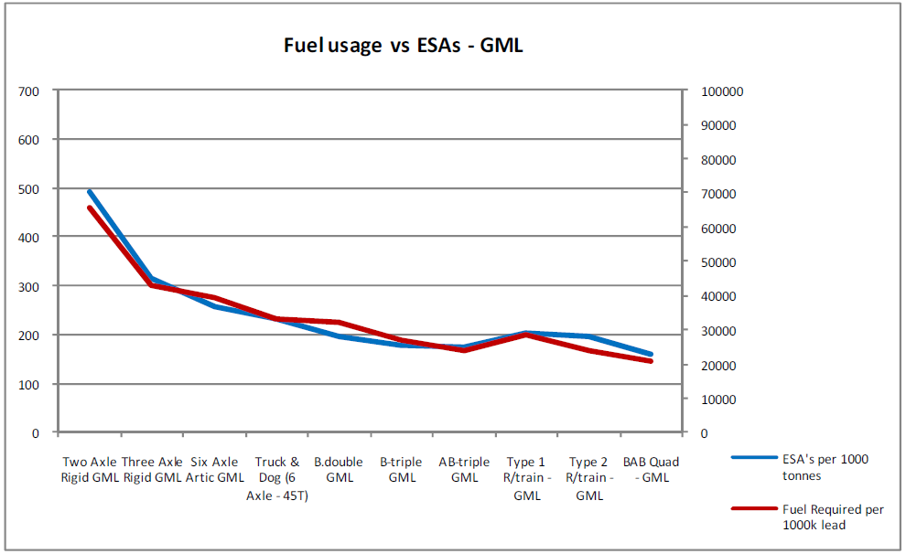

Source: The ATA and Barkwood Consulting Pty Ltd Truck Impact Chart

Having more accurate location information would mean expanding the road classification of the current PayGo model which has four road classifications (rural arterial, urban arterial, rural local and urban local). If location charging used the current classifications it would still involve a lot of averaging, as there is far more variety in Australia’s roads than these four conditions. There is no gain in multi-point charges based upon a crude division of road conditions. The key issue is getting net total right, with signals in the right general direction.

Given the concerns raised about the logic of incremental charging and the feasibility of MDL charging, PayGo should continue to be refined and should incorporate light vehicles impact and costs.

The PayGo model does not need to be abandoned; it can and should be improved while agencies get on with supply side reform. The biggest gains can be found in supply side reform.



Increasing the variable share of charges road users pay would be a logical interim step towards direct user charges.



Incremental charging should not be embraced for road access charges, as it misinterprets how heavy vehicles currently pay for impact.



Mass, distance and location charging is not feasible or practical to implement in the next decade given technological and institutional constraints.



PayGo should continue to be refined with more accurate data and serves as a very good estimate for heavy vehicle impact on infrastructure.



Light vehicles should be included in the PayGo model in order to capture their impact on infrastructure and calculate more accurate costs.

# APPENDIX A: The ATA and Barkwood Consulting Pty Ltd Truck Impact Chart

The ATA and Barkwood Consulting Pty Ltd have developed a Truck Impact Chart that clearly demonstrates a number of different heavy vehicle combinations and covers GCM, payload, the equivalent standard axles (ESAs) for each vehicle combination, being the measure by which impact of a truck on the road is measured, the amount of trips required to move 1,000 tonnes of freight, the amount of fuel required to move 1,000 tonnes of freight, emissions and driver requirement. The information provided in the tables throughout this document is taken from the Truck Impact Chart.

The Truck Impact Chart has been reviewed RTA’s Senior Pavement Engineer, Ravindra Prathapa. The Truck Impact Chart has also been separately peer reviewed by Bob Pearson, Pearson Transport Resources, and was referred to by TheCIE in the Benefit/Cost Analysis for the National Heavy Vehicle Regulator draft Regulatory Impact Statement, released in February 2011.

|  |  |  |  |
| --- | --- | --- | --- |
| E:\Public\Logos\Internal\ATA LOGO C.bmp | **Authors:** | **David Coonan - Australian Trucking Association** | BARKWOOD CONSULTING Pty Ltd |
| **Bob Woodward - Barkwood Consulting Pty Ltd.** |

This document has been prepared to assist operators and road asset managers in assessing the merits of utilising larger vehicle combinations in a transport task.

The assessment process assumes that the vehicle is dedicated to a specific task, operating travel being 50% unladen and 50% laden. The task relativities are 1000 tonnes with a lead of 1000 kilometres.

|  |  |
| --- | --- |
| **Equivalent Standard Axles:** | ESA’s are calculated by the average of the sum of ESA’s for zero load (empty) plus ESA’s for 100% load and multiplied by the number of trips as required for the transport task. |
| **Vehicle tare weights:** | Are predictions based on the averages for a range of equipment within each combination category. These estimates have been reviewed by a number of operators and confirmed as being representative of “real” vehicles of the category. |
| **Fuel consumption estimates:** | Are predictions based on accumulated averages where operation is nominally 50% unladen and 50% laden. Actual consumption will vary with operating conditions. |
| **Emissions:** | Reference is based on total fuel consumption only. |
| **20 metre 7 axle Truck & Dog:** | The maximum allowable mass limits for this combination at either CML or HML (for standard combination) is 55.5 tonnes. |
| **19 metre 7 Axle B-double:** | The maximum allowable mass limits for this combination at either CML or HML (for standard combination) is 55.5 tonnes. |
| **B-triple:** | Consists of a complying B-double with an additional complying leading trailer. |
| **Converter Dolly:** | All combinations utilizing a converter dolly are configured with a tandem axle. The configured vertical imposed loading of a 6x4 prime mover is similar to the allowable imposed vertical loading of a tandem axle converter dolly. |
| **AB-triple:** | Consists of a complying B-double with an additional complying road train leading trailer and a complying converter dolly. |
| **BAB-Quad:** | Consists of a complying B-double with an additional complying converter dolly and additional complying set of B-double trailers. |

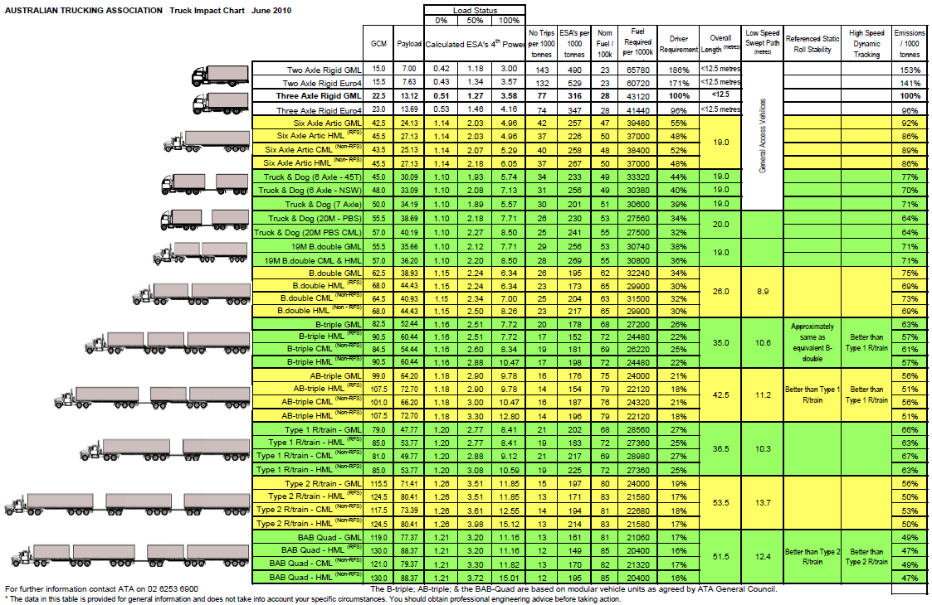

1. Page V - National Transport Commission Modelling the Marginal Cost of Road Wear Research Paper May 2011
2. NTC Heavy Vehicle charges determination regulatory impact statement volume I, December 2007
3. Antony Seely, *Hypothecated Taxation*, Standard Note SN01480, House of Commons Library, September 2011
4. <http://www.treasury.nsw.gov.au/ppp/working_with_government_wwg_guidelines_for_privately_financed_projects>
5. CRRP Preliminary Findings Consultation paper – Evaluation of options Section 4.3. Estimating road use behaviour changes
6. CRRP Preliminary Findings Consultation paper – Evaluation of options Section 4.3. Estimating road use behaviour changes
7. CRRP Preliminary Findings Consultation paper – Evaluation of options Section 4.3. Estimating road use behaviour changes
8. The Department of Transport The Eddington Transport Study December 2006
9. p. 195 Bureau of Infrastructure, Transport and Regional Economics 2009, National road network intercity traffic projections to 2030, Working Paper 75, BITRE, Canberra
10. Page 24 National Transport Commission/Deloitte: Review of Reported Jurisdictional Road Expenditure Data June 2012
11. Page 26 National Transport Commission/Deloitte: Review of Reported Jurisdictional Road Expenditure Data June 2012
12. Page 23 National Transport Commission/Deloitte: Review of Reported Jurisdictional Road Expenditure Data June 2012