**VEHICLE EMISSIONS STANDARDS: DRAFT REGULATION IMPACT STATEMENT**

**BETTER FUEL FOR CLEANER AIR DISCUSSION PAPER**

**AUSTRALIAN TRUCKING ASSOCIATION SUBMISSION**

**10 MARCH 2017**

1. **About the Australian Trucking Association**

The Australian Trucking Association (ATA) is the peak body representing trucking operators. Its members include state and sector associations, some of Australia’s major logistics companies and businesses with leading expertise in truck technology. Through its members, the ATA represents many thousands of trucking businesses, ranging from owner drivers to large fleets.

1. **Recommendations**

*Recommendation 1*

The ATA recommends that option 5 (and therefore option 6) in the draft vehicle emission RIS should not be considered further. Further consideration of these options should involve the development of a revised draft RIS that:

* assesses all the viable options
* includes all the significant costs to industry, including maintenance
* complies with the Government requirement that all increases in regulatory burden be offset
* appropriately considers the impact of the policy on rural and remote Australia.

*Recommendation 2*

In considering possible updates to existing fuel standards, the Government should note that diesel trucks do not require fuel with a higher cetane number to comply with the proposed Euro VI standard.

# Introduction

In December 2016, the Australian Government released its Draft Regulation Impact Statement (RIS) on vehicle emissions standards for cleaner air and a discussion paper on better fuels.

The vehicle emissions RIS recognises that dense urban areas in Australia frequently experience periods of poor air quality, especially in areas with high volumes of traffic. Motor vehicles, including trucks, contribute 60-70 per cent of NOx emissions in urban areas and up to 40 per cent of HC emissions.

In contrast, BITRE has previously reported that the major air quality issue in regional areas is particulate matter from bushfires, mining, agriculture and windblown particles. Motor vehicle exhaust emissions are a minor contributor.[1]

The draft RIS assesses six policy options. These are:

1. Business as usual
2. Altering Australian Government fleet purchasing policies
3. The use of voluntary standards
4. Mandating the Euro 6 emissions standard for new light vehicles
5. Mandating the Euro VI emissions standard for new heavy vehicles
6. Adopting both option 4 and option 5.[2]

The Euro VI emissions standard considered in options 5 and 6 would be implemented as an Australian Design Rule (ADR 80/04) under the *Motor Vehicle Standards Act 1989* (Cth). The ADRs, and the Euro standards generally, regulate emissions of CO, hydrocarbons, NOx and particulates.

Figure 1 shows how the emission limits for NOx and particulates have progressively become tighter.

**Figure 1: Australian heavy vehicle emission standards**

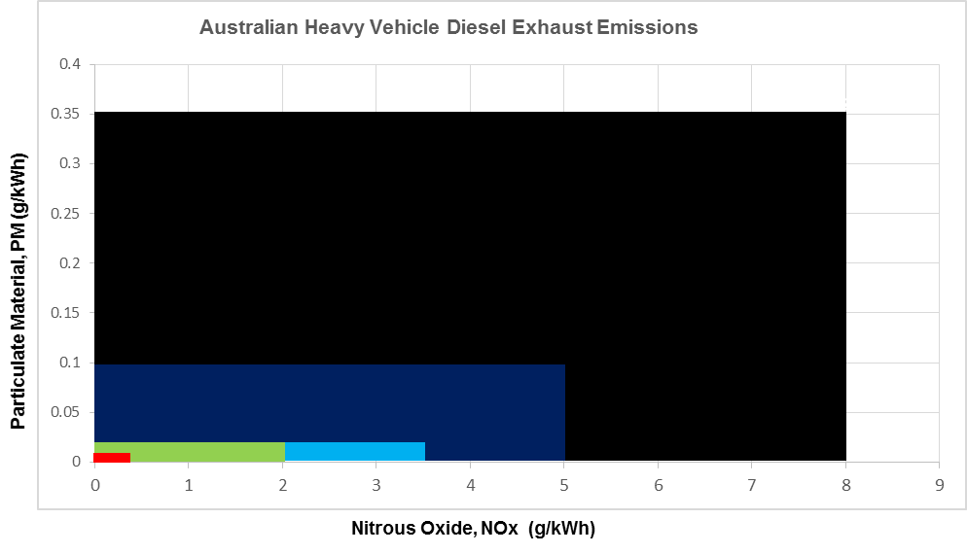



The ADRs only apply to new vehicles. Even if option 5 or 6 in the draft RIS were adopted, there would continue to be a long tail of vehicles in the fleet certified against earlier emission standards, or no emission standard at all.

Figure 2 shows that some 160,000 trucks – 33 per cent of the 2016 truck fleet – predate ADR 70/00, which mandated the Euro 1 standard.

About 21,000 new trucks are purchased in Australia each year, so changing the emissions of the truck fleet by mandating standards for new vehicles is a very slow process.

**Figure 2: Australian truck fleet by emission standard**

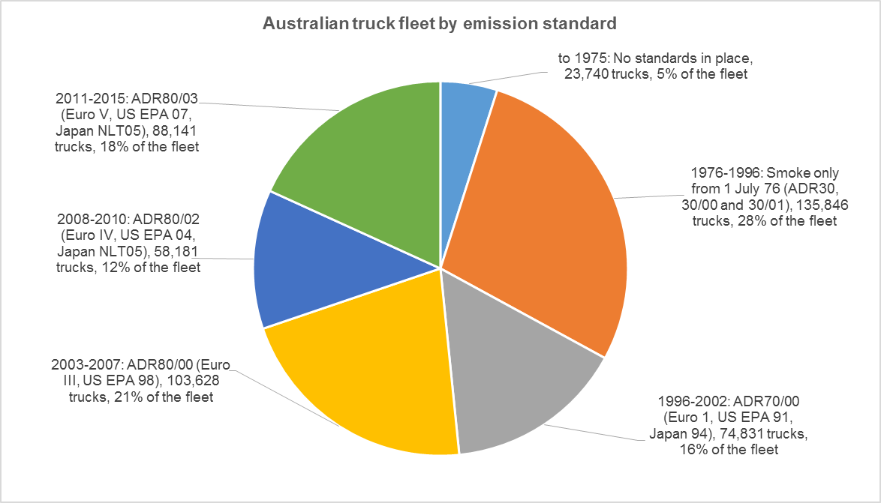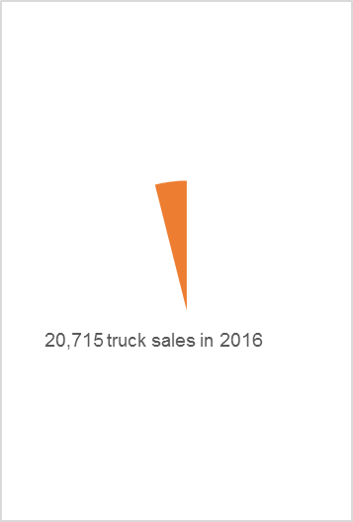

Source: Based on ARTSA analysis of Austroads NEVDIS supplied data. Used with ARTSA permission.

Meanwhile, the better fuels discussion paper examines five options for updating the existing fuel standards.[3] This submission focuses on option D in the discussion paper.

1. **Issues with options 5 and 6 in the draft vehicle emissions RIS**

Table 1 summarises the draft RIS’s analysis of the benefits and costs of option 5, mandating Euro VI. The RIS calculates that mandating Euro VI would have a positive cost-benefit ratio of 1.13, with net benefits of $264 million in net present value (NPV) terms.

|  |  |  |
| --- | --- | --- |
| **Table 1: RIS analysis of the costs and benefits of option 5 (mandating Euro VI)** | | |
|  | **Cost to 2040**  **$m** | **Net Present Value (NPV)**  **$m** |
| *Benefits* |  |  |
| Avoided health costs | 6,978.2 | 2,359.3 |
| *Less* |  |  |
| Capital costs | 3,023.6 | 1,581.5 |
| Maintenance costs | -- | -- |
| Extra fuel costs | 682.2 | 230.2 |
| Reduction in urea usage | -584.6 | -195.8 |
| Extra greenhouse gas emissions | 76.8 | 26.4 |
| Lost productivity | 1,187.7 | 452.9 |
| Total costs | 4,385.7 | 2,095.2 |
| **Net benefits** | **2592.5** | **264.1** |
| **Benefit-cost ratio** |  | **1.13** |
| Source: draft RIS, table 37, 81-82. | | |

The draft RIS goes on to recommend option 6, which includes mandating Euro 6 for light vehicles and Euro VI for heavy vehicles. Option 6 has a higher benefit cost ratio than option 5 (at 1.19) but only because the benefits of mandating Euro 6 for light vehicles drag up the benefits of option 5.

The ATA does not agree with the findings of the benefit cost analysis or the recommendation in the draft RIS. The draft RIS does not meet the requirements of the *Australian Government Guide to Regulation*, which sets out the Government’s rigorous approach to policy making.

Specifically, the draft RIS:

* does not identify and analyse an appropriate range of viable policy options (section 4.1).
* does not offer an overall net benefit (section 4.2).
* does not fully offset the increased cost burden through reductions in the existing regulatory burden (section 4.3).
* would create geographic barriers to businesses that are not properly considered (section 4.4).
  1. **The RIS does not identify an appropriate range of policy options**

The *Australian Government Guide to Regulation* emphasises that a RIS must identify a range of genuine and viable alternative policy options. RIS developers must be able to give decision-makers confidence that all the viable options have been considered. [4]

The draft RIS does not identify all the viable options for reducing on- and off-road emissions. In the ATA’s view, the draft RIS should have also considered:

*Amending vehicle design standards to increase the use of Euro VI vehicles*

Euro VI vehicles are able to be certified for supply and purchase in Australia under section 6.6 of ADR80/03. They are available now from a number of manufacturers.

The base case scenario in the cost-benefit analysis assumes that Australia will gain some benefits from imported engines and vehicles that meet the Euro VI standard.[5] The draft RIS does not, however, consider options for encouraging the take up of these vehicles.

In its discussion paper submission, the ATA recommended that vehicle design standards should be amended to encourage the purchase of Euro VI vehicles. Possible amendments to the standards are set out in section 4.3 of this submission.

The incentive package could also provide operators of Euro VI vehicles with greater access to the road network at greater mass. The NSW Government has delivered this concept already through its SPECTS scheme, which provides enrolled construction trucks with greater access to the road system provided they meet a number of standards, including, as a minimum, ADR 80/03.[6]

An advantage of incentive schemes like SPECTS is that they can be targeted at the urban areas most affected by congestion and air pollution. Accordingly, they can address concerns about the imposition of an unfair regulatory burden on rural and remote operators (see section 4.4).

*Fuel tax credits reform*

Regular maintenance is the key to ensuring that vehicles continue to meet emission standards, as the ATA has previously pointed out.[7]

When it came into force, the *Fuel Tax Act 2006* included a powerful incentive for truck operators to maintain their vehicles, as it required vehicles manufactured before 1 January 1996 to meet a maintenance or testing criteria to be eligible for fuel tax credits. While this originally applied to 61 per cent of the trucks registered in Australia, by 2016 this had fallen to 33 per cent. As a result, the majority of the truck fleet no longer has to meet any maintenance or test requirement to be eligible to receive fuel tax credits.

The ATA accordingly proposed amending the Acttoremove the 1 January 1996 threshold.

*Regulating off-road engine emissions*

The draft RIS notes that the absolute amount of emissions reduced has become smaller for each successive ADR.[8]

With successive changes to the vehicle emission standards only offering smaller improvements, a proper assessment of policy options should include non-vehicle and off-road policy options.

Improvements to urban air quality will be undermined as long as the use of off-road engines remains unregulated.

The NSW Government has reported that the emissions intensity of off-road engines within the NSW greater metropolitan region is approximately six times higher than the on-road diesel fleet.[9]

Meanwhile, *State of the Environment 2016* identifies that emissions from off-road spark-ignition engines – including gardening equipment, marine engines and small generators – put pressure on urban air quality because they are high polluters relative to their engine size and use. Even the better performing non-road engines emit disproportionately high levels of air pollutants compared with typical modern car engines, it says.[10]

The report also examines the impact of domestic wood heaters on urban air quality. On a winter weekend day, wood smoke from domestic wood heaters in Sydney contributes as much as 48 and 60 per cent of PM10 and PM2.5 particle pollution.[11]

Off-road diesel engines are another source of pollution. The report identifies that there are no regulations or standards in place to limit emissions from these engines, despite controls in place overseas.

These engines have a wide variety of uses, including rail transport, mining, construction, industrial, shipping and airport services.[12] Off-road diesel engines are estimated to emit around 18,000 tonnes of PM10 per year, which is of a similar magnitude to emissions from the on-road sector. In terms of NOx they are equal to about half of the emissions of the on-road sector.[13]

Considering the goal of improving urban air quality, and the pattern of urban development in Australia, emission standards for off-road engines should not be ignored.

The RIS should include an option where the Australian Government, in conjunction with the states and territories:

* requires marine, locomotive, off road and construction engines to meet the relevant international emission standards (ie: EU Stage III B or US EPA Tier 4).
* continues measures to reduce solid fuel fires and LPG/NG heaters in urban areas.
* curtails emissions from two stroke engines used in motor bikes, motor mowers, chain saws and brush cutters.

*These options should not be considered in a supplementary RIS*

In discussions with DIRD, it was suggested that these options could be considered as part of a supplementary RIS, once decisions are made on vehicle emission standards.

But the point of considering a range of options in a RIS is to establish how to address a policy problem (in this case, air pollution) at least cost.

It is entirely possible that a package of these options could deliver the same health outcomes at lower cost, or in a way that could be offset more easily, than options 5 and 6.

That’s why they need to be considered as part of the same RIS, rather than through a separate, supplementary process.

**4.2 The RIS does not demonstrate an overall net benefit**

When all the costs are taken into account, the draft RIS does not demonstrate that there would be an overall net benefit from option 5.

The RIS underestimates the costs of this option because it:

* does not include maintenance costs
* does not consider US/Japanese standards, and the impact on capital costs and imports if these are not included in the ADR as alternative standards
* most likely underestimates additional costs associated with urea.

*Maintenance costs*

As table 1 shows, the draft RIS does not include any additional maintenance costs in its core modelling of mandating Euro VI. According to the draft, this is due to limited information. The draft concedes the omission leads to an under-estimation of the total implementation costs of this option.[14]

When alternative scenarios were tested, the roughly modelled maintenance costs returned an unviable net benefit of negative $77.7 million for a benefit-cost ratio of 0.97.

The calculation included an average cost increase of $300 per vehicle in 2017, with a reduction in costs over time. The assumptions included roughly equal proportions of:

* minimal to no increases in annual service costs with many manufactures offering equivalent service plans for Euro V and Euro VI vehicles
* vehicles with a slight increase in annual service costs due to more detailed equipment calibration requirements, and
* vehicles with substantial increases in annual service costs due to greater equipment failure rates until the technology fully matures.[15]

As a minimum, the maintenance costs used in the sensitivity analysis should be included in the core benefit-cost analysis. The lived experience of trucking operators is that ADR 80/02 and 80/03 trucks are less reliable than older vehicles, particularly in harsh conditions. The RIS development process should have addressed the limited availability of information about this important cost by getting more information, not by leaving it out.

In addition, the ATA has concerns about the estimate of the increase in maintenance costs. The ATA has assessed a number of Euro VI truck models that are presently or soon to be available and found different approaches by truck manufacturers, including:

* increased but unquantified servicing and maintenance costs,
* increased service and maintenance costs offset by increased service intervals,
* increased service and maintenance costs of an estimated $2,400 per year, with potential offsets presently unknown.

Trucking operators have also found, in feedback reported to the ATA, that maintenance costs as a result of reliability issues are often higher then routine servicing costs for newer technology vehicles.

*Treatment of US/Japanese emission standards*

Although ADR 80/03 is based on Euro V, it allows trucks and engines certified against the equivalent US standard (US EPA 07) and Japanese standard (NLT05) to be imported into Australia.[16] The draft RIS states that specific feedback on including the latest US and Japanese standards as alternatives to Euro VI will be sought from the heavy vehicle industry during public consultation.[17]

A decision about whether to include the US and Japanese standards as alternatives in the proposed ADR 80/04 should be made now, before the RIS is completed.

If it is decided not to accept these standards, the cost estimates in the RIS would need to be increased to factor in:

* the additional cost to US/Japanese importers of certifying their engines against Euro VI as well as their home standards, if they do not do so already
* the additional cost to operators that import equipment themselves.

In considering this issue, the ATA notes that the Government is obliged under the US FTA[18] and the Japan EPA[19] to give positive consideration to accepting the equivalent US and Japanese standards.

*Cost of urea*

The draft RIS is based on the assumption that mandating Euro VI would result in more vehicles using urea than in the base case, but that urea consumption per vehicle may fall as a result of these use of EGR and SCR after treatment technologies in tandem.[20]

On the basis of the information in the draft, the ATA considers that this approach to costing the use of urea is likely to be an underestimate, because:

* the cost of installing the necessary additional equipment and storage is not included
* urea has a limited shelf life (which is shortened in hot conditions) and sells at higher prices in regional and remote areas, when it is available at all
* not all Euro VI models have reduced urea consumption compared to their Euro V equivalents.
  1. **The RIS makes no attempt to offset the cost burden of new regulation**

Principle 3 in the *Australian Government Guide to Regulation* states that:

The cost burden of new regulation must be fully offset by reductions in existing regulatory burden.[21]

The draft RIS declares that option 5 would impose an average of $225 million per year of additional regulatory costs on industry.[22]

The draft does not offset this cost, despite the Government’s requirements. The draft also does not attempt to model the impact of the cost on consumers, other industries or exporters.

If the Government wishes to proceed with considering option 5, then appropriate offsets should be developed and modelling carried out.

As the ATA has previously argued, the offsets should include:

* an increase in steer axle mass limits to 7.5t/12.5t on twin steer with load sharing axles. The draft RIS acknowledges that the additional equipment required to meet Euro VI would add some 300kg to the weight of a typical truck.[23] Since the emission standards were first introduced, the only increase in mass allowed was 500kg on single steer axle vehicles.[24] As a result, a substantial catch up is needed to maintain the industry’s productivity.
* an increase in maximum vehicle length to maintain vehicle operating range as a minimum. Further, the NTC has concluded that increasing length is the most feasible and productive means of increasing heavy vehicle capacity, at least for volumetric loads.[25]
* an increase in vehicle width. An increase in allowable width would particularly benefit operators of hard-walled refrigerated trucks, which could have thicker insulated walls without loss of payload. In 38 degree outside temperatures, these thicker walls would reduce heat gain by 36 per cent and deliver a fuel saving of 2,500 litres per typical refrigerated vehicle per year.[26]
  1. **The draft RIS does not consider the effect of option 5 on regional operators**

The Government requires regulatory impact statements to consider competition and geographic considerations including changes to geographic barriers for businesses.[27]

The ATA is particularly concerned that the draft RIS does not assess the impact of an additional $2 billion in costs on rural and regional transport operators. Under option 5, these businesses would be required to spend an extra $6,000-$15,000 to purchase each new heavy vehicle, as well as facing increased fuel costs, increased maintenance costs and a loss of productivity. It is entirely possible that those vehicles may never enter an urban airshed where vehicle emissions are a serious issue.

This policy outcome of increased regional costs would be at cross purposes with the Government’s stated aims, in other policy areas, of improving economic growth in regional communities and reducing geographical disadvantage, by imposing the costs of an urban air quality improvement policy on regional communities.

1. **Issues with the better fuel for cleaner air discussion paper**

The better fuel for cleaner air discussion paper proposes five policy alternatives, including option D – revisions to the fuel standards with strict parameters (including for cetane levels in diesel) to harmonise with the standards recommended by the Worldwide Fuel Charter.[28]

The proposal would lift the cetane number from today’s minimum requirement, 51, to 55 with a corresponding lowering of polycyclic aromatic hydrocarbons from 8 per cent to 2 per cent.

Heavy vehicles do not require a fuel with a higher cetane number to comply with Euro VI. The diesel fuel available today allows heavy vehicles to comply with the standard, without negatively impacting tailpipe emissions or the reliability of engines and after treatment systems.

Stricter requirements for diesel fuel quality would simply increase costs for trucking operators and are not required to meet the proposed new standards.

1. **ATA contact**

The ATA contact for this submission is Bill McKinley, Chief of Staff, on 02 6253 6900 or [bill.mckinley@truck.net.au](mailto:bill.mckinley@truck.net.au).

1. Bureau of Infrastructure, Transport and Regional Economics (BITRE), [Health impacts of transport emissions in Australia: economic costs](https://bitre.gov.au/publications/2005/wp_063.aspx). Working paper 63, 2005. 39.
2. Department of Infrastructure and Regional Development (DIRD), [Vehicle emission standards for cleaner air: draft regulatory impact statement](https://infrastructure.gov.au/roads/environment/forum/files/Vehicle_Noxious_Emissions_RIS.pdf). December 2016, 20.
3. Ministerial Forum on Vehicle Emissions, [Better fuel for cleaner air discussion paper](https://www.environment.gov.au/system/files/consultations/f3f4acc3-f9e6-4cc3-8a1e-a59a6490cffd/files/better-fuel-cleaner-air.pdf), December 2016, 6.
4. Australian Government, [Australian Government Guide to Regulation](http://www.cuttingredtape.gov.au/sites/default/files/files/Australian_Government_Guide_to_Regulation.pdf), March 2014.
5. DIRD, 70.
6. NSW RMS, [Safety, Productivity and Environment Construction Transport Scheme](http://www.rms.nsw.gov.au/business-industry/heavy-vehicles/safety-productivity-environment-construction-transport-scheme/index.html). (RMS webpage)
7. Australian Trucking Association, [Australian Government vehicle emissions discussion paper: ATA response](http://www.truck.net.au/advocacy/submissions/ata-response-vehicle-emissions-discussion-paper), 8 April 2016, 3-4.
8. DIRD, 66.
9. NSW EPA, [Reducing emissions from non-road diesel engines](http://www.epa.nsw.gov.au/resources/air/140586NonrdDiesInfoRpt.pdf)*,* August 2014, 11-12
10. Keywood, M., Hibberd, M., & Emmerson, K. [Australia state of the environment 2016: atmosphere](https://soe.environment.gov.au/sites/g/files/net806/f/soe2016-atmosphere-launch-version33mar17.pdf?v=1488792672). March 2017, 78-79.
11. Kenwood, 77-78.
12. Kenwood, 79-80.
13. Kenwood, 80.
14. DIRD, 75.
15. DIRD, 85.
16. ADR 80/03, s 6.
17. DIRD, 27.
18. [Australia-USA Free Trade Agreement](http://dfat.gov.au/about-us/publications/trade-investment/australia-united-states-free-trade-agreement/Pages/chapter-eight-technical-barriers-to-trade.aspx), art 8.5(1).
19. [Japan-Australia Economic Partnership Agreement](http://dfat.gov.au/trade/agreements/jaepa/official-documents/Documents/jaepa-chapters-1-to-20.pdf), art 6.5(1).
20. DIRD, 76.
21. Australian Government, 2.
22. DIRD, table 12, 38.
23. DIRD, 77.
24. See, for example, *Interstate Road Transport Regulations 1986*, r 12BAA.
25. NTC, [Increasing heavy vehicle volumetric load capacity without increasing mass limits: discussion paper](https://www.ntc.gov.au/Media/Reports/(6805FC2D-66DC-4B1C-C715-E034D3817C51).pdf). November 2016, 87.
26. Refrigerated Warehouse and Transport Association, *Submission to the National Road Transport Commission on a proposal that 2.6m trailers be permitted for the carrying of temperature controlled commodities*, July 1998, 3.
27. Australian Government, 36.
28. Ministerial Forum on Vehicle Emissions, 7.