ADR 13/00 AND IN-SERVICE VEHICLE STANDARDS
TAIL/STOP/INDICATOR LIGHT CONFIGURATIONS

AUSTRALIAN TRUCKING ASSOCIATION TECHNICAL SUBMISSION
10 MAY 2018

- About the Australian Trucking Association

The Australian Trucking Association (ATA) is the peak body representing trucking operators. Its members include state and sector associations, some of Australia’s major logistics companies and businesses with leading expertise in truck technology. Through its members, the ATA represents many thousands of trucking businesses, ranging from owner drivers to large fleets.

- Issue impacting industry

There have been some events where the installation of multiple combinations of rear mounted tail/stop/indicators have been queried by roadside enforcement. Manufacturers, at the request of many operators, often install more than the minimum light requirements on trailers.

- Governing rules

ADR 13/00 and the AVSRs do not prevent the installation of additional lights; however, additional lamps must be installed in accordance with the positional requirements defined in the ADR.

The various state vehicle standards have typically reflect the requirements of the ADRs/AVSRs. These rules do not provide detailed guidance about how to fit additional lights. The issue is not covered in the National Heavy Vehicle Inspection Manual (NHVIM).

- ATA recommended solution

The ATA’s opinion is that additional lights (within reason) provide additional safety warnings, especially in the low light transition from day to night and should be permitted.

Multiple installations of lights (as per figure 1) are common. These should be accepted by roadside enforcement.

Multiple installations of individual tail/stop and rear mounted indicators as shown in figure 2 are less than desirable and should be discouraged.

Multiple installations of individual tail/stop and rear mounted indicators as shown in figures 3 and 4 provide a clear delineation of the tail/stop and indicator function and should be specified as acceptable.

Figure 1:  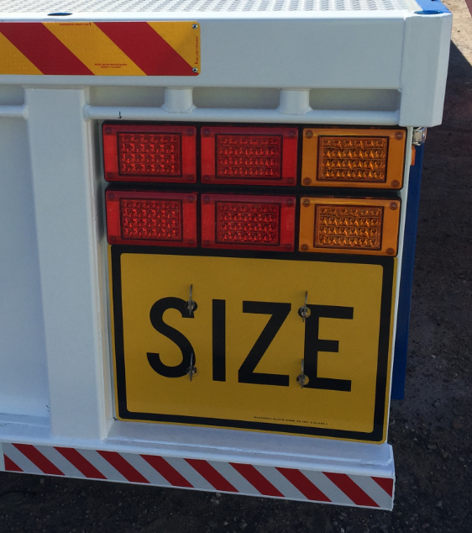  Two (2) x each ADR compliant - Jumbo Triple Module Stop/Tail/Rear Direction Indicator Lamp assemblies in combination.  Functions aligned vertically and therefore considered to be appropriately grouped and roadworthy. | Figure 2:  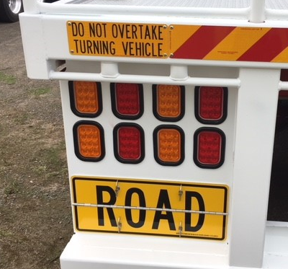  Four (4) x Indicator and four (4) x stop/tail combinations – each ADR compliant.  Functions not consistently aligned vertically or horizontally therefore considered NOT to be appropriately grouped and should be discouraged.
Figure 3:  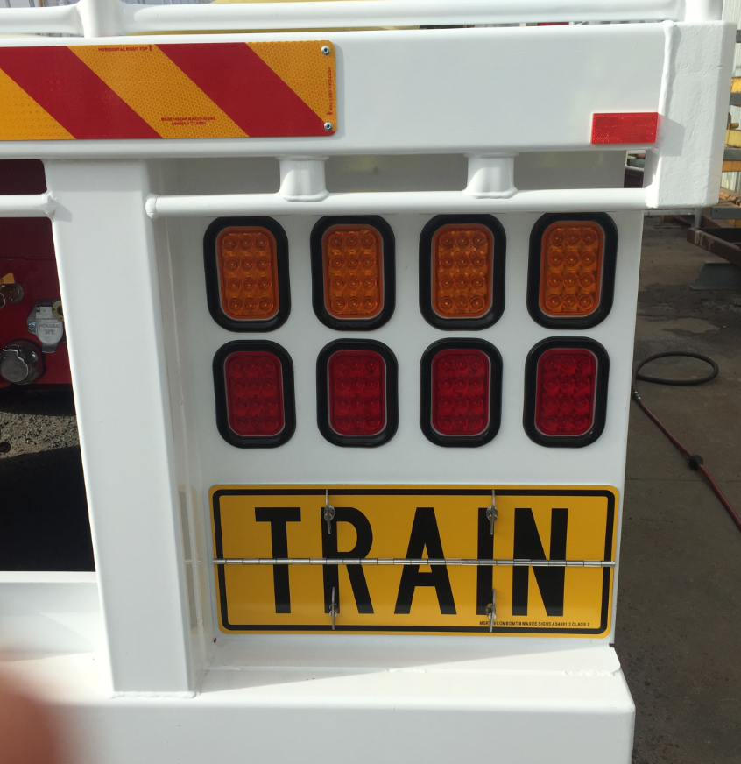  Four (4) x Indicator and four (4) x stop/tail combinations – each ADR complaint.  Turn indicator function/s horizontally aligned; and, stop/tail functions horizontally aligned; and therefore, considered to be appropriately grouped and roadworthy. | Figure 4:  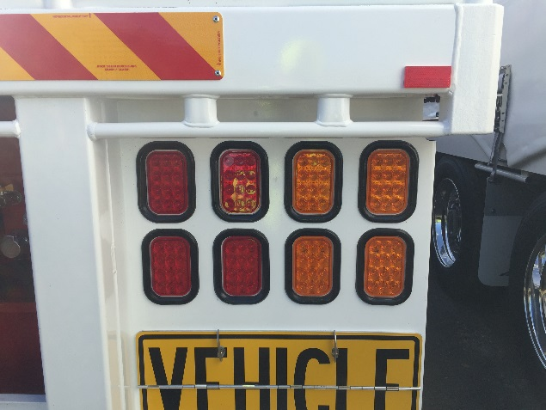  Four (4) x Indicator and four (4) x stop/tail combinations – each ADR complaint.  Turn indicator function/s grouped to right; and, stop/tail functions grouped inboard; and therefore, considered to be appropriately grouped and roadworthy.

Lighting examples – for reference only:
