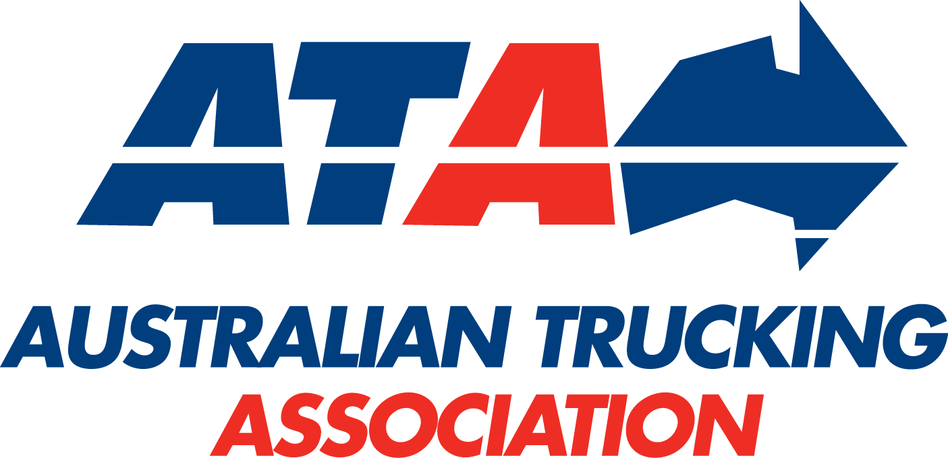

Description of truck configurations

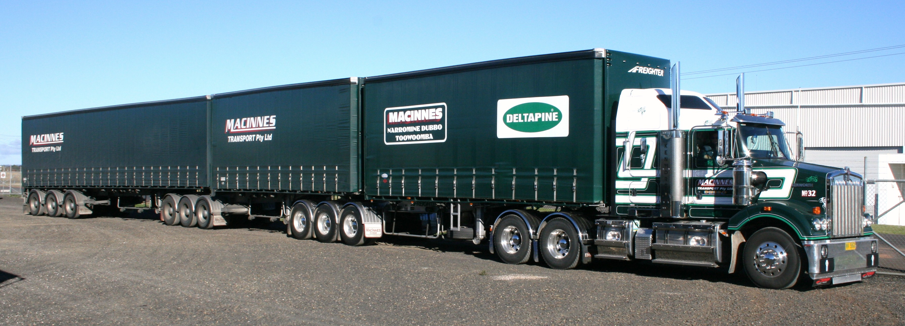
Technical
Advisory
Procedure

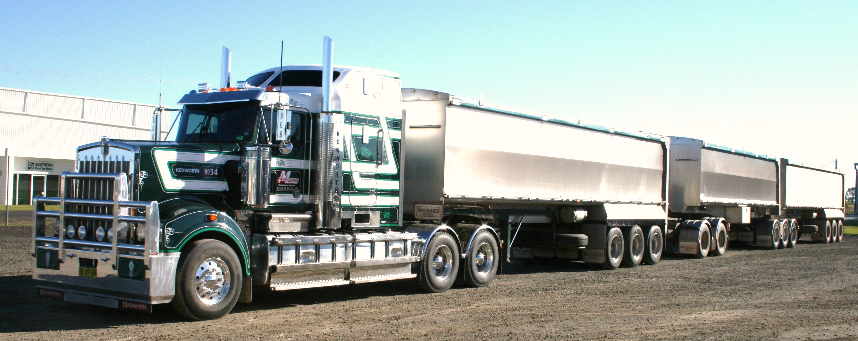
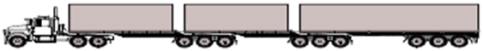
B12333, B Triple
GCM 83.0 tonnes

A123T2B33, AB Triple
GCM 99.5 tonnes

Developed by the ATA Industry Technical Council
First edition, September 2016

© 2016 Australian Trucking Association Ltd (first edition)

This work is copyright. Apart from uses permitted under the Copyright Act 1968, no part may be reproduced by any process without prior written permission from the Australian Trucking Association. Requests and inquiries concerning reproduction rights should be addressed to the Communications Manager, Australian Trucking Association, 25 National Circuit, Forrest ACT 2603 or ata@truck.net.au.

About this Technical Advisory Procedure (TAP):

This Technical Advisory Procedure is published by the Australian Trucking Association Ltd (ATA) to assist the road transport industry, authorities and the general public to accurately identify truck configurations and to achieve a better understanding of terminology.

The Technical Advisory Procedure is a guide only, and its use is entirely voluntary.

Operators must comply with the Australian Design Rules (ADRs), the Australian Vehicle Standards Regulations, roadworthiness guidelines and any specific information and instructions provided by manufacturers in relation to the vehicle systems and components.

No endorsement of products or services is made or intended.

Suggestions or comments about this Technical Advisory Procedure are welcome. Please write to the Industry Technical Council, Australian Trucking Association, Minter Ellison Building, 25 National Circuit, Forrest ACT 2603.

DISCLAIMER

The ATA makes no representations and provides no warranty that the information and recommendations contained in this Technical Advisory Procedure are suitable for use by or applicable to all operators, up to date, complete or without exception. Reliance or use upon the information or recommendations is voluntary and the user accepts all risks and responsibility for any such reliance or use and to the maximum extent permitted by law the ATA excludes all liability to any person arising directly or indirectly out of any such reliance or use.

1 Introduction
This Technical Advisory Procedure (TAP) has been developed by the ATA Industry Technical Council (ITC) to provide operators, authorities and the general public with a simple chart of heavy vehicle configurations and their descriptions. The ATA ITC identified the need for this guide to provide clarity in describing combinations during the process of preparing the second edition of the ATA ITC Truck Impact Chart TAP.

2 Understanding the coding used to identify a combination
Descriptions of truck configurations are often used, but can be too broad and often add confusion. Under the Australian Design Rules;
- a motor vehicle must be supported by an axle or axle group towards both the front and rear of the vehicle;
- a semi-trailer must be supported by an axle or axle group towards the rear; and
- a trailer, other than a semi-trailer, must be supported by either one axle group or alternatively, an axle or axle group towards both the front and the rear of the trailer.

The concept of "AnTnn" coding was developed on the basis that no vehicle can have more (as described above) than two axles or axle groups where "n" is the number of axles in each axle group. Note that “n” cannot exceed 2 for steer axles and 4 for non-steer axles.

The coding used in these illustrations uses the following convention:
R – rigid truck
A – articulated truck comprising a prime mover and a semi-trailer coupled by a turntable or B-coupling
T – trailer unit with conventional drawbar or converter dolly with drawbar
B – trailers coupled via a turntable mounted on the forward trailer
n – refers to the number of axles in an axle group

Note:-
(nn) – brackets may be included to link axle groups together in the description of the more unusual trailers configurations where the two axle groups of the a trailer cannot be separated, eg the forward axle group is not part of a converter dolly.

Dog trailer assembly usually consists of a semi-trailer with a converter dolly as the forward axle group. However, when used in a typical rigid truck and single dog trailer combination, commonly used as tippers, the forward axle group is fixed to the trailer, while dollies as extensively used with multi-trailer combinations. Brackets may be used to link the axle groups, on the trailer, as they cannot be separated eg R11T(11), but has not been used in the TAP.

By way of example,
R12 refers to a 3 axle rigid truck – a single steer and a tandem axle group
A123 refers to a conventional 6 axle articulated vehicle with a single steer
axle, tandem drive and a 3 axle semi-trailer.
B1233 refers to a conventional B-double with a 3 axle prime mover towing
two 3 axle semi-trailers – an A or lead trailer and a B or second trailer.

3 Understanding the generic configuration description
The following vehicle is commonly called a BAB quad.

Firstly, it has four trailers and is thus a quad combination. A double refers to two trailers, a triple has three trailers and a quin has five trailers within the combination.

The vehicle is made of 3 coupling segments (or elements) – BAB.
B-type coupling element, A-type coupling element and another B-type coupling element.

A-type couplings are drawbar based couplings. It does not transfer roll or load between vehicle elements. Typically, a converter dolly uses an A-type coupling.

B-type couplings are fifth wheel or turntable couplings. It typically, does transfer roll between vehicle elements and will always transfer load between vehicle elements.

BAB Quad = Prime mover with a B-type coupling for the quad (four) trailers comprising of a:
B-double (2 trailers) set,
A converter dolly and
B-double (2 trailers) set.

3 Cover images, de-coded
The two images on the front cover reflect two other longer combinations.

B12333, B Triple, GCM 83 tonnes
The truck drawing above is of an articulated unit with a single steer axle and tandem drive pulling three trailers in a B train configuration with two – three axle A or lead trailers and a single B type trailer or semi-trailer. All using a B type coupling.

A123T2B33, AB Triple, GCM 99.5 tonnes

The truck drawing above is an articulated unit with a single steer axle and tandem drive pulling a semi-trailer set with an additional B double trailer set. It is coupled via a converter dolly with an A type coupling to a B type coupling of the B-double.

5 Gross Vehicle Mass (GVM) / Gross Combination Mass (GCM)
The GVM / GCM figures listed in the truck configuration tables (section 8 of this TAP) are based on the axle limits published in the National Heavy Vehicle Regulators General Mass Limits (GML) bulletin, of which only a sub set of the limits are listed below in Table 1 below.

Axle loading limits¹.  (tonnes) | Typical limit | If the axle(s) is used within a  pig trailer
Single steer axle | 6.5 ²
Twin steering axles  with load sharing suspension ³ | 11.0
Single axle ⁴ | 9.0 | 8.5
Dual axle group ⁴ | 16.5 | 15.0
Tri axle group ⁴ | 20.0 | 18.0
Quad axle group ⁴ | 20.0⁵ | Not available
Table 1: Axle Loadings for GML

Table notes
- The tabulated figures do not take into account any other limitation, which may impact on the combination’s GVM or GCM.
- 6.0 tonnes is the typical steer axle mass limit under NHVL, but a 6.5 tonnes limit is available to units with an engine complying with ADR80/01 (Euro IV emissions), ADR84/00 front underrun protection device and the cab strength requirements of UN ECE R29. 6.5 tonnes has been used in the section 8 table.
- Non-load sharing suspensions are limited to 10.0 tonnes and have not included.
- All axles are assumed to have 4 tyres except for the steer axle(s).
- The load limit for a quad axle group is currently under review. They currently have a limit of 20 tonnes GML and limit up to 27 tonnes when operating under HML within in a PBS combination.

Certain configurations are legally limited to less than the sum of their axle groups.
- Under Heavy Vehicle National Law (HVNL) for GML, all trucks with a single trailer are limited to 43.0 tonnes GCM including the additional half tonne is available for a complying steer axle. See note 2 above.
- Rigid trucks towing dog or pig trailers are limited in that the mass of trailer shall not exceed the mass of the truck towing it.
- 7 axle (pocket, 19 m OAL) B-double is limited to a GCM of 50.5 tonnes (general access) or 56.0 tonnes (restricted access) including the half tonne for a complying steer axle.
- All combinations are still required to comply with minimum axle spacing necessary for the load being carried.

6 Definition of GVM and GCM used in this TAP
The GVMs or GCMs of a configuration is the sum of the individual axles and axle groups at the individual GML axle load limits as defined in Table 1 above.

7 Notes and key for the description of truck configuration description
used in section 8 table
Notes
- Modular truck combinations are designed that when they are broken down, each trailer or trailers will also form a legal combination for the next section of the trip.
- The table (section 8 of this TAP) is a general reference, being illustrative, and is not envisaged to be all encompassing of truck configurations driven on the road.

The truck may have 2, 3, 4 or 5 axles or more, in a range of axle configurations in either a rigid or prime mover format, dog trailers have been produced with between 2 and 6 axles, semi-trailers (both A or lead and B types) have been produced with between 1 and 4 axles, pig trailers have been produced with between 1 and 3 axles and dollies with between 2 and 4 axles.

Table key for section 8 of this TAP below:-
‘* GCM is limited to less than the sum of the axles and this may vary between the states and territories.
^ Heavy Vehicle National Law (NHVL) limits the GCM of a truck and single trailer to 43.0 tonnes with a complying steer axle.
@ These configurations include at least one quad axle group. The GCM noted is based on 27 tonnes for the quad group, which is only available for HML as a PBS model with restricted access.

8 Description of truck configurations
Rigid Trucks |  | Coding | GVM / GCM (tonnes) | Potentially a modular  combination
2-axle rigid |  | R11 | 15.5 | NA
3-axle rigid |  | R12 | 23.0 | NA
4-axle rigid |  | R22 | 27.5 | NA
Rigid truck and pig trailer combinations (pig trailers have one axle or axle group in the centre of the trailer) |  | Coding | GVM / GCM (tonnes) | Potentially a modular  combination
2-axle rigid, 1-axle pig |  | R11T1 | 24.0 | NA
2-axle rigid, 2-axle pig |  | R11T2 | 30.5 | NA
3-axle rigid, 2-axle pig |  | R12T2 | 38.0 | NA
3-axle rigid, 3-axle pig |  | R12T3 | 41.0 | NA
4-axle rigid, 3-axle pig |  | R22T3 | 45.5 (42.5)*^ | NA
Rigid truck and dog trailer combinations (dog trailers have an axle or axle group at each end of the trailer)  Dog trailer assembly usually consists of a semi-trailer with a converter dolly as the forward axle group. However, typical of the following combinations, commonly refer to a rigid truck and dog, the forward axle group is fixed to the trailer. |  | Coding | GVM / GCM (tonnes) | Potentially a modular  combination
2-axle rigid, 2-axle dog |  | R11T11 | 33.5 (31.0)* | NA
3-axle rigid, 2-axle dog |  | R12T11 | 41.0 | NA
3-axle rigid, 3-axle dog |  | R12T12 | 48.5  (43.0)*^ | NA
3-axle rigid, 4-axle dog |  | R12T22 | 56.0 (43.0)*^ | NA
3-axle rigid, 5-axle dog | 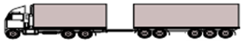 | R12T23 | 59.5 (43.0)*^ | NA
3-axle rigid, 6-axle dog | 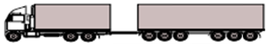 | R12T33 | 63.0 (43.0)*^ | NA
4-axle rigid, 3-axle dog |  | R22T12 | 53.0  (43.0)*^ | NA
4-axle rigid, 4-axle dog |  | R22T22 | 60.5 (43.0)*^ | NA
Single articulated vehicles (prime mover coupled to a single semi-trailer) |  | Coding | GVM / GCM (tonnes) | Potentially a modular  combination
3-axle semi, single drive, single axle |  | A111 | 24.5 | NA
4-axle semi, single drive, tandem axle |  | A112 | 32.0 | NA
5-axle semi, single drive, tri-axle |  | A113 | 35.5 | NA
5-axle semi, tandem drive, tandem axle |  | A122 | 39.5 | NA
6-axle semi, tandem drive, tri-axle |  | A123 | 43.0 | NA
7-axle semi, tandem drive, quad-axle |  | A124 | 43.0*^  (50.0 @) | NA
7-axle semi, tri-drive, tri-axle |  | A133 | 46.5  (43.0)*^ | NA
B-Doubles (Prime mover coupled to 2 semi-trailers, connected via a B coupling)  Trailers are sometimes described as an A or lead trailer with a following B or semi-trailer. |  | Coding | GVM / GCM (tonnes) | Potentially a modular  combination
B-double, tandem drive, tandem axle |  | B1222 | 56.0 (50.5)* | M
B-double, tandem drive, tandem-tri axle |  | B1223 | 59.5 | M
B-double, tandem drive, tri-tandem axle |  | B1232 | 59.5 | M
B-double, tandem drive, tri-axle |  | B1233 | 63.0 | M
B-double, tandem drive, quad-tri-axle |  | B1243 | 63.0  (70.0 @) | M
B-double, tandem drive, quad-axle |  | B1244 | 63.0  (77.0 @) | -
B-Triples (Prime mover coupled to 3 semi-trailers, connected via a B coupling)  The trailers are 2 A or lead trailers with a following B or semi-trailer) |  | Coding | GVM / GCM (tonnes) | Potentially a modular  combination
B-triple, tandem drive, 3 tandem axle groups |  | B12222 | 72.5 | M
B-triple, tandem drive, tri-tri-tandem axle |  | B12332 | 79.5 | M
B-triple, tandem drive, tri-axle |  | B12333 | 83.0 | M
Conventional double road train, type I road train or A double. (prime mover coupled firstly to a semi-trailer and then a dog trailer connected via an A coupling and comprising of a converter dolly and semi-trailer) |  | Coding | GVM / GCM (tonnes) | Potentially a modular  combination
Double road-train, tandem drive, tri-axle, tandem dolly |  | A123T23 | 79.5 | M
Double road-train, tandem drive, tri-axle, tri-dolly |  | A123T33 | 83.0 | M
Conventional triple road train, type II road train or A triple. (prime mover coupled firstly to a semi-trailer and then  2 dog trailers connected via an A coupling, and both comprising of a converter dolly and semi-trailer) |  | Coding | GVM / GCM (tonnes) | Potentially a modular  combination
Triple road-train, tandem drive, tri-axle, tandem dolly |  | A123T23T23 | 116.0 | M
Triple road-train, tandem drive, tri-axle, tri-dolly |  | A123T33T33 | 123.0 | -

Modern road trains, a variation of the tradition type I and II road trains.  They are modular and include both A and B type coupling(s) of the semi-trailer elements. |  | Coding | GVM / GCM (tonnes) | Potentially a modular  combination
AB-triple, tandem drive, tri-axle, tandem dolly |  | A123T2B33 | 99.5 | M
AB-triple, tandem drive, tri-axle, tri-axle dolly |  | A123T3B33 | 103.0 | -
AB-triple, tandem drive, tri-quad-tri, tri-axle dolly |  | A124T3B43 | 103.0  (117.0 @) | -
AB-triple, tri-drive, tri-axle, tandem dolly |  | A133T2B33 | 103.0 | -
AB-triple, tri-drive, tri-quad-tri, tri-axle dolly |  | A133T3B43 | 106.5  (113.5 @) | -
BAB-quad, tandem drive, tri-axle, tandem dolly |  | B1233T2B33 | 119.5 | M
BAB-quad, tandem drive, tri-axle, tri-dolly |  | B1233T3B33 | 123.0 | -
BAB-quad, tandem drive, quad-tri, tri-dolly |  | B1243T3B43 | 131.0 | -
BAB-quad, tri-drive, tri-axle, tandem-dolly |  | B1333T2B33 | 143.0 | M

TAP development process, history and validation

The process

The ITC will approve the need for the creation of a new TAP or the triennial routine review of an existing TAP. The nominated editor(s), who are listed below, with support of the ITC and specialist industry technical members as required, will agree on the TAP content with approval by a majority vote of ITC members. A suitably qualified and experience ATA appointed peer reviewer will further review the publication and if necessary, recommend changes. These changes will then be reviewed and approved again by a majority vote of ITC members before the document is released.

Document version control

Edition | Date | Nature of change / comment | Editor(s)
First | September 2016 | Initial release | Chris Loose, ATA  Senior Adviser Engineering

The next review is expected on or before September 2020.

Drafting committee

Edition | Date | Drafting | Organisation / Qualifications
First | September 2016 | Bob Woodward | Barkwood Consulting, BEng
First |  | Chris Loose | Australian Trucking Association, BEng

Peer review

Edition | Date | Peer Reviewer | Organisation / Qualifications
First | September 2016 | Bob Pearson | Pearsons Transport Resource Centre, BEng

About the ATA Industry Technical Council:

The Industry Technical Council (ITC) is a standing committee of the Australian Trucking Association (ATA). The ITC’s mission is to improve trucking equipment, its maintenance and maintenance management. The ITC was established in 1995.

As a group, the ITC provides the ATA with robust professional advice on technical matters to help underpin the ATA’s evidence based policymaking. It is concerned with lifting technical and maintenance standards, improving the operational safety of the heavy vehicle sector, and the development of guidelines and standards for technical matters.

ITC performs a unique service in the Australian trucking industry by bringing operators, suppliers, engineers and other specialists together in a long-term discussion forum. Its members provide expert and independent advice in the field to inform the work of the ITC. The outcomes from ITC benefit all ITC stakeholders and the heavy vehicle industry at large.

The ITC operates under the Australian Trucking Association’s Council, which formulates industry policy for implementation by the organisation.

Joining ITC:

We welcome applications to join the ITC. For further information,
please call the ATA (02) 6253 6900
email ata@truck.net.au
or download information from the ATA website www.truck.net.au follow the links under the members tab to join here.

